ENGINEERING CHANGE REQUEST

First Phase of Installation of Low-Impedance Secondary Collimators (TCSPM) in IR7
BRIEF DESCRIPTION OF THE PROPOSED CHANGE(S):
The LHC impedance budget is dominated by the contribution of the LHC collimators, and in particular by the eleven secondary collimators (TCSG) per beam of the betatron insertion region, located in IR7. The baseline upgrade of the LHC collimation system foreseen by the HL-LHC project considers to replace all the IR7 TCSGs with new ones (TCSPM) to reduce impedance and ensure with sufficient margin the stability of the brighter HL-LHC beams. The installation of the new hardware will proceed in two stages, with four collimators per beam installed during the Long Shutdown 2 (LS2) and the remaining seven collimators per beam during LS3. This ECR details the first phase of installation, taking place during LS2.
DOCUMENT PREPARED BY: | DOCUMENT TO BE CHECKED BY: | DOCUMENT TO BE APPROVED BY:
Roderik Bruce BE-ABP  Alessio Mereghetti BE-ABP  Stefano Redaelli BE-ABP | O. Aberle, J. Albertone, C. Adorisio,  G. Arduini, M. Barberan, I. Bejar Alonso,  M. Bernardini, A. Bertarelli, F. Bertinelli,  C. Bertone, C. Boccard, G. Bregliozzi,  S. Bustamante, M. Calviani, F. Carra,G. Cattenoz, P. Chiggiato, J. P. Corso,  B. Delille, R. De Maria, P. Fessia, R. Folch,  J. F. Fuchs, C. Gaignant, L. Gentini,  S. Gilardoni, M. Giovannozzi, B. Goddard,  R. Jones, I. Lamas Garcia, M. Lamont,  J. Lendaro, A. Masi, D. Missiaen,Y. Muttoni, T. Otto, E. Page, S. Roesler, B. Salvant,  R. Steerenberg, L. Tavian, M. Tavlet,  C. Vollinger, J. Wenninger | P. Collier  (on behalf of the LMC)  L. Rossi  (on behalf of the HL-LHC Project)
DOCUMENT SENT FOR INFORMATION TO:
[List of persons to whom the document is sent]
SUMMARY OF THE ACTIONS TO BE UNDERTAKEN:

EXISTING SITUATION AND INTRODUCTION
The betatron collimation system [1] of the Large Hadron Collider (LHC) is located in the Insertion Region 7 (IR7). For each beam it is composed by:
- three primary collimators (TCPs), intercepting tail protons;
- eleven secondary collimators (TCSGs), aimed at intercepting most of the beam particles leaking out of the TCPs;
- shower absorbers (TCLAs), aimed at containing the most energetic component of the secondary particle showers started in the upstream collimator families.
Due to the relatively high number of TCSG collimators, the jaw material and gaps deployed in operation, they are the largest contributors to the machine impedance [2]. Octupoles are used in LHC operation to stabilise the beam, compensating the machine impedance with enough margins that can be used for compensating also other sources of instability.
The High Luminosity LHC (HL-LHC) project [3] foresees to collide beams brighter than those presently available in the LHC. Numerical calculations [4] show that if no action in reducing the collimator impedance is taken, then there would be not enough margin for the octupoles to stabilise the beams. Therefore, the HL-LHC project foresees to replace the present TCSG collimators with low impedance ones (TCSPMs).
It is proposed to proceed with the installation of the new collimators in IR7 in two phases. The first one will be carried out during the Long Shutdown 2 (LS2), when four TCSGs per beam will be replaced with the equivalent number of TCSPMs. During LS3, the seven remaining TCSG per beam will be replaced. The present ECR details the LS2 installation.

REASON FOR THE CHANGE
While the low-impedance upgrade of the IR7 collimation system is part of the baseline upgrades foreseen by the HL-LHC project [3], it has been proposed to proceed in two installation phases. The assets of this approach are:
- Having some low-impedance collimators already installed in LS2 already provides an important reduction of the collimator impedance for the LHC Run III, when the upgraded beam parameters from the LHC Injector Upgrade (LIU) program will progressively become available. This will provide important benefits to the LHC operation and will allow studying better the possible impedance limitations;
- A staged deployment allows possible further iterations on the new collimator design for the second production line for LS3;
- The staged approach also allows distributing resources that would otherwise have to be made available in LS3, when various other parallel activities for different HL-LHC upgrades will be on-going, in particular the collimation upgrade of the high-luminosity insertions IR1 and IR5

DETAILED DESCRIPTION
The present TCSPM design [5] (see Figure 1) is an evolution of the present TCSGs [1]; among the most noticeable differences, there are material and coating of the jaw, and the presence of Beam Position Monitors (BPMs). The BPMs are embedded in the jaw and shall be added in the database with the same notations used for the present TCTP and TCSP collimators. Other features are described in [7]. In fact, the design foresees jaws made of a composite material (MoGr) obtained from Molybdenum and graphite, chosen for its similar robustness and superior impedance characteristics with respect to the jaw material of the present TCSGs, in particular since a thin coating layer of Mo will be deployed. The collimator jaws are equipped with BPM button pick-ups, for an easy determination of the beam closed orbit at the collimator and fast and precise alignment of the jaws. A third BPM is installed on the tank, to measure the beam position on the axis orthogonal to the one of cleaning.

Table 1 summarises the main collimator parameters of the TCSPM design.

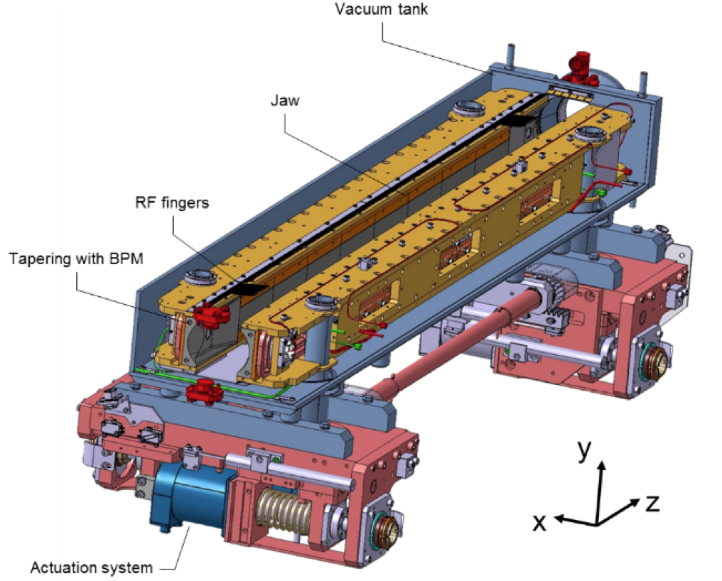
Figure 1 — 3D view [5] of the TCSPM collimator (smarTeam code: ST0948103), showing an extremity of the jaw with the embedded BPM, the “third” BPM for orbit measurements in the plane orthogonal to the collimation plane, and the new tapered transitions made of MoGr.

Table 1 — Detailed parameter list of the TCSPM collimator design.
Characteristics | Units | Value
Jaw active length | mm | 1000
Jaw absorbing material |  | MoGr
Flange-to-flange distance | mm | 1480
Number of jaws |  | 2
Orientation |  | Depending on installation slot (see Table 2)
Number of BPM buttons per jaw |  | 2
Number of tank BPM buttons |  | 2
RF damping |  | RF fingers
Cooling of the jaw |  | Demineralised water
Minimum gap | mm | <2
Maximum gap | mm | 50
Stroke across zero | mm | 5
Number of motors per jaw |  | 2
Angular adjustments |  | Yes
Transverse jaw movement (fifth axis) |  | Yes

During the 2016 Extended Year End Technical Stop (EYETS 2016) a prototype of TCSPM collimator was installed on beam 2 (B2) [6]. Prototyping allowed verifying the feasibility of the new design. Moreover, the jaws of the prototype were equipped with three superficial stripes of different materials, in order to perform impedance measurements with each stripe and hence finalise the choice of coating material.
The layout of the betatron collimation cleaning insertion was prepared for a low-impedance upgrade from the initial design phase [1]. Each IR7 TCSG has a corresponding TCSM slot, immediately downstream. These slots are all equipped with the required cabling and ancillaries (support, cooling water, beam loss monitor, etc...) for the installation of a new collimator. Cabling for the readout of the in-jaw BPMs is not part of the initial installation because the previous collimator design did not include this feature. The short, radiation-hard cables from the tunnel's cable trays to the collimator support are also not installed for every TCSM slot. The short water braided flexibles from the series water system to the collimator support are also not installed for every TCSM slot.
Therefore, where possible, the installation of the new collimators is done by using the empty slots. Such a hybrid scenario where both old and new collimators are temporarily kept operational is not favored over a long time scale because this configuration would entail the maintenance of a larger number of devices; nevertheless, this configuration is suitable for the initial commissioning of new collimators. The impact on the requirements for the collimator control units should be assessed.
At the time of writing, a complete assessment of radiation levels of the present TCSGs is not available. In case of high doses, it might be preferable or even necessary to remove the TCSG collimator in order to allow personnel to work in the areas. A detailed assessment will be carried out in 2018 depending on the progress with the luminosity performance. Presently, no show-stoppers are identified for the intervention on any TCSG slot.
Detailed numerical studies [7] allowed to spot the best set of slots for installation of the new TCSPM collimators. The optimization mainly took into account impedance reduction, energy deposition and induced thermos-mechanical stresses, and cleaning inefficiency. Table 2 lists the chosen slots for both B1 and B2 along with the DCUM (distance cumulée), the existing components and the name of the new one; for ease of coordination of activities, the vacuum sector is also indicated. The TCSM slot is used whenever available, hence the new TCSPMs are added downstream of the respective TCSG. The only exception is the TCSM.D4L7.B1, where the crystal collimator is installed; hence, the TCSG.D4L7.B1 will be replaced by the new TCSPM. If tests probing the endurance of the stripes of the TCSPM.D4R7.B2 will be carried out in 2018, then this collimator will be replaced with the new TCSPM; otherwise, the TCSPM prototype will remain in the TCSM slot, and the upstream TCSG.D4R7.B2 will be exchanged with the TCSPM.

Table 2 — Installation slot of the new TCSPM in IR7.
B1 Slot | Angle [deg] | DCUM | Existing components | New Components | Vacuum Sector
TCSG.D4L7.B1 | 90.0 | 19989 | TCSG.D4L7.B1 | TCSPM.D4L7.B1 | A4L7.B
TCSM.B4L7.B1 | 0.0 | 19919 | VCDSS.B4L7.B | TCSPM.B4L7.B1 | IP7.B
TCSM.E5R7.B1 | 130.5 | 20108 | VCDSS.C5R7.B | TCSPM.E5R7.B1 | A5R7.B
TCSM.6R7.B1 | 0.5 | 20143 | VCDSS.6R7.B | TCSPM.6R7.B1 | B5R7.B

B2 Slot | Angle [deg] | DCUM | Existing components | New Components | Vacuum Sector
TCSG.D4R7.B2 | 90.0 | 20070 | TCSG.D4R7.B2 | TCSPM.D4R7.B2 | A4R7.R
TCSM.B4R7.B2 | 0.0 | 20002 | VCDSS.B4R7.R | TCSPM.B4R7.B2 | IP7.R
TCSM.E5L7.B2 | 130.5 | 19879 | VCDSS.C5L7.R | TCSPM.E5L7.B2 | A5L7.R
TCSM.6L7.B2 | 0.5 | 19844 | VCDSS.6L7.R | TCSPM.6L7.B2 | B5L7.R

Table 3 — Names of the BPM for the new TCSPM collimators.

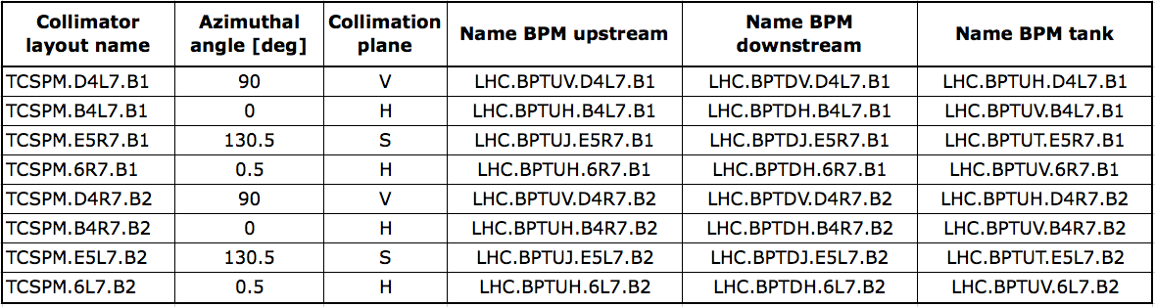IMPACT ON OTHER ITEMS

IMPACT ON ITEMS/SYSTEMS
BE/BI | BE/BI is responsible for the BPM acquisition. Cables should be pulled for the new BPMs. Controls units DOROS should be installed for the signal processing.
BE/OP | Necessary change to the control system of the LHC must be performed to control the new collimator and read the new BPM signals.
Item/System xxxxx

IMPACT ON UTILITIES AND SERVICES
Raw water: | No
Demineralized water: | The circuit of cooling water of the TCSPM will have to be connected, in series to other collimators.
Compressed air: | No
Electricity, cable pulling  (power, signal, optical fibres…): | Cables have already been pulled in LS1 and need only to be connected to the new collimator;  New cables needed for the BPMs.
DEC/DIC: | RQF0875886 (EN/SMM)  RQF0943607 (BE/BI)
Racks (name and location): | TZ76  BE/BI racks: BY03, BY04, BY05;
Vacuum Tunnel activities: | For each collimator the entire vacuum sector must be vented, the bakeout installed and finally NEG activation for a total of about 3.5 wks of work per vacuum sector.  In addition to tunnel activities:  - Vacuum acceptance test of all collimator sub-assemblies: Pickup button, PU flanges and BPM cables, motor bellows, MoGr blocks and complete jaw.  - Contractor vacuum test:  - -Test bench procurement, and in situ installation with commissioning,  - -Test follow up and validation before any shipping to CERN.  - Bake out procurement and equipment of each collimator at CERN
Special transport/ handling: | No
Temporary storage of conventional/radioactive components: | No
Alignment and positioning: | The component must be updated in the CERN layout Database before SU activities in the LHC tunnel. SU needs to know the positions of both targets by doing a “fiducialisation” with a laser tracker few days before the transportation of the component into the LHC.  Standard alignment procedures apply – at installation, the collimator position should be adjusted by the survey team.
Scaffolding: | No
Controls: | The LHC control system must be updated to include the new collimator.
GSM/WIFI networks: | No
Cryogenics: | No
Contractor(s): | No
Surface building(s): | No
Layout DB: | The layout database should be updated with new slot names.

IMPACT ON COST, SCHEDULE AND PERFORMANCE

IMPACT ON COST
Detailed breakdown of the change cost: | Paid by HL-LHC WP5 halo cleaning
Budget code: | HL-LHC WP05-Halo Cleaning-EN/STI : 53702  HL-LHC WP05-Halo Cleaning-EN/SMM - electronics: 53719  HL-LHC WP05 Collimator Vacuum: 99150  HL Consolidation : 53706 (for spares)

IMPACT ON SCHEDULE
Proposed installation schedule: | Installation foreseen during first half of 2020
Proposed test schedule (if applicable): | Prior to installation: controls tests (EN/STI) and vacuum validation (TE/VSC). Impact on the EN/EL team to be evaluated.
Estimated duration: | 1-2 weeks: 2 days of mechanical intervention (minimum) ; 3-4 days of BO equipment ; 5 days of NEG activation ; 2 days for dismantling (MECA+BO).
Urgency: | No
Flexibility of scheduling: | Limited.

IMPACT ON PERFORMANCE
Mechanical aperture: | As for all other collimators, the TCSPM has movable jaws in the collimation plane (horizontal, vertical and skew) and no deterioration is expected. Thus, this installation has no impact on the available aperture.
Impedance: | Improved.
Optics/MADX | To be checked
Electron cloud  (NEG coating, solenoid…) | No change
Insulation (enamelled flange, grounding…) | No change
Vacuum performance: | TE-VSC will perform vacuum acceptance tests on each component to assess vacuum compatibility within LHC vacuum environment based on EDMS 1752123. In case of not conformity the collimators could be rejected and not being installed.
Others:

IMPACT ON OPERATIONAL SAFETY

ÉLÉMENT(S) IMPORTANT(S) DE SECURITÉ
No Impact on EISs.

OTHER OPERATIONAL SAFETY ASPECTS
Have new hazards been created or changed? | No
Could the change affect existing risk control measures? | No
What risk controls have to be put in place? | -
Safety documentation to update after the modification | -
Define the need for training or information after the change | -

WORKSITE SAFETY

ORGANISATION
Requirement | Yes | No | Comments
IMPACT – VIC: | X
Operational radiation protection  (surveys, DIMR…): | X |  | RP survey needed  TE-VSC: Dedicated WDP should be prepared and validated by RP for each step of the installation: mechanical, bake-out and NEG activation.
Radioactive storage of material: | X |  | Dummy beam pipe to be removed, TCSG.D4L7.B1, and TCSG.D4R7.B2 / TCSPM.D4R7.B2 (prototype)
Radioactive waste: | X |  | TCSG.D4L7.B1, and TCSG.D4R7.B2 / TCSPM.D4R7.B2 (prototype)
Non-radioactive waste: | X
Fire risk/permit (IS41)  (welding, grinding…): |  | X
Alarms deactivation/activation (IS37): |  | X
Others: |  | X

REGULATORY TESTS
Requirement | Yes | No | Responsible Group | Comments
Pressure/leak tests: | X |  | EN-STI  TE-VSC | Water pressure test of cooling pipes must be done, as specified, before vacuum acceptance test. All cooling pipes must be emptied for the vacuum test. Any water leakage during the bake out could induce short circuits and permanent damage of the bake out system with consequently exposure to higher dose for its replacements.  Helium leak test of the complete collimator before and after bake out cycle is performed.
Electrical tests: |  | X
Others:

PARTICULAR RISKS
Requirement | Yes | No | Comments
Hazardous substances (chemicals, gas, asbestos…): |  | X
Work at height: |  | X
Confined space working: |  | X
Noise: |  | X
Cryogenic risks: |  | X
Industrial X-ray  (tirs radio): |  | X
Ionizing radiation risks (radioactive components): | X |  | The collimators are installed in slots presently occupied by a replacement chamber or another collimators. The elements to be removed will be radioactive.
Others:

FOLLOW-UP OF ACTIONS BY THE TECHNICAL COORDINATION
Action | Done | Date | Comments
Carry out site activities:
Carry out tests:
Update layout drawings:
Update equipment drawings:
Update layout database:
Update naming database:
Update optics (MADX)
Update procedures for maintenance and operations
Update Safety File according to EDMS document 1177755:
Others:

REFERENCES
[1] O. Brüning et al. (eds), “LHC design report”, Vol. I, CERN, Geneva, Switzerland, Rep. CERN-2004-003-V-1, 2004.
[2] N. Mounet, “Trensverse impedance in the HL-LHC era”, presentation at the 3rd
HL-LHC Annual Collaboration meeting, Daresbury, UK (2013), https://indico.cern.ch/event/257368/
[3] G. Apollinari et. al, “High Luminosity Large Hadron Collider (HL-LHC) Technical Design Report V.01'', CERN, Geneva, Switzerland, EDMS n. 1833445 v.09.05, https://edms.cern.ch/document/1833445
[4] S. Antipov et al., “Machine Impedance and HOM Power Update”, presentation at the 7th HL-LHC Annual Collaboration Meeting, Madrid, Spain (2017), https://indico.cern.ch/event/647714/
[5] F. Carra, “Status of TCSPM Prototype Production”, presentation at the 80th Collimation Upgrade Specification Meeting (ColUSM), Dec. 9th 2016, https://indico.cern.ch/event/591788
[6] R. Bruce and S. Redaelli, “Installation of a low-impedance secondary collimator (TCSPM) in IR7”, LHC-TC-EC-0006, EDMS doc. 1705738, CERN, Geneva, Switzerland (2016).
[7] S. Antipov, N. Biancacci, A. Bertarelli, R. Bruce, F. Carra, A. Lechner, A. Mereghetti, E. Métral, S. Redaelli, B. Salvant “Staged implementation of low-impedance collimation in IR7: plans for LS2”, to be published (2018).

