ENGINEERING CHANGE REQUEST

Installation of New Passive Absorbers (TCAPM) for Warm Magnet Protection in IR7
BRIEF DESCRIPTION OF THE PROPOSED CHANGE(S):
As a part of the consolidation of the warm magnet systems of the betatron cleaning insertion (IR7), one MQW module of the Q5 magnet will be removed from the tunnel [1]. This is planned for LS2 as a part of the mitigation measures to reduce the absorbed dose on warm magnets and increase their lifetime. In order to ensure adequate protection of the downstream magnets, a new passive absorber TCAPM (Target Collimator Absorber Passive Mask), will be installed. This document presents the solution proposed for implementation in LS2. This activity is part of the consolidation project.
DOCUMENT PREPARED BY: | DOCUMENT CHECKED BY: | DOCUMENT APPROVED BY:
S. Redaelli BE-ABP,  R. Bruce BE-ABP,  A. Mereghetti BE-ABP | O. Aberle, J. Albertone, C. Adorisio,  G. Arduini, M. Barberan, M. Bernardini, A. Bertarelli, F. Bertinelli,  C. Bertone, C. Boccard, G. Bregliozzi,  S. Bustamante, M. Calviani, F. Carra,  G. Cattenoz, P. Chiggiato, J. P. Corso,  R. De Maria, R. Folch,  J. F. Fuchs, C. Gaignant, L. Gentini,  S. Gilardoni, G. Girardot,  M. Giovannozzi, B. Goddard,  E. Jensen, R. Jones, I. Lamas Garcia, M. Lamont, J. Lendaro, A. Masi,  D. Missiaen,Y. Muttoni, T. Otto,  E. Page, S. Roesler,  B. Salvant, R. Steerenberg,  M. Tavlet, C. Vollinger, J. Wenninger | P. Collier  (on behalf of the LMC)
DOCUMENT SENT FOR INFORMATION TO:
LMC participants, Collimation working group, Collimation Upgrade Specification working group, Machine Protection working group, ATS groups leaders
SUMMARY OF THE ACTIONS TO BE UNDERTAKEN:

EXISTING SITUATION AND INTRODUCTION
Details of mitigation plans for the absorbed dose of warm quadrupoles and dipoles in the betatron cleaning insertion (IR7) of the LHC can be found in [1]. Mitigations include the removal of the first (along the incoming beam direction) MQW module of the Q5 assemblies at either side of IP7. This leaves the subsequent magnets more exposed to radiation doses. In order to make the intervention effective for the overall dose reduction, an upgrade of the passive collimation system is required. As a design goal for this upgrade, we set the design requirement that all remaining 5 magnets should receive doses not exceeding the levels that they receive in the present layout. This requires adding one new passive absorber per beam, called TCAPM (Target Collimator Absorber Passive Mask), at the locations of the magnets that will be i.e. at the location of the MQWA.E5.
The requirements and a detailed performance assessment of possible new layouts were discussed in various Collimation Upgrade Specification meetings – see the presentations by C. Bahamonde in [2,3,4,5,6]. Figure 1 shows in an illustrative sketch, taken from the FLUKA geometry used in simulations, the present layout (top view) and the modified one (bottom view) [2,3]. The latest design was reviewed and endorsed in [6a].
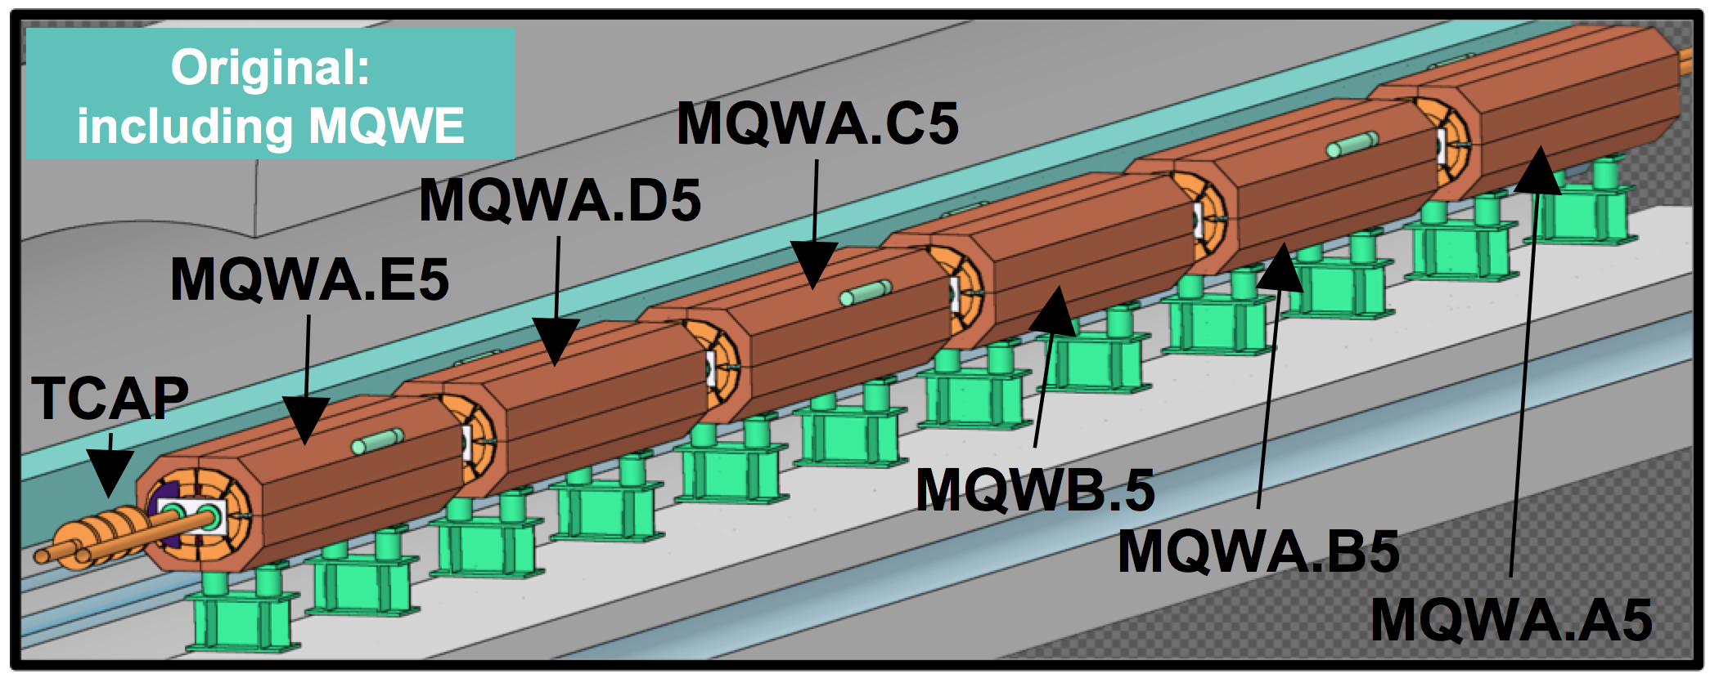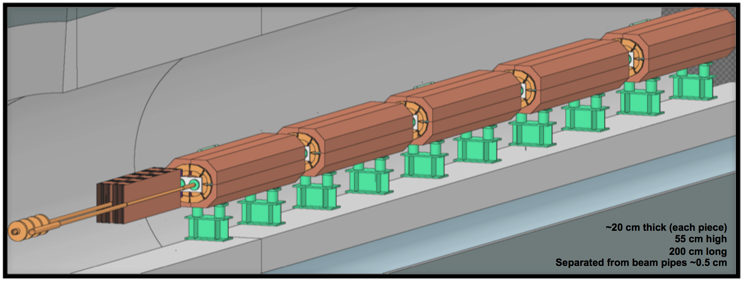
Figure 1 — Illustrative view of the present (top) and post-LS2 (bottom) layouts of the IR7 Q5 [2,3]. The new TCAPM is represented by the brown box immediately upstream of the MQWA.D5, installed in the space freed by the removal of the MQWA.E5. A specular layout is planned for beam 2.
The present passive collimator TCAP (installed upstream of the present MQWA.E5, see Fig. 1) will remain in place and the new passive absorber TCAPM will be added. The latter is outside the vacuum, contrary to the existing passive absorbers. The same elliptical chambers as the present MQW one will be used in this area.

REASON FOR THE CHANGE
The computed doses in all modules of the Q5 magnets for beam 1, estimated for the whole lifetime of the HL-LHC project [7], are illustrated in Figure 2 for three different layouts [2,3]:
- Present layout (top graph);
- Hypothetical layout without collimation upgrade after magnet removal (middle);
- Proposed post-LS2 layout (bottom) with TCAPM.
Dose values are estimated both for the coil and for the spacers [1]. Note that for all cases, the present TCAPC.6L7.B1 collimator remains at the same location, as this was found to produce good performance. This also avoids intervening on a radioactive collimator. It is clear that without an improvement of the passive collimation layout (middle plot), doses on the downstream MQWs would be much higher than in the present layout. In particular, the dose on the coil spacers [1] of the most exposed magnet would be about a factor 4 larger. The proposed solution with TCAPM (bottom line) described in detail in the next section, solves this issue and brings the doses to an acceptable level.
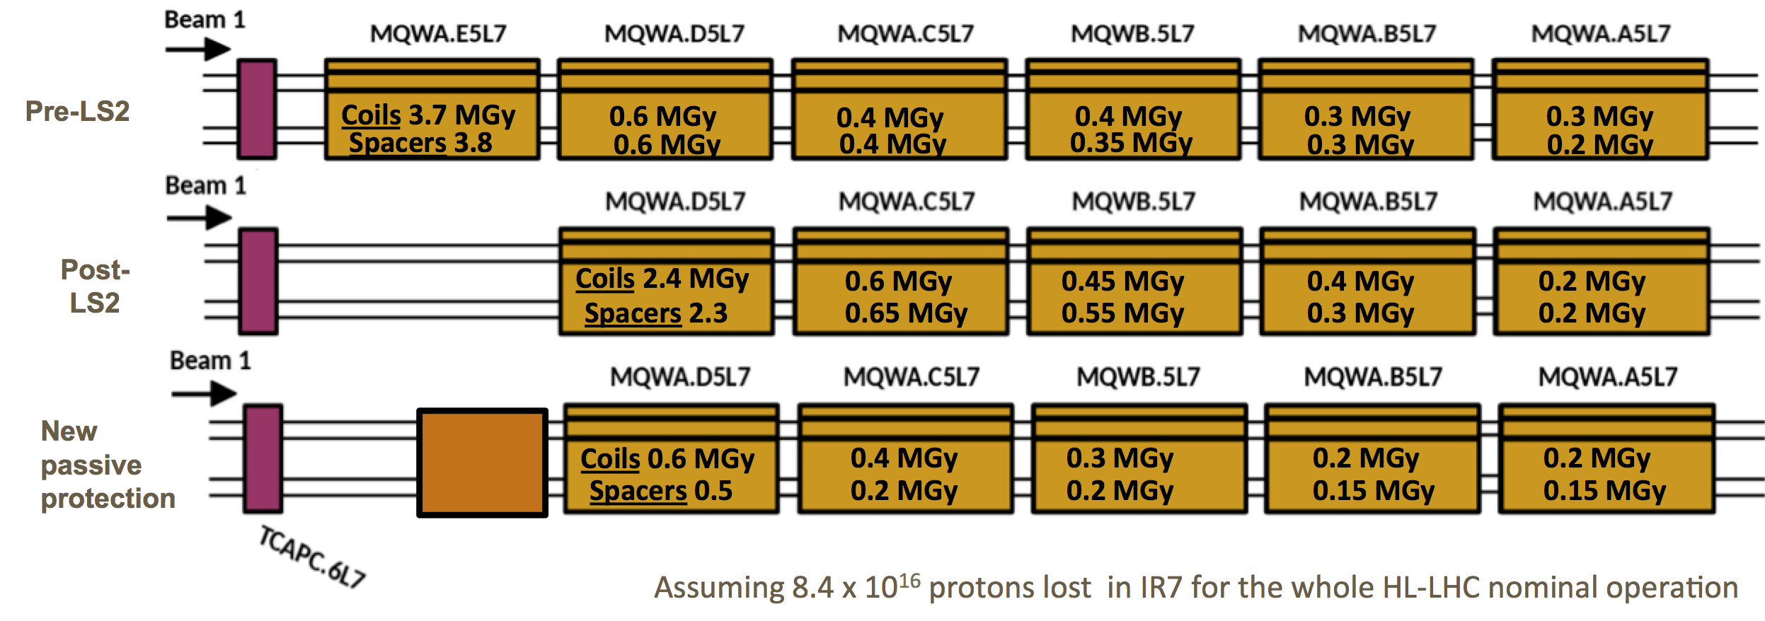
Figure 2 — Summary of doses in different magnets of the Q5 assembly for B1, in the present (top) and proposed post-LS2 (bottom) layouts. The middle plot shows the situation in case no upgrade of the passive collimation system is made. The new TCAPM is indicated by the brown box immediately upstream of the MQWA.D5L7. Courtesy of C. Bahamonde [2,3]. We propose to call these new absorbers TCAPM.A5L7.B1 and TCAPM.A5R7.B2.

DETAILED DESCRIPTION
The new absorber’s design [8] is shown in Figure 3. More details can be found in:
- https://edms.cern.ch/document/1395378/0 (LSSR7)
- https://edms.cern.ch/document/1395377/0 (LSSL7)
A new support that will be installed under the vacuum chamber will house a modular structure made of steel blocks, assembled together to fill a volume that ensures adequate shielding of the downstream magnet. The supporting structure consists thereby of a girder (see figure 4) resting on the reused magnet support feet provided by TE-MSC. The absorbing part consists of three block assemblies shown in Figure 4. The assemblies 1, 2 and 3 weight respectively 781 Kg, 756 Kg and 779 Kg, for a total of about 2590 kg with the support. The TCAPM transverse cross section is shown in Figure 5. The absorber assemblies are mounted around the existing elliptical beam pipes in a way that leaves minimum empty spaces. The integration layout is shown in Figure 6. The longitudinal central positions of the new passive absorbers are 19852.4064 m for B1 and 20135.9184 m for B2.
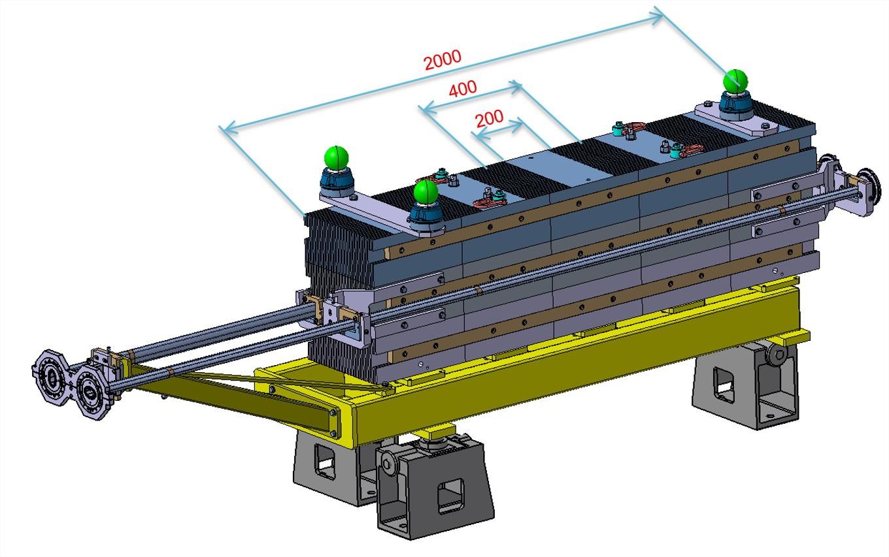
Figure 3 — Overall design of the TCAPM. Lengths are given in mm. Courtesy of L. Gentini [8].
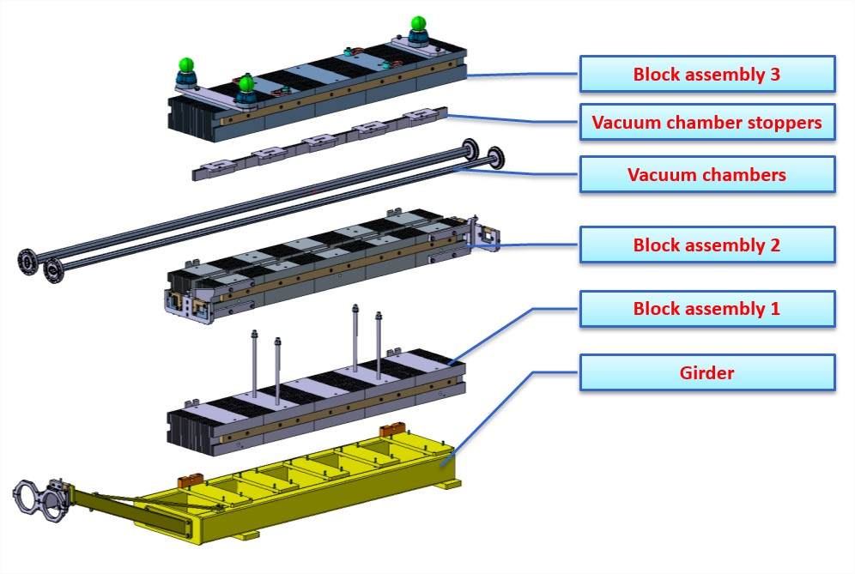
Figure 4 — The three assembly blocks of the TCAPM. Courtesy of L. Gentini [8].

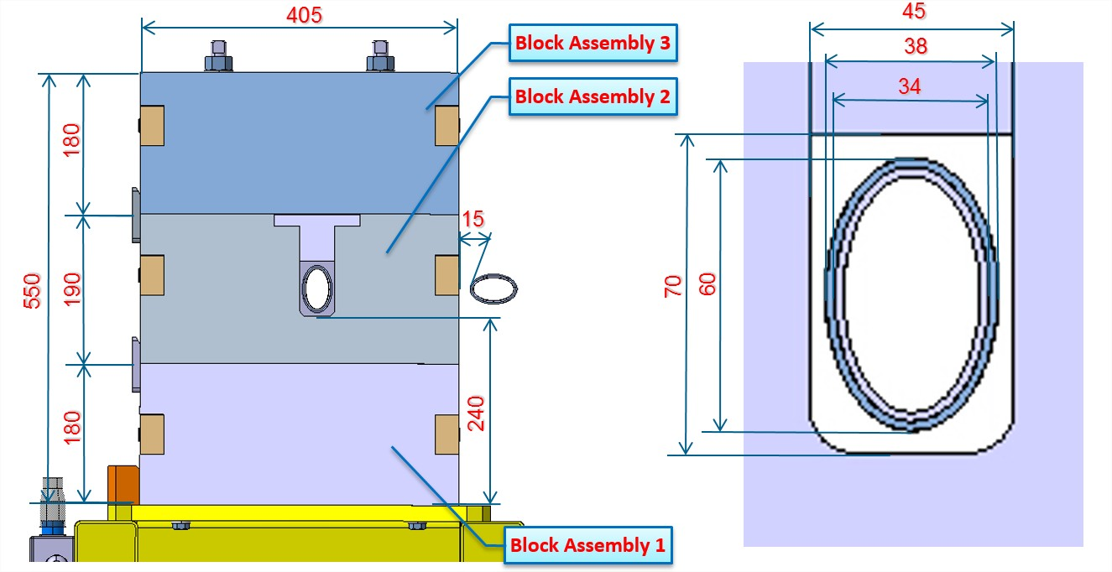

Figure 5 — Cross section of the TCAPM, with the vacuum chambers. Dimensions are given in mm. Courtesy of L. Gentini [8].
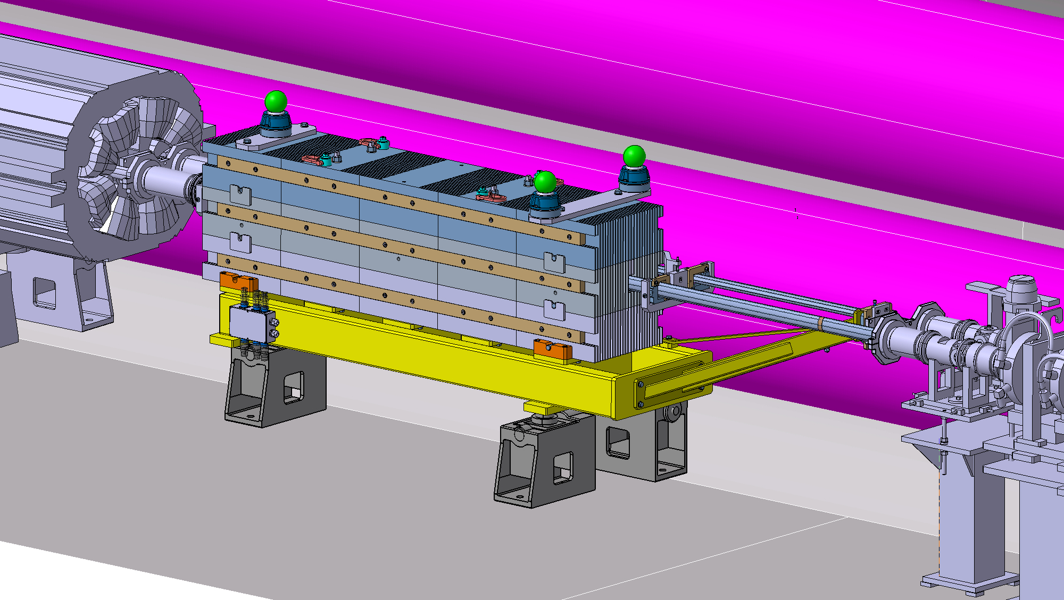
Figure 6 — Preliminary integration drawing of the TCAPM. Courtesy of L. Gentini and integration team [8].

Vacuum Layout Modifications

Modifications in Sector B5L7

Current Vacuum Layout in Sector B5L7
Table 1 shows an extract of the current layout on B5L7 where the MQW to be removed (in blue) is located.
Table 1 – Current Layout on Vacuum Sector B5L7.
- Internal line
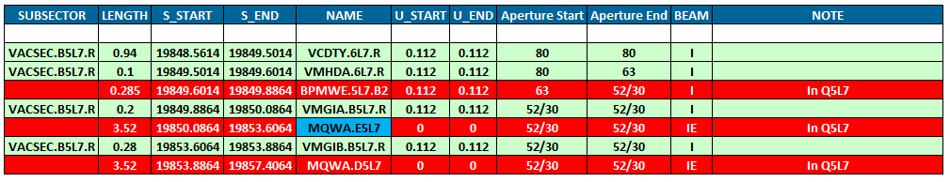

(b) External line
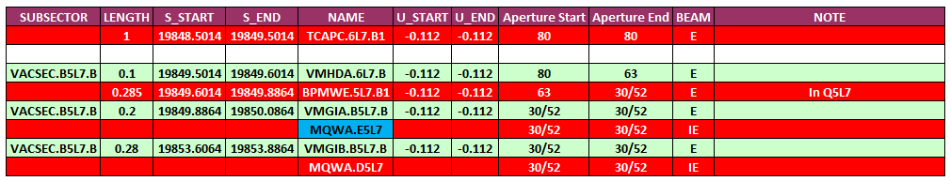

New Vacuum Layout in Sector B5L7
Table 2 shows an extract of the current layout on B5L7 where the TCAPM (in green) is to be installed in place of the removed MQW. Like in the current MQW, the VCELQ vacuum chambers will be children of the TCAPM assemblies.
Table 2 - New Layout on Vacuum Sector B5L7.
(a) Internal line
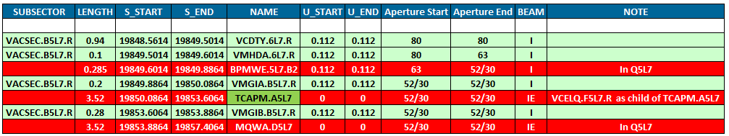

(b) External line
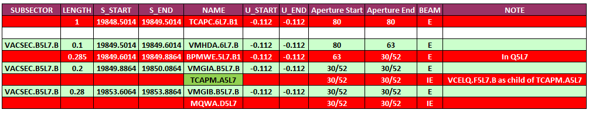

Modifications in Sector B5R7

Current Vacuum Layout in Sector B5R7
Table 3 shows an extract of the current layout on B5R7 where the removed MQW (in blue) is located.
Table 3 – Current Layout on Vacuum Sector B5R7.
- Internal line
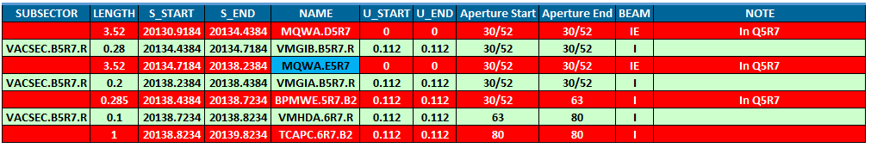

(b) External line
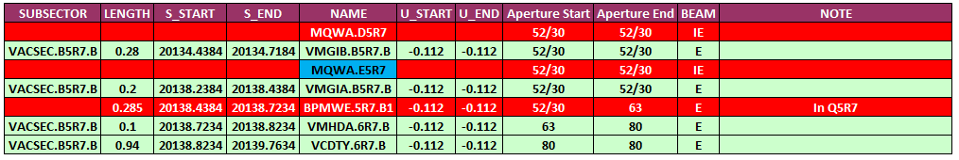

New Vacuum Layout in Sector B5R7
Table 4 shows an extract of the current layout on B5R7 where the TCAPM (in green) is to be installed in place of the removed MQW. Just as explained for the left side the left side of point 7, the VCELQ vacuum chambers will be children of the TCAPM assemblies.

Table 4 – New Layout on Vacuum Sector B5R7.
(a) Internal line
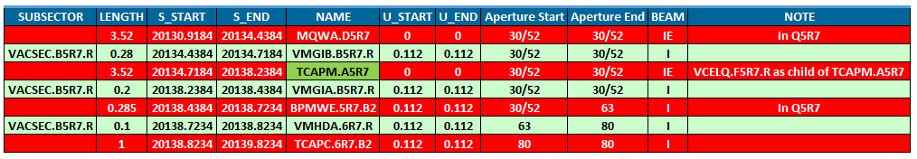

(b) External line
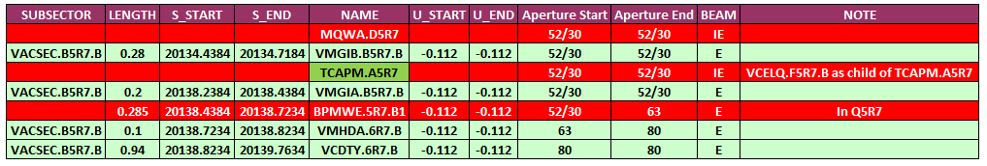

IMPACT ON OTHER ITEMS

IMPACT ON ITEMS/SYSTEMS
LHC collimation system | No changes to the other IR7 movable and passive collimators.
BE/BI | No dedicated BI equipment, like BLMs, will be needed for this passive absorber: with the removal of the MQWA.E5 magnets, its protection using the BLM system also becomes unnecessary. Therefore, the corresponding detector (see list below) will be disconnected from the tunnel acquisition system and removed together with their supports. The BLM configuration database will be also updated at the same time to declare this as a spare/empty channel and remove its virtual connection to the BIS system:  - BLMQI.05L7.B2I10_MQWA.E5L7 (19851.85 m)  - BLMQI.05R7.B1E30_MQWA.E5R7 (20136.48 m)
Machine protection | No impact.
BE/OP | No impact.
TE/VSC | No impact.

IMPACT ON UTILITIES AND SERVICES
Raw water: | No.
Demineralized water: | No.
Compressed air: | No.
Electricity, cable pulling  (power, signal, optical fibres…): | No.
DEC/DIC: | A electrical junction boxes presently below each magnet will have to be removed for the installation of the TCSPM collimators. See attached image.  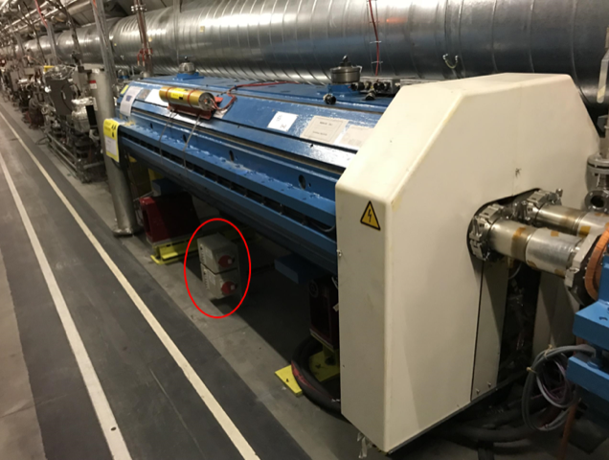
Racks (name and location): | No.
Vacuum (bake outs, sectorisation…): | Yes
Special transport/ handling: | Transport of heavy assemblies to be planned.
Temporary storage of conventional/radioactive components: | -
Alignment and positioning: | Activities for the survey team :  - Fiducialisation of the assemble TCAPM, to be done on surface.  - « Tracage » of the TCAPM position on the tunnel floor ;  - Alignment of different componets.
Scaffolding: | Not needed.
Controls: | -
GSM/WIFI networks: | Needed for TE-VSC intervention
Cryogenics: | No.
Contractor(s): | N/A
Surface building(s): | N/A
Others:

IMPACT ON COST, SCHEDULE AND PERFORMANCE

IMPACT ON COST
Detailed breakdown of the change cost: | All activities will be covered by the Consolidation project.
Budget code: | Collimation consolidation code 61727.

IMPACT ON SCHEDULE
Proposed installation schedule: | Installation toward end of LS2.
Proposed test schedule (if applicable): | No special tests planned after the assembly.
Estimated duration: | <1 week installation time for EN/STI group. 2-3 weeks for TE-VSC.
Urgency: | --
Flexibility of scheduling: | Hardware is unlikely to be available before the end of 2019.

IMPACT ON PERFORMANCE
Mechanical aperture: | No impact as the new hardware is outside the beam vacuum.
Impedance: | No impact as the new hardware is outside the beam vacuum.
Optics/MADX | The active absorbing parts of the new TCAPM is installed outside the vacuum. It is proposed to add these new objects as elements in the MADX sequence with names TCAPM.A5L7.B1 and TCAPM.A5R7.B2. Vacuum chambers can be added as child to these elements.
Electron cloud  (NEG coating, solenoid…) | -
Insulation (enamelled flange, grounding…) | -
Vacuum performance: | -
Layout database: | It should be updated with the new TCAPM in the old MQW slot. The 2 vacuum chambers will be children of the TCAPM.

IMPACT ON OPERATIONAL SAFETY

ÉLÉMENT(S) IMPORTANT(S) DE SECURITÉ
Requirement | Yes | No | Comments
EIS-Access |  | X | -
EIS-Beam |  | X | -
EIS-Machine |  | X | -

OTHER OPERATIONAL SAFETY ASPECTS
Have new hazards been created or changed? | Implications of removal of MQW magnets discussed in [1].
Could the change affect existing risk control measures? | No.
What risk controls have to be put in place? | None.
Safety documentation to update after the modification | -
Define the need for training or information after the change | -

WORKSITE SAFETY

ORGANISATION
Requirement | Yes | No | Comments
IMPACT – VIC: | X
Operational radiation protection  (surveys, DIMR…): | x |  | Installation in high radiation environment must be done by taking the ALARA principle into account.
Radioactive storage of material: | x |  | Works on magnets and vacuum components discussed in [1].
Radioactive waste: | X |  | Seals and bolts for TE-VSC mechanics
Fire risk/permit (IS41)  (welding, grinding…): |  | x
Alarms deactivation/activation (IS37): |  | x
Others:

REGULATORY TESTS
Requirement | Yes | No | Responsible Group | Comments
Pressure/leak tests: | X |  | TE-VSC | Leak test of the sector after mechanical intervention
Electrical tests: |  | X
Others:

PARTICULAR RISKS
Requirement | Yes | No | Comments
Hazardous substances (chemicals, gas, asbestos…): |  | x
Work at height: |  | x
Confined space working: |  | x
Noise: |  | x
Cryogenic risks: |  | x
Industrial X-ray  (tirs radio): |  | x
Ionizing radiation risks (radioactive components): |  | x
Others:

FOLLOW-UP OF ACTIONS BY THE TECHNICAL COORDINATION
Action | Done | Date | Comments
Carry out site activities:
Carry out tests:
Update layout drawings:
Update equipment drawings:
Update layout database:
Update naming database:
Update optics (MADX)
Update procedures for maintenance and operations
Update Safety File according to EDMS document 1177755:
Others:

REFERENCES
[1] P. Fessia et al., “Radiation Shielding Installation and Possible Optics Change for the MBW and MQW Magnets in IR 3 and 7 of the LHC”, EDMS 1321045 or LHC-MW-EC-0002.
[2] 95th ColUSM, https://indico.cern.ch/event/676111.
[3] 83rd ColUSM, http://indico.cern.ch/event/614887.
[4] 81st ColUSM, http://indico.cern.ch/event/588072.
[5] 77th ColUSM, http://indico.cern.ch/event/568895.
[6] 76th ColUSM, http://indico.cern.ch/event/562586.
[6a] 107th ColUSM, https://indico.cern.ch/event/739443
[7] G. Apollinari, I. Bejar Alonso, O. Bruning, P. Fessia, M. Lamont, L. Rossi, and L. Tavian (editors). High-Luminosity Large Hadron Collider (HL-LHC): Technical Design Report V. 0.1. CERN Yellow Reports: Monographs. CERN-2017-007-M. CERN, Geneva, 2017.
[8] 17th HiColDEM meeting, “HL-LHC Collimators: Design, Engineering and Prototyping” https://indico.cern.ch/event/699699.

