ENGINEERING CHANGE REQUEST

Installation in IR2 of dispersion suppressor collimators (TCLD)
BRIEF DESCRIPTION OF THE PROPOSED CHANGE(S):
During LHC heavy-ion collisions, ultra-peripheral interactions take place. They modify the charge-to-mass ratio of outgoing ions, which are lost on the aperture in the dispersion suppressors around the collision points. The impacted magnets are likely to quench with HL-LHC Pb beam parameters. As demonstrated in the 2015 operation, this can be alleviated in IR1 and IR5 through orbit bumps, displacing the losses to the empty connection cryostat. This is not possible in IR2, where instead an installation of one new horizontal tungsten collimator (TCLD) per side is proposed. Instead of substituting a dipole with a TCLD and a pair of 11T magnets like it is foreseen for IR7, the baseline for IR2 is to install the collimators in the connection cryostat in cell 11 and to use orbit bumps to steer losses at this location. The new connection cryostat is described in a separate ECR.
DOCUMENT PREPARED BY: | DOCUMENT TO BE CHECKED BY: | DOCUMENT TO BE APPROVED BY:
R. Bruce, A. Mereghetti,  S. Redaelli | [FisrtName LastName Dept-Grp] | P. Collier  (on behalf of the LMC)  L. Rossi  (on behalf of the HL-LHC project)
DOCUMENT SENT FOR INFORMATION TO:
[List of persons to whom the document is sent]
SUMMARY OF THE ACTIONS TO BE UNDERTAKEN:
[List the main actions to be undertaken]

EXISTING SITUATION AND INTRODUCTION
When heavy ions undergo ultra-peripheral interactions in the collision points of the experiments, secondary ion beams with a modified magnetic rigidity are generated [1,2]. These ions represent a source of local heat deposition in the adjacent dispersion suppressor regions where the dispersion function starts rising. The dominating processes are bound-free pair production (BFPP), where electron–positron pairs are created and one (BFPP1) or two (BFPP2) electrons are caught in a bound state of one of the colliding nuclei, thus changing their charge, and 1- or 2-neutron electromagnetic dissociation (EMD1 and EMD2) where one nucleus emits one or two neutrons, thus changing mass. Further photon-induced processes also take place, but the four mechanisms mentioned here have the higher cross-sections. An example of ion beams produced in collisions of ²⁰⁸Pb⁸²⁺ nuclei in IR2 is given in Figure 1.
The magnets that are impacted by these losses are likely to quench at the high luminosities foreseen for HL-LHC. As alleviation, it is planned to install additional collimators (shown as black lines in Figure 1).

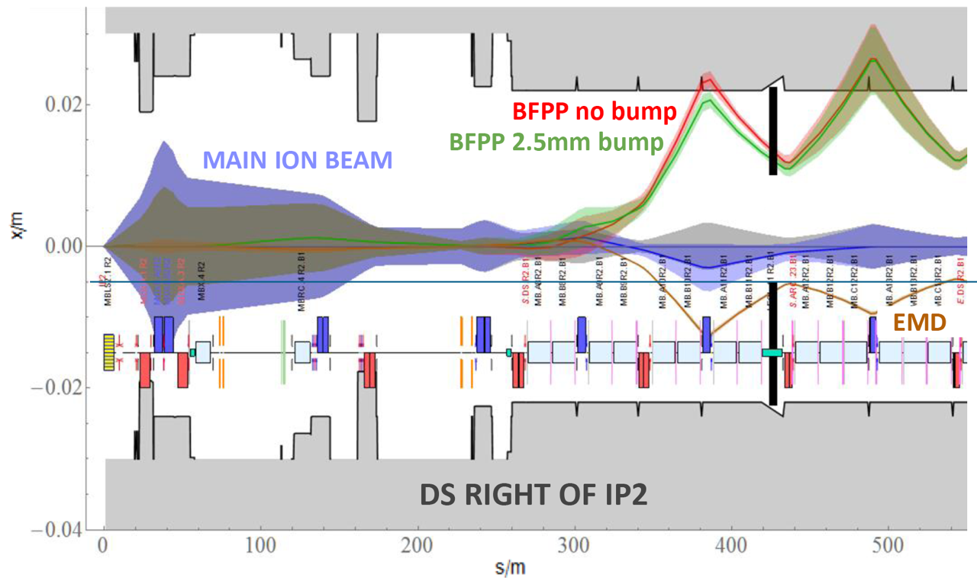
Figure 1 – The 1 σ envelope of the main Pb⁸²⁺ beam (violet) together with the dispersive trajectories of ions undergoing BFPP1 (red) and EMD1 (brown), coming out of the ALICE experiment (IP2). The TCLD collimator jaws appear as black lines. The green line indicates the shifted BFPP1 orbit using a closed orbit bump, which is necessary to intercept the beam with the collimator. The EMD1 beam can be intercepted with the other jaw. Courtesy of J. Jowett [7].

REASON FOR THE CHANGE
As can be seen in Figure 1, these secondary beams are lost very locally due to the large and sudden change of magnetic rigidity at the interaction point. After the LS2 ALICE upgrade, aiming at a peak luminosity of 6 × 10²⁷cm⁻² s⁻¹ (about six times higher than the nominal one) [3], the dominant BFPP1 beam can carry about 155 W, resulting in a power load in the coils of the MB.B10 dipole of about 44 mW/cm³ [4] on both sides of ALICE. Similar ion losses also occur in the DS regions around ATLAS and CMS, however at different locations than in IR2. A beam loss experiment carried out during the 2015 Pb-Pb run at 6.37 Z TeV [5] confirmed the long-standing presumption that BFPP1 ions risk to quench magnets [1,2]. The experiment was carried out around CMS because it was running at higher peak luminosity than ALICE. The deposited power during the quench was estimated with FLUKA simulations to be about a factor 6 lower than what is calculated for HL-LHC, hence this effect could be a serious limitation for HL-LHC.
During standard operation, special bumps were deployed around ATLAS and CMS to steer the BFPP1 losses into the locations of the connection cryostat, however, because of the quadrupole polarities in IR2, this solution alone is not possible at ALICE. Instead, the HL-LHC baseline is to install one additional collimator, called TCLD, on each outgoing beam in the IR2 dispersion suppressor, where the dispersion is already rising [3]. Orbit bumps allow making sure that the beam is not lost at the first (lower) dispersion peak (see Fig. 1) and enable shifting the losses into the collimators. These TCLD will also intercept the most powerful EMD beam (EMD1). FLUKA simulations have shown that the proposed TCLDs reduce the peak load on the magnets to tractable levels at HL-LHC design luminosity [4].

DETAILED DESCRIPTION
The most loaded magnet in IR2 is MB.B10 on each side. The TCLD in IR2 can be placed further downstream in the connection cryostat (LECL.11R2.B1 and LECL.11L2.B2). This requires two new shorter connection cryostats to be designed, and in between them, the TCLD assembly will be placed. The connection cryostats are described in a separate ECR under the responsibility of WP11. A drawing of the integration in the area, as well as the absolute positions, is shown in Figure 2. More details on the integration can be found in Ref. [6]. In order to optimize design and production efforts, the design of the TCLD assembly is identical to the one used in IR7.
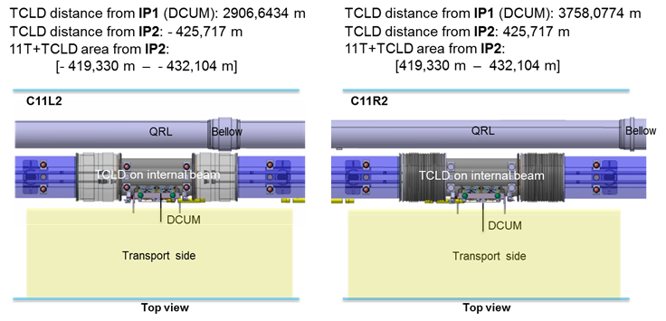
Figure 2 —Positions of new TCLD collimators in IR2. Figure taken from Ref. [6].

The TCLD consists, as most other LHC collimators, of two parallel jaws collimating the beam in the horizontal plane, with the beam passing in between them. The active material of the jaws is the tungsten alloy Inermet 180. The design of the TCLD collimator, shown in more detail in Figure 3 and Figure 4, is derived from the design of the present LHC collimators, but with some differences. Since the design of the IR2 TCLDs is identical to that of the IR7 ones, and because of the very tight space requirements in IR7, the design is challenging and the active length of the material had to be reduced to only 60 cm, in order to make it fit. This means that also a non-standard support design is used. Furthermore, the bellows at the two longitudinal extremities are integrated in the tank transitions in order to gain longitudinal space. A 3D drawing of the tank and support is shown in Figure 5.
The actuation system does not include any movement in the vertical plane, which allowed reducing the jaw height. Otherwise, each jaw can be independently moved by two stepping motors per jaw, which maintains the possibility to tilt the jaws in the horizontal plane. The maximum opening of each jaw is 25 mm from the centre, 5 mm less than for standard collimators, and the stroke across the centre is 5 mm.
As all recent collimators, the design includes two BPMs per jaw, integrated at the extremities outside of the tapering. The jaws feature water cooling, using squared 9 mm pipes. Each jaw contains also 3 LVDT position sensors and 2 TP100 temperature sensors.
All these require new connections, i.e. pulling new cabling for the motors, including LVDTs and temperature sensors. Cables should be pulled also for the BPMs, which should be connected to the standard DOROS electronics as for other collimators. Furthermore, the water cooling has to be connected to the demineralized water circuit. A new tapping for incoming and outgoing water with a valve on each line is needed. No extra BLM is needed – it is instead foreseen to slightly displace one of the existing BLMs to a position on the connection cryostat in the horizontal plane, just downstream of the TCLD, to monitor losses at the collimator [6].
The characteristics of the TCLD are summarized in Table 1.
The TCLD will be integrated in a specially designed assembly, containing a beam pipe for the other beam, as well as a cryo-bypass, which is needed since the TCLD is a warm element placed between two cold ones. This assembly, which is discussed more in detail in a separate ECR, is shown in Figure 6.
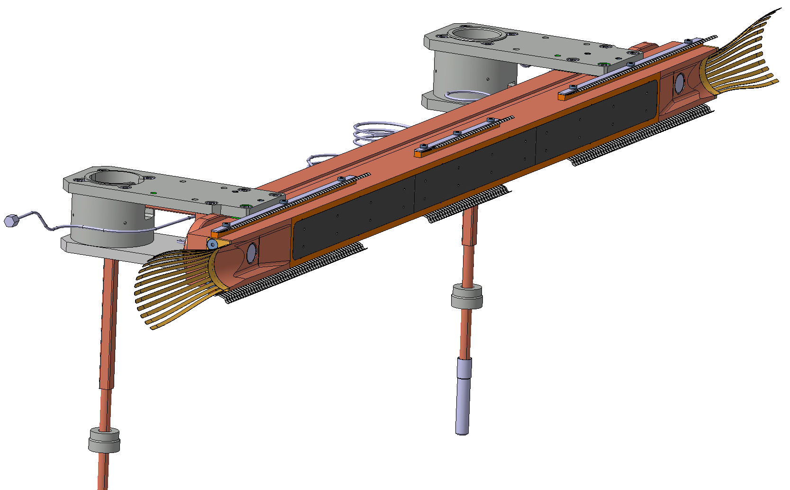
Figure 3 – Drawing of one of the TCLD jaws (top), including RF fingers, cooling pipes and BPMs, and the two jaws installed on the table (bottom). Courtesy of L. Gentini.

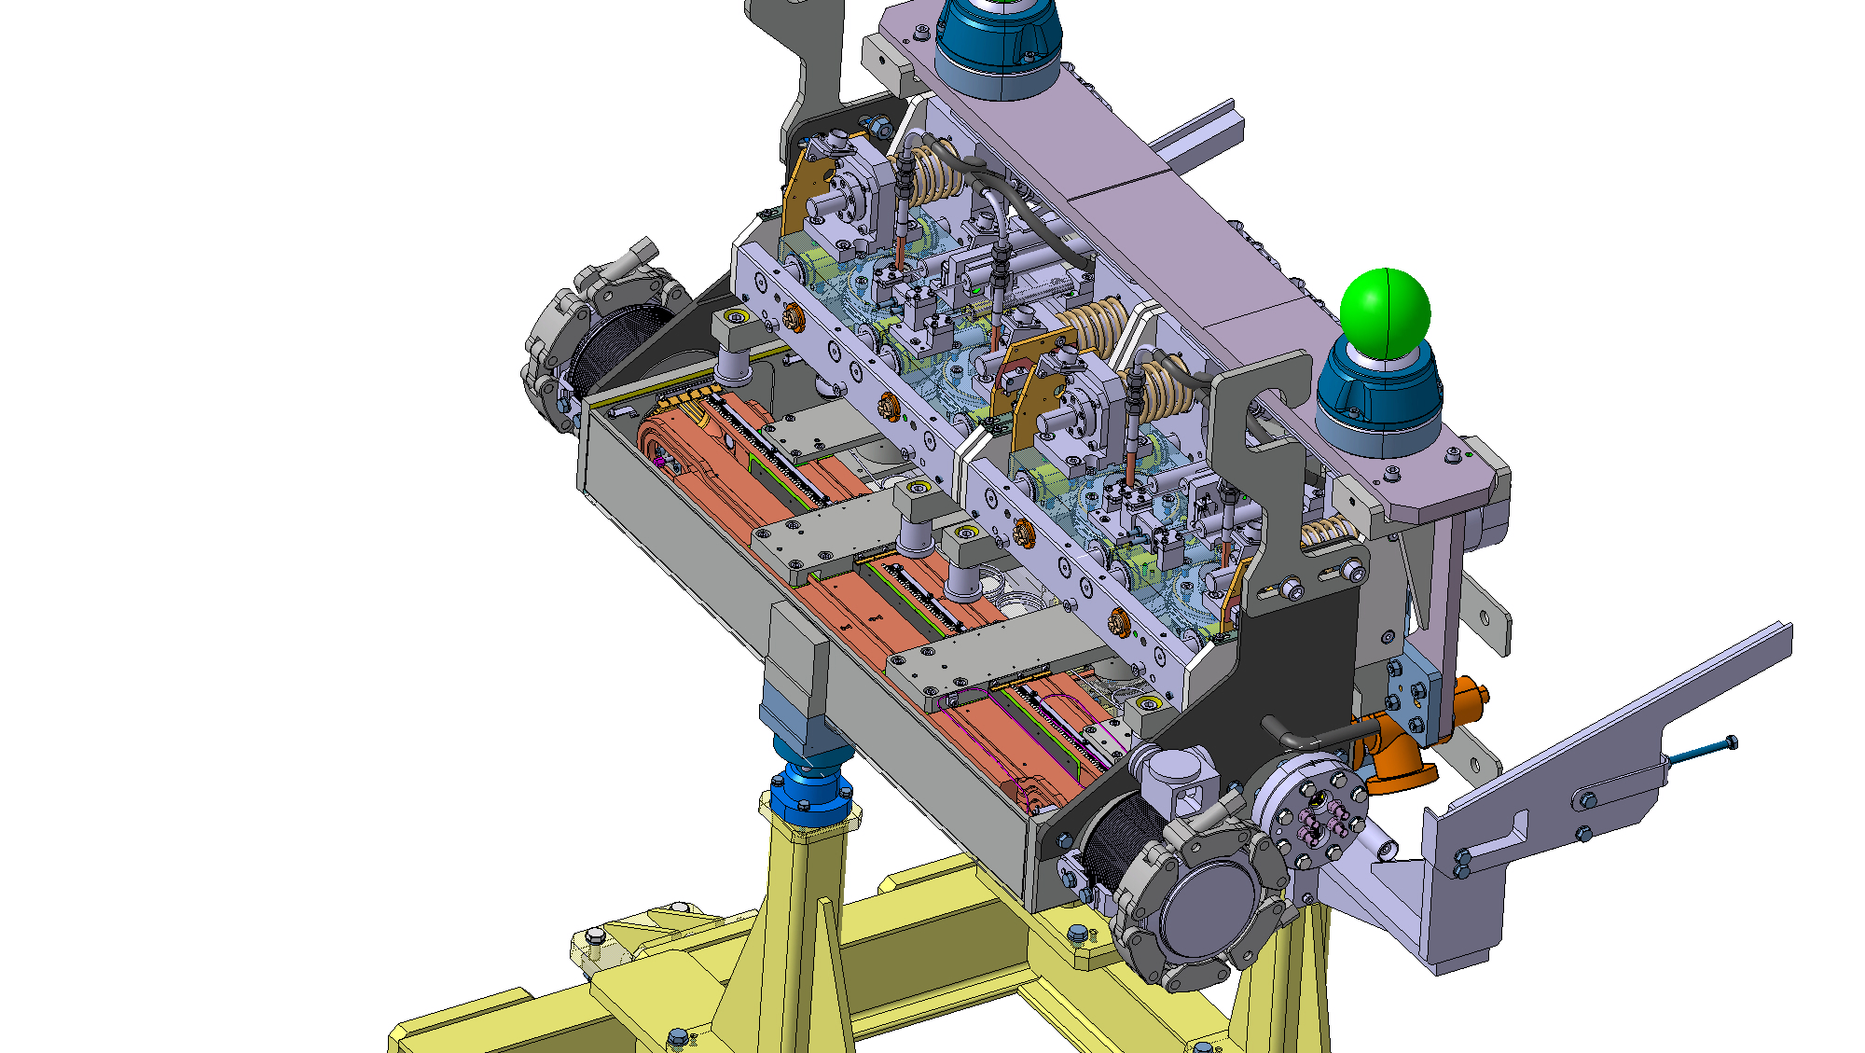
Figure 4 — 3D drawing of the TCLD jaws, integrated in the tank and installed on the supports. Courtesy of L. Gentini.

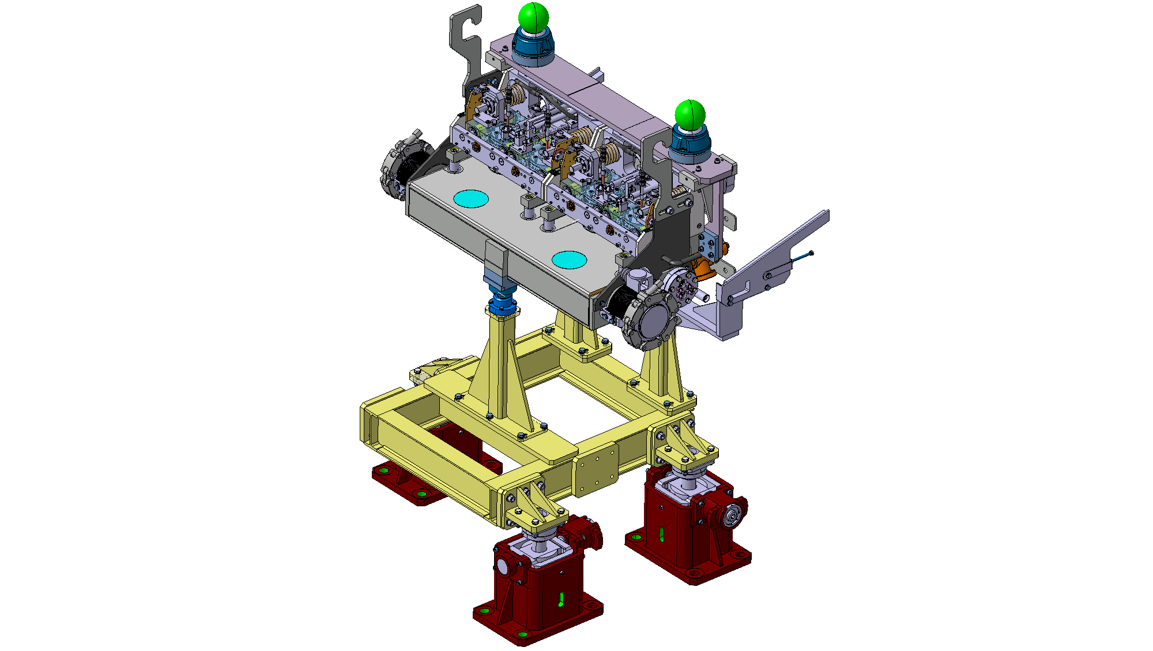
Figure 5 – 3D drawing of the TCLD tank and support. Courtesy of L. Gentini.
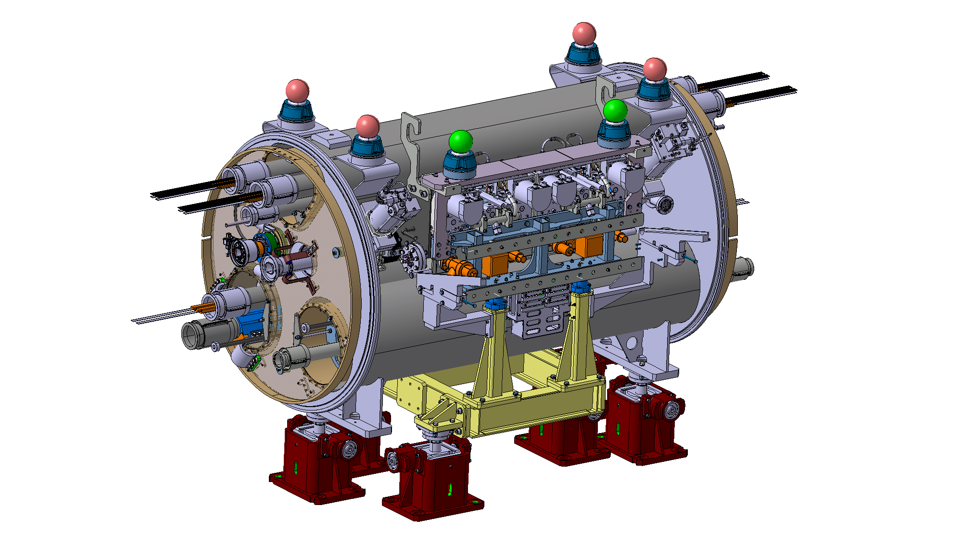
Figure 6 – The assembly to be installed between the two 11T dipoles, consisting of TCLD collimator, support, beam pipe for the other beam, and cryo-bypass. Courtesy of L. Gentini.

Table 1 — Detailed parameters of the TCLD collimator.
Characteristics | Units | Value
Jaw active length | mm | 600
Jaw absorbing material | - | Inermet 180
Flange-to-flange distance | mm | 1080
Number of jaws | - | Two
Orientation | - | Horizontal
Number of BPMs per jaw | - | Two
RF damping | - | RF fingers
Cooling of the jaw | - | Yes
Cooling of the vacuum tank | - | No
Minimum gap | mm | <2
Maximum gap | mm | 50
Stroke across zero | mm | 5
Number of motors per jaw | - | Two
Angular adjustment | - | Yes
Transverse jaw movement (fifth axis) | - | No

IMPACT ON OTHER ITEMS

IMPACT ON ITEMS/SYSTEMS
Item/System: BE/BI | BE/BI support is required for the BLM acquisition associated to the collimator. It is required to displace an existing nearby BLM to a position just downstream of each TCLD. Details are found in [6].  BE/BI is responsible for the BPM acquisition. Cables should be pulled for the new BPMs. Controls units DOROS should be installed for the signal processing.
Item/System: BE/OP | New devices will have to be properly configured in the top level control layer of LSA.

IMPACT ON UTILITIES AND SERVICES
Raw water: | No
Demineralized water: | The circuit of cooling water of the TCLD will have to be connected, in series to other collimators. New tapping required.
Compressed air: | No
Electricity, cable pulling  (power, signal, optical fibres…): | New cables are required for the motors, LVDTs and temperature sensors.  New cables required for BPMs are described in the previous section.
DEC/DIC: | Details by Jérome.
Vacuum (bake outs, sectorisation…): | The TCLD has to pass standard vacuum qualification procedures before installation in the tunnel.
Special transport/ handling: | No
Temporary storage of conventional/radioactive components: | No
Survey: | Standard alignment procedures apply – at installation, the collimator position should be adjusted by the survey team.
Scaffolding: | No
Controls: | The LHC control system must be updated to include the new collimator and BPMs.
GSM/WIFI networks: | No
Cryogenics: | The implementation of the cryo-bypass is described in the companion ECR by WP11 (under preparation).
Contractor(s): | No
Others:

IMPACT ON COST, SCHEDULE AND PERFORMANCE

IMPACT ON COST
Detailed breakdown of the change cost: | The activity is funded by the HL-WP5, unit 5.2 (DS cleaning)
Budget code: | Various codes across the ATS sectors:  53701: HL-LHC WP05-DS Collimation-EN/STI  53709: HL-LHC WP05-DS Collimation-EN/STI [CONS]  53718: HL-LHC WP05-DS Collimation-EN/SMM  53722: HL-LHC WP05-DS Collimation-EN/SMM [CONS]  64073: HL-LHC WP05-DS Collimation-BE/BI  53707: HL-LHC WP05 Collimator production TCLD-TE/VSC

IMPACT ON SCHEDULE
Proposed installation schedule: | Installation foreseen during 2020.
Proposed test schedule (if applicable): | Prior to installation: controls tests (EN/STI) and vacuum validation (TE/VSC).  Impact on the EN/EL team to be evaluated.
Estimated duration: | Details by Inigo.
Urgency:
Flexibility of scheduling: | Limited

IMPACT ON PERFORMANCE
Mechanical aperture: | The movable collimator will (intentionally) be operated at smaller aperture than the previous beam pipe, in order to intercept beam losses that otherwise would hit the magnets. This will, however, not have any negative influence on the global aperture.
Impedance: | The impedance has been studied by the impedance team for a preliminary design and no issues were found. Checks of the final design are on-going.
Electron cloud  (NEG coating, solenoid…) | No change
Insulation (enamelled flange, grounding…) | No change
Vacuum performance: | No change. The collimator will be qualified by VCS before installation.
Others:

IMPACT ON OPERATIONAL SAFETY

ÉLÉMENT(S) IMPORTANT(S) DE SECURITÉ

Requirement | Yes | No | Comments
EIS-Access |  | X | --
EIS-Beam |  | X | --
EIS-Machine |  | X | --

OTHER OPERATIONAL SAFETY ASPECTS
Have new hazards been created or changed? | no
Could the change affect existing risk control measures? | no
What risk controls have to be put in place? | none
Safety documentation to update after the modification
Define the need for training or information after the change

WORKSITE SAFETY

ORGANISATION
Requirement | Yes | No | Comments
IMPACT – VIC: | X
Operational radiation protection  (surveys, DIMR…): | X |  | Installation in high radiation environment must be done by taking the ALARA principle into account. RP survey needed.
Radioactive storage of material: |  | X | --
Radioactive waste: |  | X | --
Fire risk/permit (IS41)  (welding, grinding…): |  | X
Alarms deactivation/activation (IS37): |  | X
Others:

REGULATORY TESTS
Requirement | Yes | No | Responsible Group | Comments
Pressure/leak tests: |  | X
Electrical tests: |  | X
Others:

PARTICULAR RISKS
Requirement | Yes | No | Comments
Hazardous substances (chemicals, gas, asbestos…): |  | X
Work at height: |  | X
Confined space working: |  | X
Noise: |  | X
Cryogenic risks: | X |  | Warm collimator to be installed between two cold elements with cryo bypass
Industrial X-ray  (tirs radio): |  | X
Ionizing radiation risks (radioactive components): |  |  | [Traceability by TREC.]
Others:

FOLLOW-UP OF ACTIONS BY THE TECHNICAL COORDINATION
Action | Done | Date | Comments
Carry out site activities:
Carry out tests:
Update layout drawings:
Update equipment drawings:
Update layout database:
Update naming database:
Update optics (MADX)
Update procedures for maintenance and operations
Update Safety File according to EDMS document 1177755:
Others:

REFERENCES
[1] J.M. Jowett et al., Heavy ion beams in the LHC, 20th IEEE Particle Accelerator Conference, Portland, OR, USA, 12 - 16 May 2003, pp.1682 LHC-Project-Report-642
[2] R. Bruce et al., Beam losses from ultraperipheral nuclear collisions between 208Pb82+ ions in the Large Hadron Collider and their alleviation, Phys. Rev. ST Accel. Beams 12 (2009) 071002.
[3] G. Apollinari, I. Bejar Alonso, O. Bruning, P. Fessia, M. Lamont, L. Rossi, and L. Tavian (editors). High-Luminosity Large Hadron Collider (HL-LHC): Technical Design Report V. 0.1. CERN Yellow Reports: Monographs. CERN-2017-007-M. CERN, Geneva, 2017
[4] G. Steele et al., Heat load scenarios and protection levels for ions, presentation at the 2013 LHC Collimation Review 2013 https://indico.cern.ch/event/251588/timetable/?view=standard
[5] M. Schaumann, et al. LHC BFPP Quench Test with Ions (2015) CERN-ACC-NOTE-2016-0024, 2016
[6] M. Gonzalez de la Aleja, HL-LHC INTEGRATION REPORT FOR INSTALLATION APPROVAL, CERN EDMS document 1903950
[7] J. Jowett, Heavy-ion performance of HL-LHC, Presentation at the 7th HL-LHC Collaboration meeting, Ciemat, Madrid, November 2017, https://indico.cern.ch/event/647714/contributions/2632851/attachments/1557678/2450759/HL-LHC_Madrid_Jowett_14Nov2017.pdf

