ENGINEERING CHANGE REQUEST

Installation of Low-Impedance Primary Collimators with BPMs (TCPPM) in IR7
BRIEF DESCRIPTION OF THE PROPOSED CHANGE(S):
The primary collimators (TCPs) are essential for the operation of the LHC at high intensity as they are used to intercept primary off-momentum and betatron losses in the multi-stage cleaning systems in IR3 and IR7. As part of the consolidation of the collimation system, horizontal and vertical primary collimators of IR7 (four collimators) will be replaced in LS2. The new collimators will ensure high-efficiency operations in Run III and in the HL-LHC era. The new design with in-jaw beam position monitors will be used. As part of the HL-LHC-WP5, the absorbing material will also be upgraded to a low-impedance material (MoGr). This ECR details the hardware installation, proposed to take place during the Long Shutdown 2 (LS2). This activity is within the scope of the Consolidation project (with a contribution from the HL-LHC WP5 for the jaw material).
DOCUMENT PREPARED BY: | DOCUMENT TO BE CHECKED BY: | DOCUMENT TO BE APPROVED BY:
R. Bruce BE-ABP  A. Mereghetti BE-ABP  S. Redaelli BE-ABP | O. Aberle, J. Albertone, C. Adorisio,  G. Arduini, M. Barberan, I. Bejar Alonso,  M. Bernardini, A. Bertarelli, F. Bertinelli,  C. Bertone, C. Boccard, G. Bregliozzi,  S. Bustamante, M. Calviani, F. Carra,  G. Cattenoz, P. Chiggiato, J. P. Corso,  R. De Maria, B. Delille, P. Fessia, R. Folch,  J. F. Fuchs, C. Gaignant, L. Gentini,  S. Gilardoni, M. Giovannozzi, G. Girardot, B. Goddard, E. Jensen, R. Jones,  I. Lamas Garcia, M. Lamont, J. Lendaro,  A. Masi, D. Missiaen, Y. Muttoni, T. Otto, E. Page, S. Roesler, B. Salvant,  R. Steerenberg, L. Tavian, M. Tavlet,  C. Vollinger, J. Wenninger. | P. Collier  (on behalf of the LMC)  L. Rossi  (on behalf of the HL-LHC Project)
DOCUMENT SENT FOR INFORMATION TO:
ATS groups leaders
SUMMARY OF THE ACTIONS TO BE UNDERTAKEN:

EXISTING SITUATION AND INTRODUCTION
The betatron collimation system [1] of the Large Hadron Collider (LHC) is located in the Insertion Region 7 (IR7). It is composed by:
- three primary collimators (TCPs), intercepting tail protons;
- eleven secondary collimators (TCSGs), aimed at intercepting most of the beam particles leaking out of the TCPs;
- shower absorbers (TCLAs), aimed at containing the most energetic component of the secondary particle showers started in the upstream collimator families.
Primary and secondary collimators are made of a robust material as they are potentially more exposed to primary beam losses. Carbon fibre composites (CFC) are used, which have the drawback of contributing significantly to the LHC impedance [2].
TCP and TCSG collimators are significantly activated during the LHC high-intensity operations and radiation ageing/wear is a main concern for these collimators, also because after some years of LHC operation, working on these collimators might become challenging in terms of doses to personnel. The horizontal and vertical primary collimators of IR7 (one collimator per beam per plane) are essential for any operation of the LHC at high intensity.
While the TCSGs will all be replaced in two campaigns in LS2 and LS3 as a part the HL-LHC collimation upgrade [3] (see also [4] for the LS2 upgrade), the renewal of primary collimators for the high-efficiency operation in Run III and in the HL-LHC era is covered by the Consolidation project. The TCP upgrade starts in LS2 by replacing the horizontal and vertical primary collimators of IR7. The need to replace the IR7 skew collimators and the IR3 TCPs might follow in LS3 or later depending on the ageing of the present TCPs.
The new collimators will be built according to the latest design that embeds in-jaw BPMs and a modular jaw design compatible with different absorbing materials. Moreover, because of the resistivity of the jaw material and typical gaps deployed in operation, present TCPs give an important contribution to machine impedance [2]. The TCP upgrade will also include the exchange of absorbing material to MoGr (molybdenum-graphite), which has similar robustness as the one of present TCPs against beam losses; moreover, with the new jaw material, the single-collimator impedance is reduced by about a factor 2. This upgrade is funded by HL-LHC-WP5.
New primary collimators are called TCPPM, as Target Collimator Primary Pickup Metallic.

REASON FOR THE CHANGE
The construction of new primary collimators as consolidation of the IR7 system is considered necessary to ensure high-efficiency operations in Run III and in the HL-LHC era. The “consolidated” collimator design similar to the one adopted for new collimators built in LS1 [5] will be used. This will add BPMs to the design for a faster alignment and orbit interlock capability. A TCP prototype with BPMs has already been used in operation since 2016 [Error! Reference source not found.].
As a part of the HL-LHC-WP5, the TCP absorbing material will also be upgraded. MoGr will be used to reduce by about a factor 5 the material resistivity as compared to the one of CFC, for a gain of about a factor 2 in single-collimator impedance.

DETAILED DESCRIPTION
The present TCPPM design (see Figure 1) is similar to the one of the present TCPs [1]; among the most noticeable differences, there are the jaw material and the presence of in-jaw Beam Position Monitors (BPMs). In fact, the design foresees jaws made of a composite material (MoGr) obtained from Molybdenum and graphite, chosen for its lower impedance and similar robustness with respect to the jaw material of the present TCPs (Carbon-Fiber-Composite, CFC). The new material is characterised by a bulk resistivity a factor 5 lower than the one of CFC. The collimator jaws are equipped with BPM button pick-ups, for an easy determination of the beam closed orbit at the collimator and fast and precise alignment of the jaws. A third BPM is installed on the tank, to measure the beam position on the axis orthogonal to the one of cleaning.
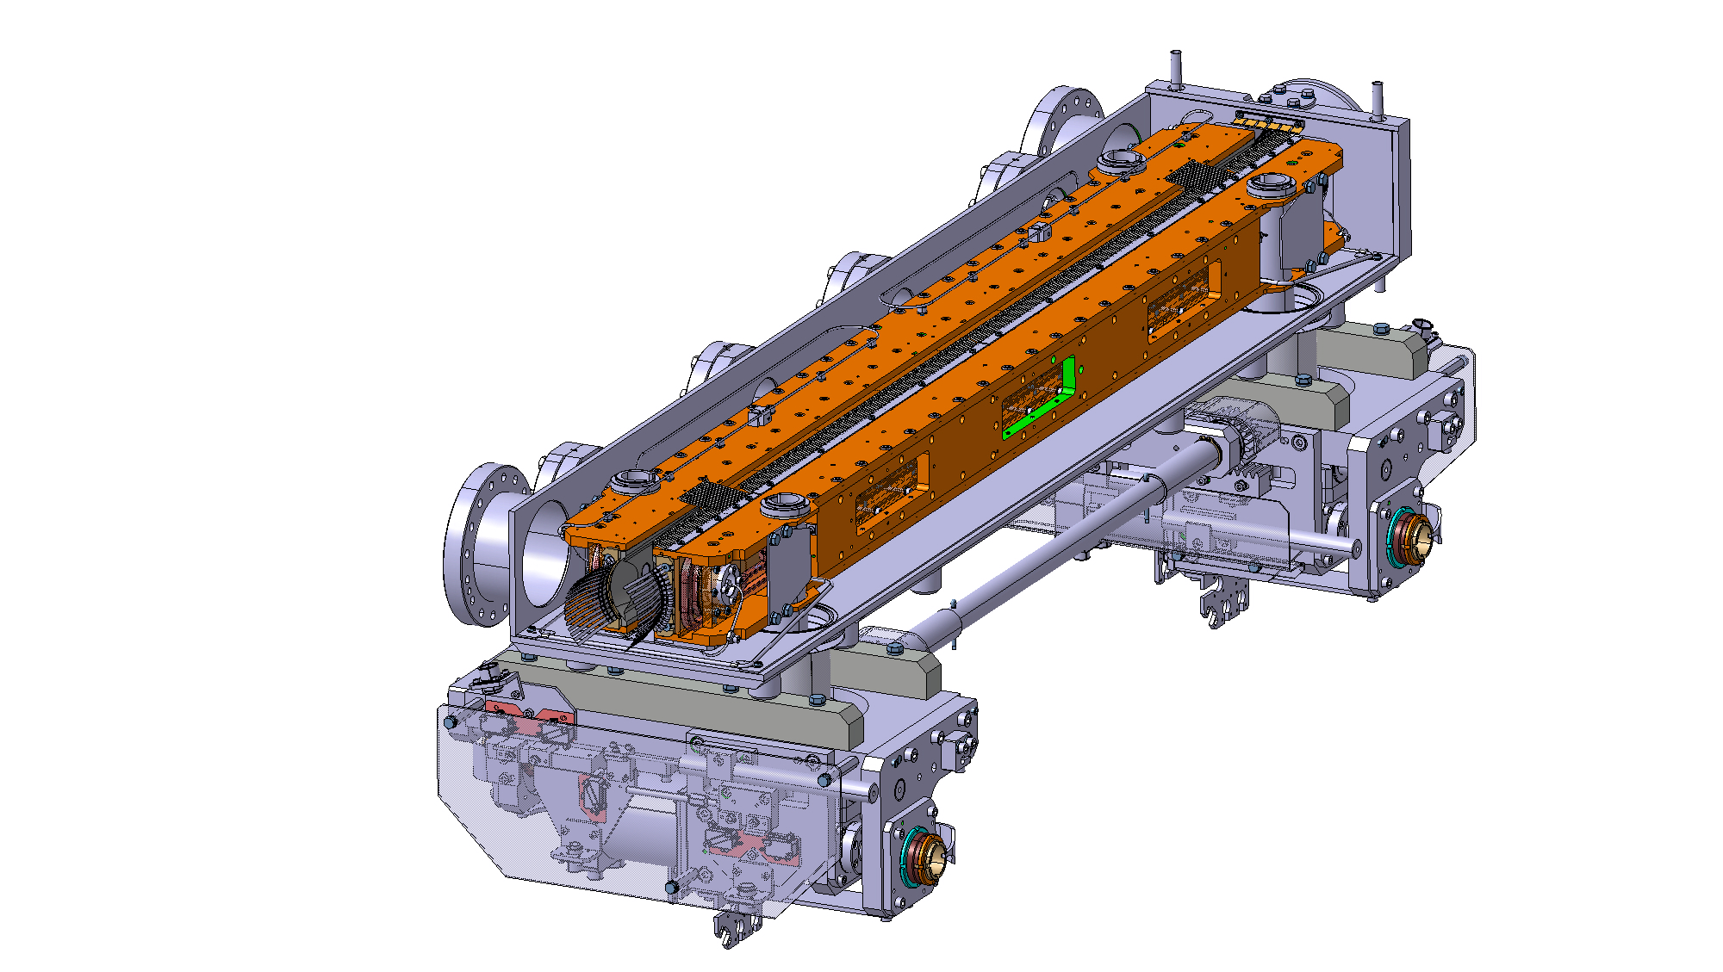
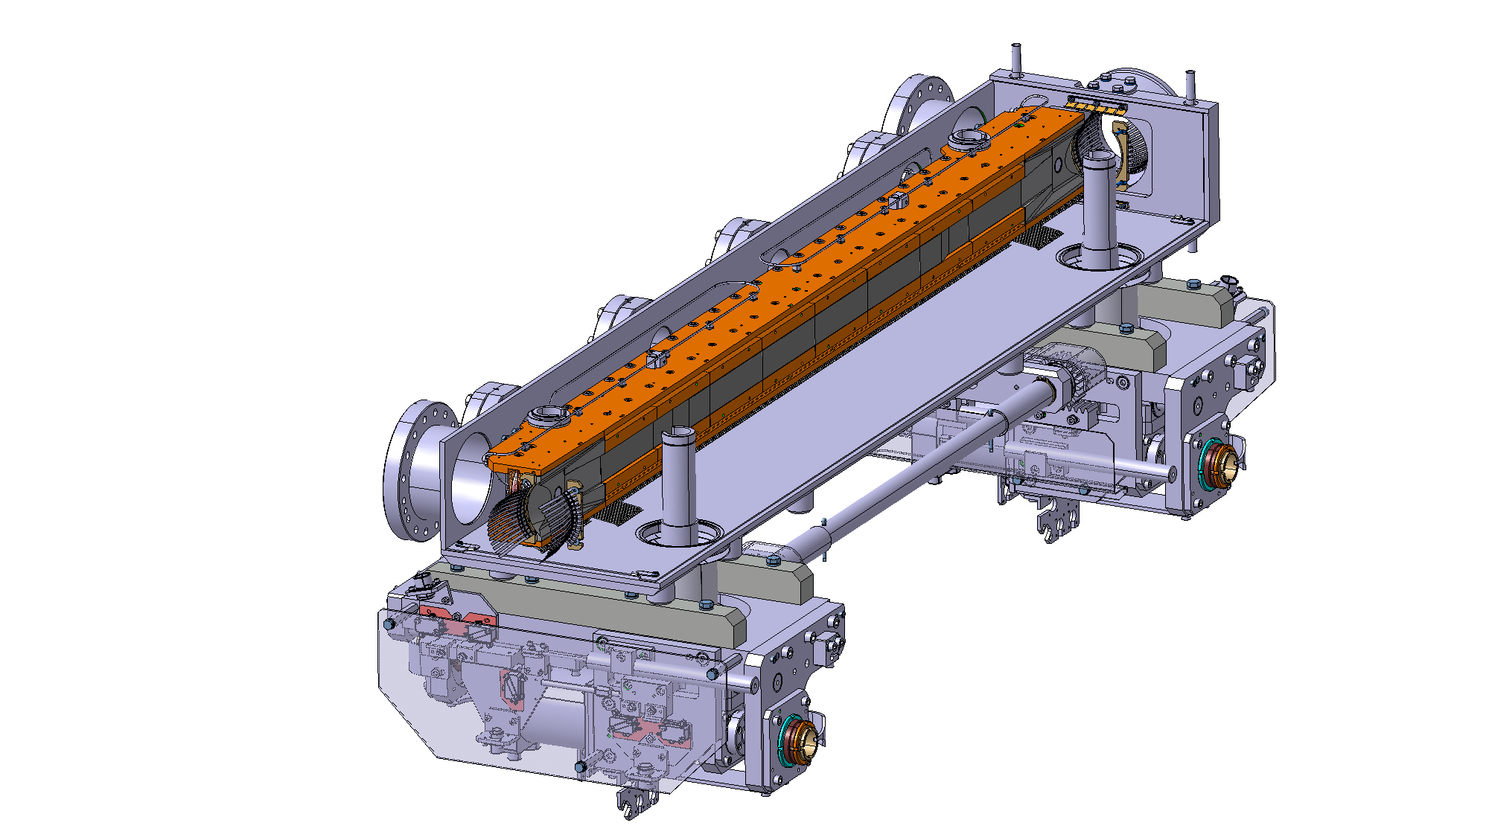
Figure 1 — 3D view [Error! Reference source not found.] of the TCPPM collimator (SmarTeam code: ST0953409). Top: full collimator, with RF fingers. Bottom: sketch with left jaw only to show the 60 cm active length (obtained through blocks of different thickness).
Table 1 summarises the main collimator parameters of the TCPPM design and

Table 2 reports the SmarTeam codes of the assembly sub-modules. The installation of the new collimators is done by replacing the existing ones. Table 3 lists the concerned slots for both B1 and B2. The layout names for the new collimators and the names of the embedded BPMs are listed in
Table 4.
Table 1 — Detailed parameters list of the TCPPM collimator design.
Characteristics | Units | Value
Jaw active length | mm | 600
Jaw absorbing material |  | MoGr
Flange-to-flange distance | mm | 1480
Number of jaws |  | 2
Orientation |  | Depending on installation slot (see Table 3)
Number of BPM buttons per jaw |  | 2
Number of tank BPM buttons |  | 2
RF damping |  | RF fingers
Cooling of the jaw |  | Demineralised water
Minimum gap | mm | <2
Maximum gap | mm | 50
Stroke across zero | mm | 5
Number of motors per jaw |  | 2
Angular adjustments |  | Yes
Transverse jaw movement (fifth axis) |  | Yes

Table 2 - SmarTeam codes of the assembly sub-modules.
ST Reference | Description
ST0953409 | Model of the TCPPM collimator
ST0266511 | Model of the support/pied for P7 (low)
ST0266352 | Model of the lower plug-in (no BPM integrated)
ST0489484 | Model of the cradle 0 degrees
ST0267922 | Model of the protection 0 degrees
ST0489576 | Model of the cradle 90 degrees
ST0267893 | Model of the protection 90 degrees
ST0953409 | Model of the TCPPM collimator
ST0266511 | Model of the support/pied for P7 (low)

Table 3 — Installation slots of the four new TCPPMs in IR7, replacing the existing vertical and horizontal primary collimators in IR7. We propose to keep the same layout names as for the present primary collimators.
B1 Slot | B2 Slot | Skew Angle [deg]
TCP.D6L7.B1 | TCP.D6R7.B2 | 90.0
TCP.C6L7.B1 | TCP.C6R7.B2 | 0.0

Table 4 — ‘Names’ (Layout DB functional positions) of the BPMs for the new TCPPM collimators.
Name of New Collimator  (LDB functional position) | Azimuthal Angle [deg] | Coll. Plane | Layout Functional Position of Upstream in-Jaw BPM | Layout Functional Position of Downstream in-Jaw BPM | Layout Functional Position of Tank BPM | Vacuum Sector
TCP.D6L7.B1 | 90 | V | BPTUV.D6L7.B1 | BPTDV.D6L7.B1 | BPTUH.D6L7.B1 | A6L7.B
TCP.C6L7.B1 | 0 | H | BPTUH.C6L7.B1 | BPTDH.C6L7.B1 | BPTUV.C6L7.B1 | A6L7.B
TCP.D6R7.B2 | 90 | V | BPTUV.D6R7.B2 | BPTDV.D6R7.B2 | BPTUH.D6R7.B2 | A6R7.R
TCP.C6R7.B2 | 0 | H | BPTUH.C6R7.B2 | BPTDH.C6R7.B2 | BPTUV.C6R7.B2 | A6R7.R

IMPACT ON OTHER ITEMS

IMPACT ON ITEMS/SYSTEMS
BE/BI | BE/BI support is required for the mounting/dismounting of the BLMs associated to the collimators:  - BLMTI.06L7.B1E10_TCP.D6L7.B1 (s=19790.05 m);  - BLMTI.06L7.B1E10_TCP.C6L7.B1 (s=19792.05 m);  - BLMTI.06R7.B2I10_TCP.C6R7.B2 (s=20196.27 m);  - BLMTI.06R7.B2I10_TCP.D6R7.B2 (s=20198.27 m).  BE/BI is responsible for the BPMs acquisition. Cables should be pulled for the new BPMs. Controls units DOROS should be installed for the signal processing.
BE/OP | Necessary changes to the control system of the LHC must be performed to control the new collimators and read the new BPMs signals.

IMPACT ON UTILITIES AND SERVICES
Raw water: | No
Demineralized water: | Same as the present TCPs that will be replaced with the new TCPPM.
Compressed air: | No
Electricity, cable pulling  (power, signal, optical fibres…): | Same as the present TCPs. Collimator controls will re-use the cabling of the present TCPs. On the contrary, BPM cables should be pulled for the TCP.D6L7.B1 and for the two TCPs on B2.  Note that new collimators have more temperature sensors that monitor the cooling water. Controls should be updated accordingly.
DEC/DIC: | RQF0943607 (BE/BI)
Racks (name and location): | BE/BI racks in TZ76: BYY03, BY04, BY05
Vacuum (bake outs, sectorisation…): | For each collimator the entire vacuum sector must be vented, the bakeout installed and finally NEG activation for a total of about 3.5 wks of work per vacuum sector.  In addition to tunnel activities:  - Vacuum acceptance test of all collimator sub-assemblies: Pickup button, PU flanges and BPM cables, motor bellows, MoGr blocks and complete jaw.  - Contractor vacuum test:  - Test bench procurement, and in situ installation with commissioning,  - Test follow up and validation before any shipping to CERN.  - Bake out procurement and equipment of each collimator at CERN  - Final vacuum acceptance test of each collimator after bake out cycle of 48h at 250°C.  Pump down and storage under nitrogen of all operational TCPs spares removed from machine.
Special transport/ handling: | No
Temporary storage of conventional/radioactive components: | Storage of the removed TCPs is under the responsibility of EN/STI. They should be kept as operational spares if radiation levels allow this.
Alignment and positioning: | The component must be updated in the CERN layout Database before Survey activities in the LHC tunnel. Survey needs to know the positions of both targets by doing a “fiducialisation” with a laser tracker few days before the transportation of the component into the LHC.  Standard alignment procedures apply – at installation, the collimator position should be adjusted by the survey team.
Scaffolding: | No
Controls: | Same as the present TCPs.
GSM/WIFI networks: | No
Cryogenics: | No
Contractor(s): | No
Surface building(s): | No
Others: | No

IMPACT ON COST, SCHEDULE AND PERFORMANCE

IMPACT ON COST
Detailed breakdown of the change cost: | Covered by the Consolidation project except the jaw material.  Jaw material (about 300 kCHF) covered by HL-LHC WP5. See detailed discussions at the 49th HL-TCC meeting of April 19th, 2018 [Error! Reference source not found.].
Budget code: | 61717: Consolidation of LHC primary collimators of IR7 (TCP)  53706: HL-LHC WP05-Halo Cleaning-EN/STI (code for spares)

IMPACT ON SCHEDULE
Proposed installation schedule: | Installation readiness (see Table 4 for the layout names):  - TCP.D6R7.B2 and TCP.C6R7.B2: Dev. 2019;  - TCP.D6L7.B1 and TCP.C6L7.B1: Feb. 2020;
Proposed test schedule (if applicable): | Prior to installation: controls tests (EN/STI) and vacuum validation (TE/VSC). Impact on the EN/EL team to be evaluated.
Estimated duration: | 2-3 weeks
Urgency: | No
Flexibility of scheduling: | Yes. According to production schedule, TCPPM should be available for installation as of Q4 2019.

IMPACT ON PERFORMANCE
Mechanical aperture: | As for all other collimators, the TCPPMs have movable jaws in the collimation plane (horizontal and vertical) and no deterioration is expected. Thus, this installation has no impact on the available aperture.
Impedance: | Improved compared to the present TCPs.  The impedance team requires an impedance measurement with the stretched wire technique for all produced collimators (in addition to the validation of the design that was performed through measurements on prototypes) to detect potential impedance non-conformities before installation. The EN/STI team assessed that this activity is compatible with the present planning. Implications on the budgets are estimated to less than 2 kCHF per collimator that can be absorbed by the general WP5 budget (BC 61071). A risk assessment is beam organised to identify other potential implications, in particular on the vacuum conformity of the collimators, before taking a final decision on the feasibility and strategy of these measurements.
Optics/MADX | Changes in the Layout DB should be transferred to the generated MAD-X LHC sequence, in order to have the new collimators and BPMs available in the sequence.
Electron cloud  (NEG coating, solenoid…) | The SEY of MoGr has been measured and found to be close to the one of CFC in the TCSG collimators to be removed
Insulation (enamelled flange, grounding…) | No change
Vacuum performance: | TE-VSC will perform vacuum acceptance tests on each components to assess vacuum compatibility within LHC vacuum environment based on EDMS 1752123. In case of not conformity the collimators could be rejected and not being installed.
Others:

IMPACT ON OPERATIONAL SAFETY

ÉLÉMENT(S) IMPORTANT(S) DE SECURITÉ
No Impact on EISs.

OTHER OPERATIONAL SAFETY ASPECTS
Have new hazards been created or changed? | No
Could the change affect existing risk control measures? | No
What risk controls have to be put in place? | -
Safety documentation to update after the modification | The TCPPM safety assessment is available at [8].
Define the need for training or information after the change | -

WORKSITE SAFETY

ORGANISATION
Requirement | Yes | No | Comments
IMPACT – VIC: | X
Operational radiation protection  (surveys, DIMR…): | X |  | RP survey needed.  TE-VSC: Dedicated WDP should be prepared and validated by RP for each step of the installation: mechanical, bake-out and NEG activation.
Radioactive storage of material: | X |  | Existing TCPs will be stored as operational spares. Storage space must be made available
Radioactive waste: | X |  | Bolts, seals, consumables from the removed TCPs.
Non-radioactive waste: | X
Fire risk/permit (IS41)  (welding, grinding…): |  | X
Alarms deactivation/activation (IS37): |  | X
Others: |  | X

REGULATORY TESTS
Requirement | Yes | No | Responsible Group | Comments
Pressure/leak tests: | X |  | EN-STI  TE-VSC | Water pressure test of cooling pipes must be done, as specified, before vacuum acceptance test. All cooling pipes must be emptied for the vacuum test. Any water leakage during the bake out could induce short circuits and permanent damage of the bake out system with consequently exposure to higher dose for its replacements.  Helium leak test of the complete collimator before and after bake out cycle is performed.
Electrical tests: |  | X
Others: | X |  |  | The impedance should be measured and validated - see section 5.3.

PARTICULAR RISKS
Requirement | Yes | No | Comments
Hazardous substances (chemicals, gas, asbestos…): |  | X
Work at height: |  | X
Confined space working: |  | X
Noise: |  | X
Cryogenic risks: |  | X
Industrial X-ray  (tirs radio): |  | X
Ionizing radiation risks (radioactive components): | X |  | The collimators are installed in slots presently occupied by other collimators. The elements to be removed will be radioactive.
Others:

FOLLOW-UP OF ACTIONS BY THE TECHNICAL COORDINATION
Action | Done | Date | Comments
Carry out site activities:
Carry out tests:
Update layout drawings:
Update equipment drawings:
Update layout database:
Update naming database:
Update optics (MADX)
Update procedures for maintenance and operations
Update Safety File according to EDMS document 1177755:
Others:

REFERENCES
[1] O. Brüning et al. (eds), “LHC design report”, Vol. I, CERN, Geneva, Switzerland, Rep. CERN-2004-003-V-1, 2004.
[2] N. Mounet, “Trensverse impedance in the HL-LHC era”, presentation at the 3rd
HL-LHC Annual Collaboration meeting, Daresbury, UK (2013), https://indico.cern.ch/event/257368/
[3] G. Apollinari et. al, “High Luminosity Large Hadron Collider (HL-LHC) Technical Design Report V.01'', CERN, Geneva, Switzerland, EDMS n. 1833445 v.09.05, https://edms.cern.ch/document/1833445
[4] S. Redaelli et al. “First Phase of Installation of Low Impedance Secondary Collimators (TCSPM) in IR7”TCSPM ECR, under preparation, EDMS: LHC-TC-EC-0014 or 1973031, (2018).
[5] S. Redaelli et al., “Replacement of TCT in IR1, IR2, IR5 and of TCSG Collimators in IR6 with Collimators with Embedded BPM Buttons”, LHC-TC-EC-0003 v.1.0, EDMS doc. 1251162.
[6] S. Redaelli et al., “Installation of a primary collimator with orbit pickups (TCPP) replacing a TCP”, LHC-TC-EC-0005 v.1.0, EDMS doc. 1705737.
[7] 49th HL-TCC meeting of April 19th, 2018. https://indico.cern.ch/event/722206/
[8] C. Gaignant, “TCSPM, TCTPM and TCPPM (WP5) Safety Assessment Form”, EDMS doc. 1871440, CERN, Geneva, Switzerland (2018), https://edms.cern.ch/document/1871440

