ENGINEERING CHANGE REQUEST

Installation of new passive absorbers (TCAPM) for warm magnet protection in IR7
BRIEF DESCRIPTION OF THE PROPOSED CHANGE(S):
As a part of the consolidation of the warm magnet systems of the betatron cleaning insertion (IR7), one MQW module of the Q5 magnet will be removed from the tunnel (described in a separate ECR by WP15). This is planned for LS2 as a part of the mitigation measures to reduce the absorbed dose on warm magnets and increase their lifetime. In order to ensure adequate protection of the downstream magnets, a new passive absorber will be installed. We call this device TCAPM (Target Collimator Absorber Passive Mask). This document presents the solution proposed for implementation in LS2. This activity is part of the consolidation project.
DOCUMENT PREPARED BY: | DOCUMENT CHECKED BY: | DOCUMENT APPROVED BY:
S. Redaelli, R. Bruce, A. Mereghetti | xx. | P. Collier  (on behalf of the LMC)  L. Rossi  (on behalf of the HL-LHC project)
DOCUMENT SENT FOR INFORMATION TO:
LMC participants, Collimation working group, Collimation Upgrade Specification working group, Machine Protection working group
SUMMARY OF THE ACTIONS TO BE UNDERTAKEN:

EXISTING SITUATION AND INTRODUCTION
Details of mitigation plans for the absorbed dose of warm quadrupoles and dipoles in the betatron cleaning insertion (IR7) of the LHC can be found in [1]. Mitigations include the removal of the first (along the incoming beam direction) MQW module of the Q5 assemblies at either side of IP7. This leaves the subsequent magnets more exposed to radiation doses. In order to make the intervention effective for the overall dose reduction, an upgrade of the passive collimation system is required. As a design goal for this upgrade, we set the requirement that all remaining 5 magnets should receive doses not exceeding the levels that they receive in the present layout. This requires adding one new passive absorber per beam, which we call TCAPM (Target Collimator Absorber Passive Mask), at the locations of the magnets that will be removed.
The requirements and a detailed performance assessment of possible new layouts were discussed in various Collimation Upgrade Specification meetings – see presentations by C. Bahamonde in [2,3,4,5,6]. Figure 1 shows in an illustrative sketch, taken from the FLUKA geometry used in simulations, of the present layout and the modified one [2,3].
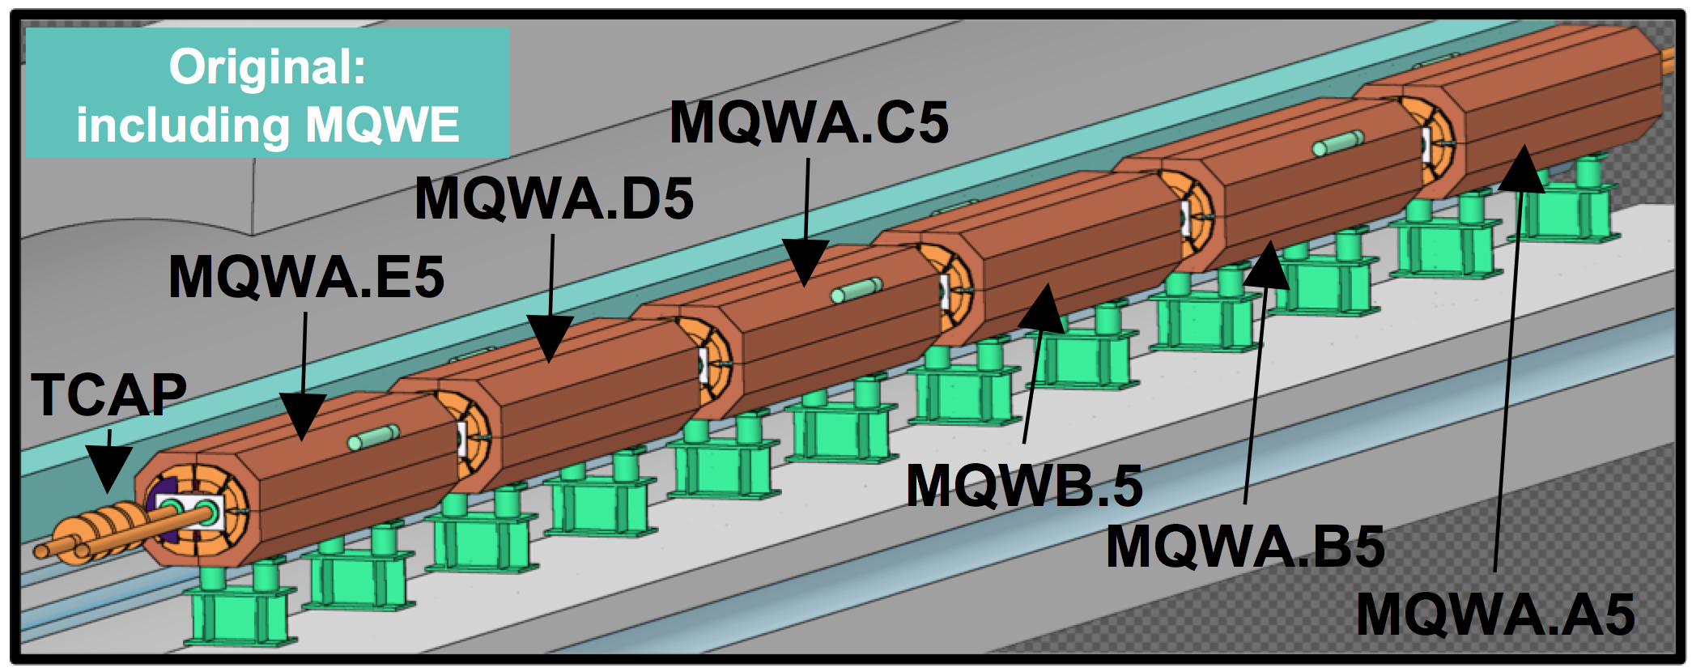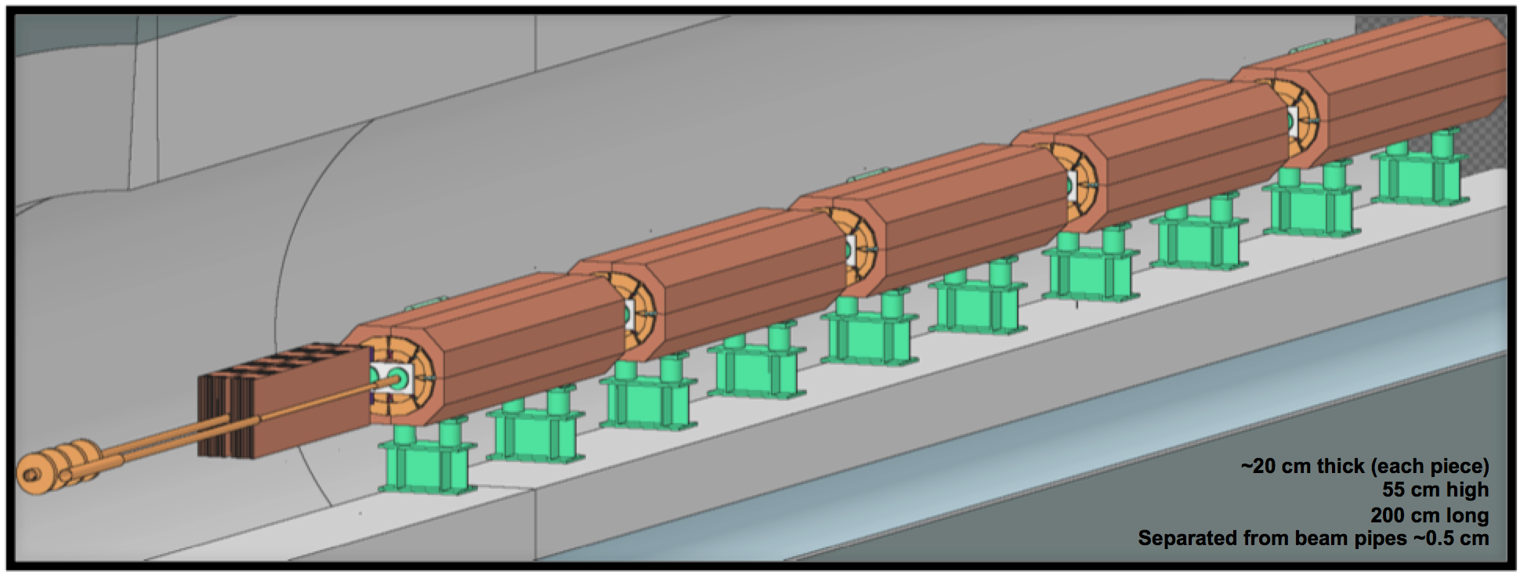
Figure 1 — Illustrative view of the present and post-LS2 layouts of the IR7 Q5 [2,3].
The present passive collimator TCAP will remain in place and a new passive absorber will be added. The latter is outside the vacuum, contrary to the existing passive absorbers. The same elliptical chambers as the present MQW one will be used in this area. The vacuum layout is described in detail in [1] so we focus here only on the new absorber outside vacuum.

REASON FOR THE CHANGE
The computed doses in all modules of the Q5 magnets for beam 1, estimated for the whole lifetime of the HL-LHC project [7], are illustrated in Fig. 2 for three different layouts [2,3]:
- Present layout (top graph);
- Hypothetical layout without collimation upgrade after magnet removal (middle);
- Proposed post-LS2 layout (bottom).
Dose values are estimated both for the coil and for the spacers [1]. Note that for all cases, the present TCAPC.6L7.B1 collimator remains at the same location, as this was found to produce good performance. This also avoids intervening on a radioactive collimator. It is clear that without an improvement of the passive collimation layout (middle plot), doses on the downstream MQWs would be much higher than in the present layout. In particular, the dose on the coil spacers [1] of the most exposed magnet would be about a factor 4 larger. The proposed solution (bottom line) described in detail in the next section, solves this issue and brings the levels to an acceptable level.
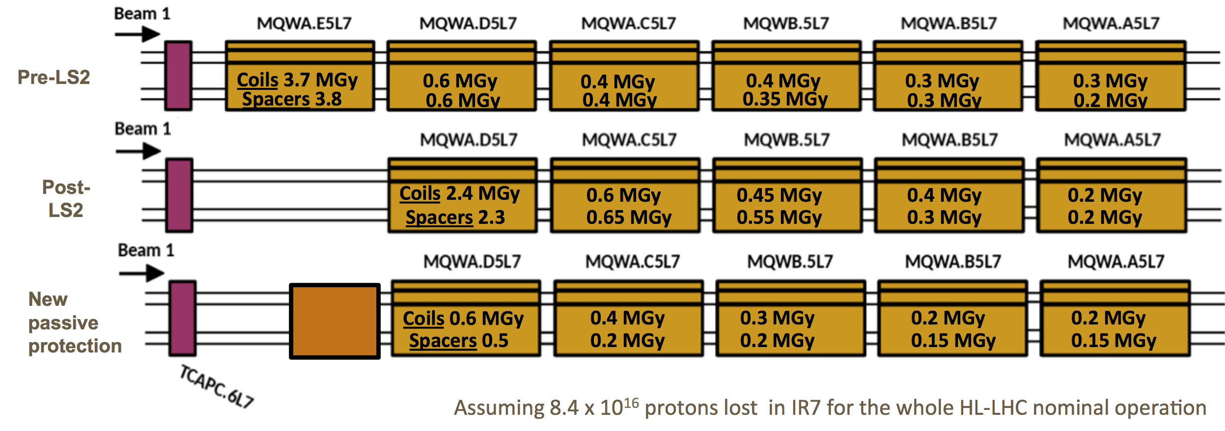
Figure 2 — Summary of doses in different magnets of the Q5 assembly for B1, in the present (top) and proposed post-LS2 (bottom) layouts. The middle plot shows the situation in case no upgrade of the passive collimation system is made. Courtesy of C. Bahamonde [2,3].

DETAILED DESCRIPTION
The new absorber’s present design [8] is shown in Fig. 3. A new support that will be installed under the vacuum chamber will house a modular structure made of steel blocks, assembled together to fill a volume that ensures adequate shielding of the downstream magnet. The absorbing part consists of three block assemblies shown in Fig. 4. The assemblies 1, 2 and 3 weigh respectively 835 Kg, 795 Kg and 820 Kg, for a total of about 2800 kg with the support. The TCAPM transverse cross section is shown in Fig. 5. The absorber assemblies are mounted around the elliptical beam pipes in a way that leaves minimum empty spaces. More detailed technical drawings are under preparation. A preliminary integration layout is shown in Fig. 6.
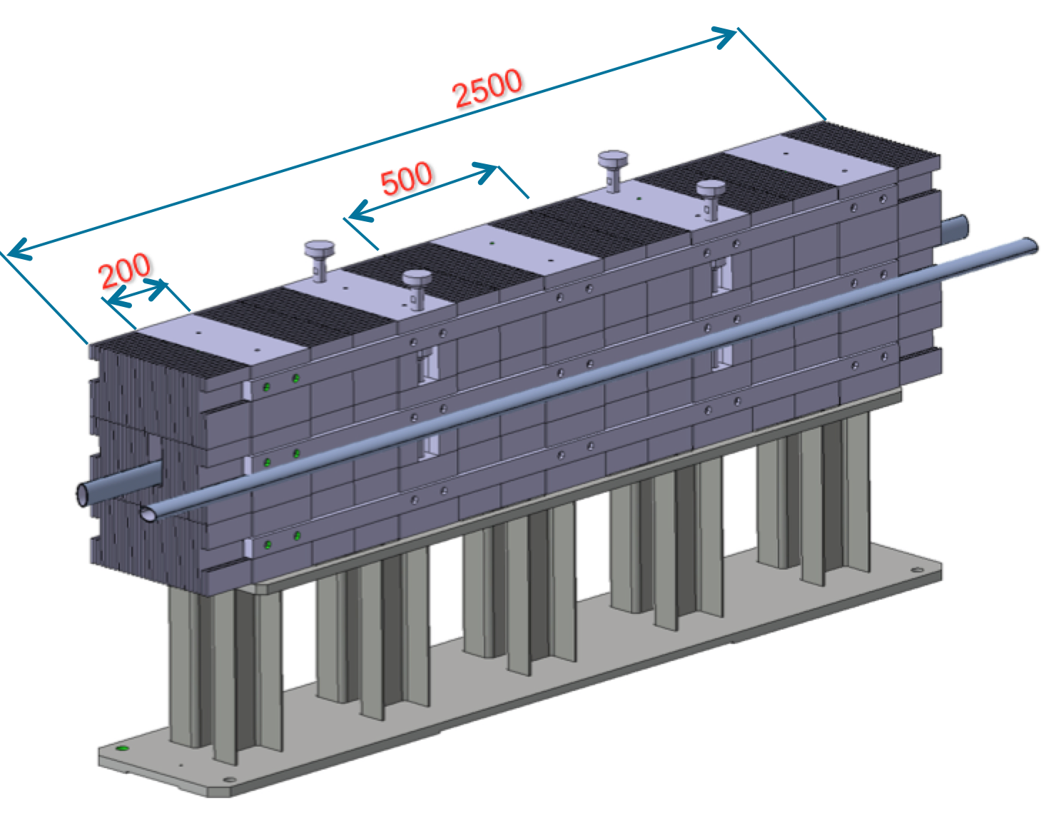
Figure 3 — Overall design of the TCAPM. Lengths are given in mm. Courtesy of L. Gentini [8].
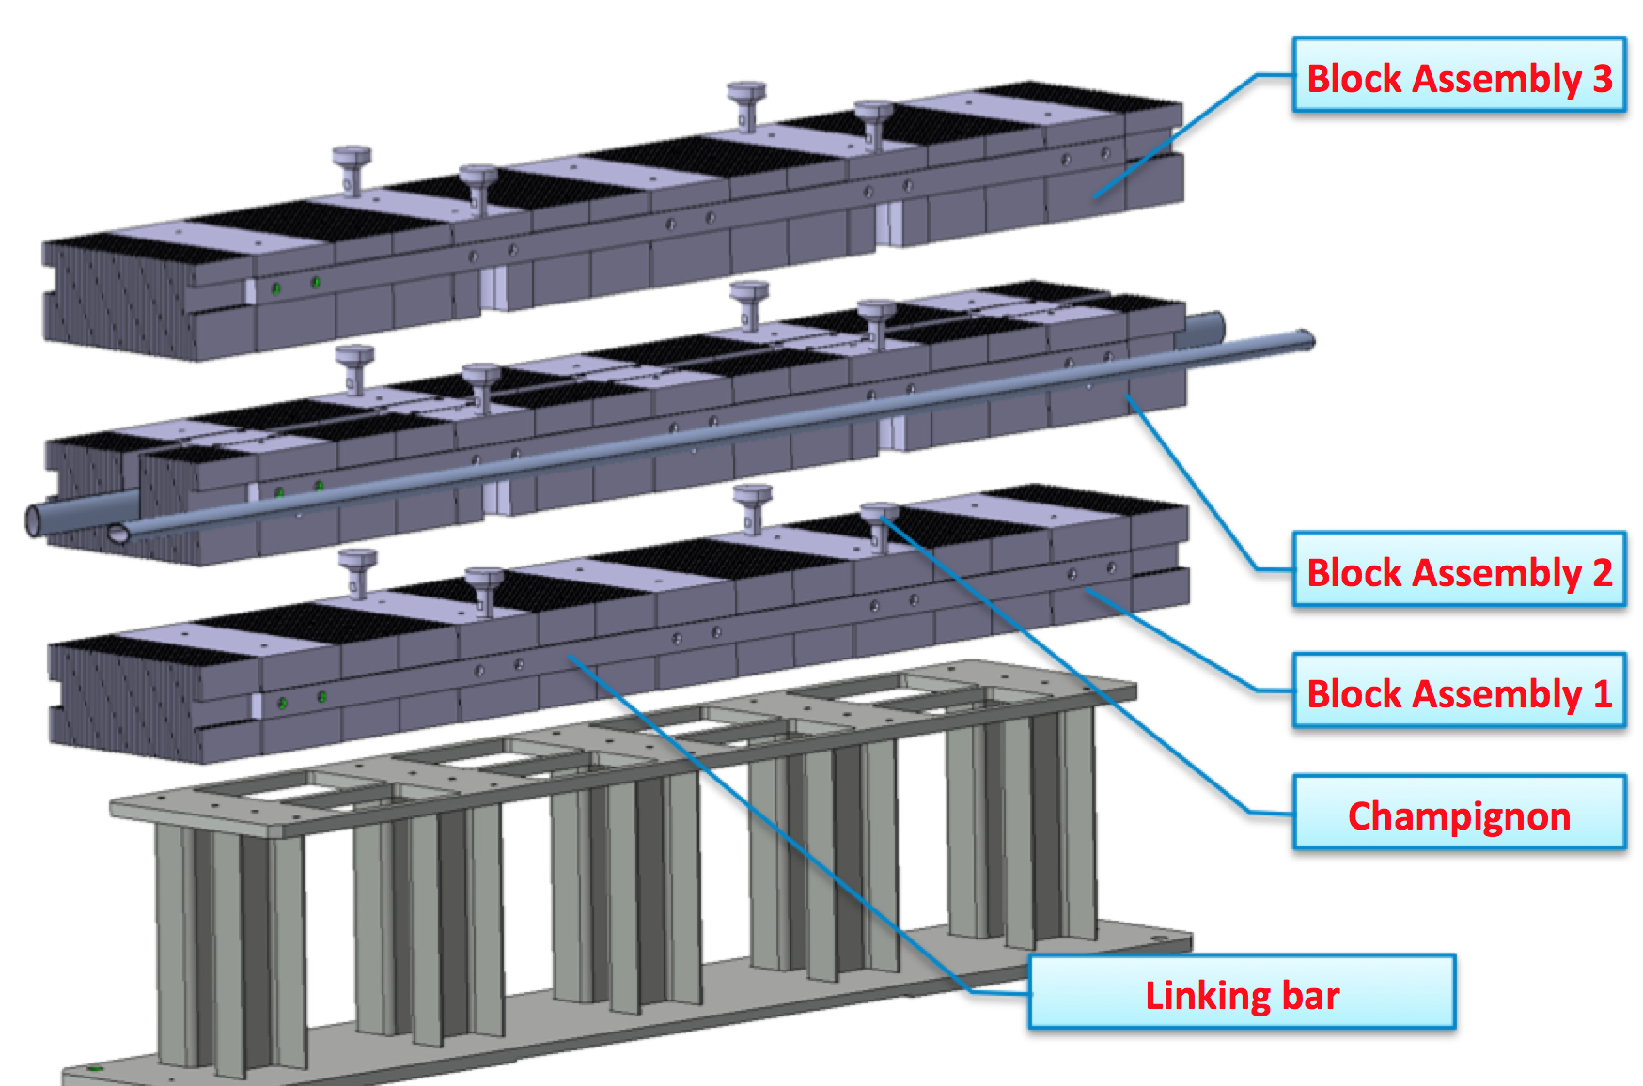
Figure 4 — The three assembly blocks of the TCAPM. Courtesy of L. Gentini [8].

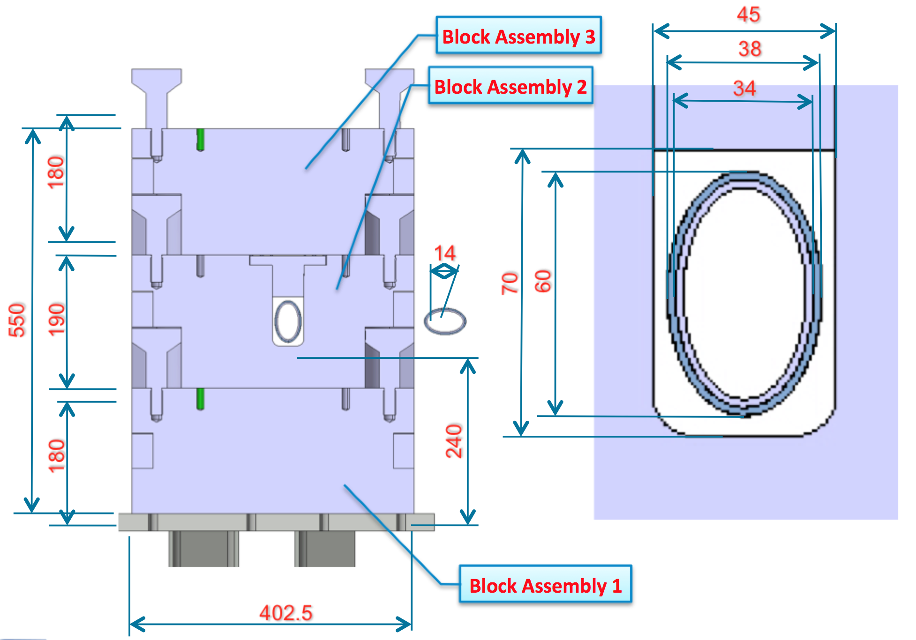

Figure 5 — Cross section of the TCAPM, with the vacuum chambers. Dimensions are given in mm. Courtesy of L. Gentini [8].
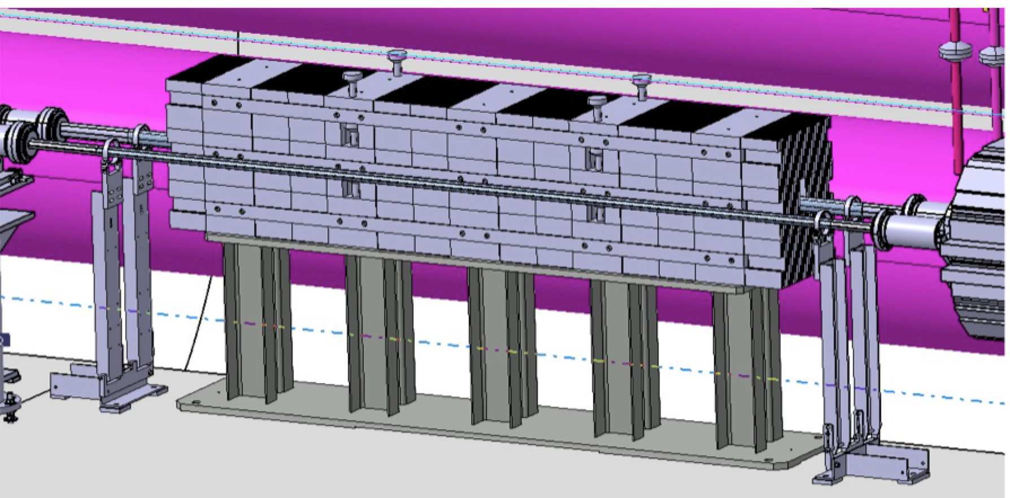
Figure 6 — Preliminary integration drawing of the TCAPM. Courtesy of L. Gentini and integration team [8].

IMPACT ON OTHER ITEMS

IMPACT ON ITEMS/SYSTEMS
LHC collimation system | No changes to the other IR7 movable and passive collimators.
BE/BI | No dedicated BI equipment, like BLMs, will be needed for this passive absorber.
Machine protection | No impact.
BE/OP | No impact.
TE/VSC | No impact for the TCAPM. Vacuum implications following the removal of the MQW are described in [1].  Note that the middle block might have to be transported in the tunnel with the vacuum pipe installed.

IMPACT ON UTILITIES AND SERVICES
Raw water: | No.
Demineralized water: | No.
Compressed air: | No.
Electricity, cable pulling  (power, signal, optical fibres…): | No.
DEC/DIC: | No.
Racks (name and location): | No.
Vacuum (bake outs, sectorisation…): | -
Special transport/ handling: | Transport of heavy assemblies to be planned.
Temporary storage of conventional/radioactive components: | -
Alignment and positioning: | -
Scaffolding: | Not needed.
Controls: | -
GSM/WIFI networks: | -
Cryogenics: | No.
Contractor(s): | N/A
Surface building(s): | N/A
Others:

IMPACT ON COST, SCHEDULE AND PERFORMANCE

IMPACT ON COST
Detailed breakdown of the change cost: | All activities will be covered by the Consolidation project.
Budget code: | Collimation consolidation code 61727.

IMPACT ON SCHEDULE
Proposed installation schedule: | Installation toward end of LS2.
Proposed test schedule (if applicable): | No special tests planned after the assembly.
Estimated duration: | <1 week installation time for EN/STI group.
Urgency: | --
Flexibility of scheduling: | Hardware is unlikely to be available before the end of 2019.

IMPACT ON PERFORMANCE
Mechanical aperture: | No impact as the new hardware is outside the beam vacuum.
Impedance: | No impact as the new hardware is outside the beam vacuum.
Optics/MADX | -
Electron cloud  (NEG coating, solenoid…) | -
Insulation (enamelled flange, grounding…) | -
Vacuum performance: | -
Others: | -

IMPACT ON OPERATIONAL SAFETY

ÉLÉMENT(S) IMPORTANT(S) DE SECURITÉ
Requirement | Yes | No | Comments
EIS-Access |  | X | -
EIS-Beam |  | X | -
EIS-Machine |  | X | -

OTHER OPERATIONAL SAFETY ASPECTS
Have new hazards been created or changed? | Implications of removal of MQW magnets discussed in [1].
Could the change affect existing risk control measures? | No.
What risk controls have to be put in place? | None.
Safety documentation to update after the modification | -
Define the need for training or information after the change | -

WORKSITE SAFETY

ORGANISATION
Requirement | Yes | No | Comments
IMPACT – VIC: |  | X
Operational radiation protection  (surveys, DIMR…): | x |  | Installation in high radiation environment must be done by taking the ALARA principle into account.
Radioactive storage of material: | x |  | Works on magnets and vacuum components discussed in [1].
Radioactive waste: |  | x
Fire risk/permit (IS41)  (welding, grinding…): |  | x
Alarms deactivation/activation (IS37): |  | x
Others:

REGULATORY TESTS
Requirement | Yes | No | Responsible Group | Comments
Pressure/leak tests: |  | X
Electrical tests: |  | X
Others:

PARTICULAR RISKS
Requirement | Yes | No | Comments
Hazardous substances (chemicals, gas, asbestos…): |  | x
Work at height: |  | x
Confined space working: |  | x
Noise: |  | x
Cryogenic risks: |  | x
Industrial X-ray  (tirs radio): |  | x
Ionizing radiation risks (radioactive components): |  | x
Others:

FOLLOW-UP OF ACTIONS BY THE TECHNICAL COORDINATION
Action | Done | Date | Comments
Carry out site activities:
Carry out tests:
Update layout drawings:
Update equipment drawings:
Update layout database:
Update naming database:
Update optics (MADX)
Update procedures for maintenance and operations
Update Safety File according to EDMS document 1177755:
Others:

REFERENCES
[1] P. Fessia et al., “Radiation Shielding Installation and Possible Optics Change for the MBW and MQW Magnets in IR 3 and 7 of the LHC”, LHC-TC-EC-00XX, EDMS 1321045.
[2] 95th ColUSM, https://indico.cern.ch/event/676111.
[3] 83rd ColUSM, http://indico.cern.ch/event/614887.
[4] 81st ColUSM, http://indico.cern.ch/event/588072.
[5] 77th ColUSM, http://indico.cern.ch/event/568895.
[6] 76th COlUSM, http://indico.cern.ch/event/562586.
[7] G. Apollinari, I. Bejar Alonso, O. Bruning, P. Fessia, M. Lamont, L. Rossi, and L. Tavian (editors). High-Luminosity Large Hadron Collider (HL-LHC): Technical Design Report V. 0.1. CERN Yellow Reports: Monographs. CERN-2017-007-M. CERN, Geneva, 2017.
[8] 17th HiColDEM meeting, “HL-LHC Collimators: Design, Engineering and Prototyping” https://indico.cern.ch/event/699699.

