conceptual SPECIFICATION

hollow e-lens

[HEBC preliminary name]

Equipment/system description

Electron beams have been used for different purposes in hadron colliders. Hollow electron beams running coaxially to the circulating hadron beams at the LHC are considered as a possible way of enhancing the performance of the LHC collimation system by providing an active control of beam halo population and beam loss rates. The electromagnetic field generated by a pulsed (or modulated) hollow electron beam leaves the beam core unperturbed while acting on the beam tails at transverse amplitudes above the electron beam inner radius. This results in the possibility to control the beam halo loss rates on the primary collimators and the impact parameter of particles impinging on the collimators, which ultimately allows a active control of the beam tail population.

Note that the name equipment name “HEBC” is preliminary: to be updated by Samy (same conventions for ELENA and LEIR).

Layout Versions |  | LHC sectors concerned |  |  | CDD Drawings root names (drawing storage):
V 1.1 |  | IR4 |  |  | HLHEB to be created by S. Chemli

Traceability
Project Engineer in charge of the equipment  tbd |  |  |  | WP Leader in charge of the equipment  S. Redaelli
Committee/Verification Role |  |  |  | Decision |  | Date
PLC-HLTC/ Performance and technical parameters  Configuration-Integration / Configuration, installation and interface parameters  TC / Cost and schedule |  |  |  | Rejected/Accepted  Rejected/Accepted  Rejected/Accepted |  | 2014-07-01  20YY-MM-DD  20YY-MM-DD
Final decision by PL |  |  |  | Rejected/Accepted/Accepted pending (integration studies, …) |  | 20YY-MM-DD

Distribution: HL-TC
Rev. No. | Date |  | Description of Changes (major changes only, minor changes in EDMS)
X.0 | 20YY-MM-DD |  | Description of changes

Conceptual description

Scope

The hollow electron beam collimation (HEBC) is considered as a possible way to improve the LHC collimation system. A hollow electron beam running co-axially to the LHC proton or ion beams, with the “hole” centred around the main beam core and the circular electron “wall” cutting into the main beam tails, can be used to control the diffusion speed of the main beam halo. This has been demonstrated experimentally at the Tevatron during dedicated LHC collimation beam studies [ref G. Stancari, IPAC 2014, and refs therein], showing that a controlled halo excitation, selective by transverse amplitude, is indeed possible. The potential advantages for collimation are several:
- Control of the primary loss rates, with potential mitigation of peak loss rates in the cold magnets, for a given collimation cleaning. Peak power losses on the collimators themselves can be optimized as well.
- Controlled depletion of beam tails, with beneficial effects in case of fast failures.
- Reduction of tails population and therefore peak loss rates in case of orbit drifts.
- Beam scraping at very low amplitudes (>3σ) without damage risk as for standard bulk scrapers.
- Tuning of the impact parameters on the primary collimators with possible improvement in cleaning efficiency.

Since the main beam core is not affected, the HEBC operation is transparent for the luminosity performance if this technique works as promised.

The usage of HEBC requires the collimation system in place in order to dispose of the tail particles expelled in a controlled way by the HEBC. No losses occur at the HEBC location. The tail control mechanism can actually be put in place in any ring location. Larger beam size locations are favourable as they entail reduced alignment accuracy for the hollow beam. The IR4 is considered as a best candidate for two HEBC devices due to cryogenics availability, low-radiation environment, and quasi-round beam.

Benefit or objective for the HL-LHC machine performance

While the functionality of HEBC will provide clear benefits for the LHC operation, the real need for such scheme at the LHC and HL-LHC needs to be addressed after gaining sufficient operational experience at energies close to 7 TeV, on quench limits, beam lifetime and loss rates during the operational cycle, and collimation cleaning. Fast failure scenarios of the crab cavities require a low tail population above about 4 beam sigma’s: HEBC is the only technique solidly validated experimentally in other machines that could ensure a safe operation in this case.

Equipment performance objectives

The HEBC is targeted at enabling active control of beam tails above 3 beam sigma’s, with tail depletion efficiencies of the order of 90 % over times of tens of seconds, in all phases of the operational cycle, specifically before and after beams are put in collision.

The HEBC implementation should ensure (1) the possibility to pulse the current turn-by-turn (as required to drive resonances in the linear machine before beams are in collision); (2) a train-by-train selective excitation (leaving “witness” trains with populated halos for diagnostics and machine protection purposes).

TECHNICAL ANNEXES

preliminary technical parameters

Assumptions

The need for the HEBC depends on the following machine parameters (to be experimentally addressed starting in 2015):
- Total beam intensity and minimum allowed beam lifetime during the operational cycle;
- Collimation cleaning and quench limits of superconducting magnets;
- Halo population and diffusion rates at high energy;
- Orbit stability (amplitude and duration of “orbit jitters”) in dynamics operation phases;
- Crab-cavity failure scenarios (determining requirements on beam tail population).

It is important to note that the need for HEBC also depends on the results of beam tests of alternative halo excitation methods (like tune modulation and narrow-band excitation with the transverse damper) that will be tested in MD’s starting in 2015 with high priority.

Equipment Technical parameters
The main systems/components of a HEBC can be summarized as:
- Electron beam generation and disposal: electron gun and collector, with the required powering.
- Several superconducting and resistive magnets: solenoids, dipoles and correctors to stabilize and steer the electron beam.
- Beam instrumentation for the optimization of the electron beam.
The parameters listed here are extracted from the conceptual design document [2] compiled by the colleagues from FNAL who worked on this topics within the US-LARP collaboration. A detail engineering design is now ongoing at CERN. The first goal will be to define the volumes for a 3D integration into the LHC. The e-beam parameters are considerate adequate for HEBC purposes at the LHC.

Table 1: Equipment parameters [2]

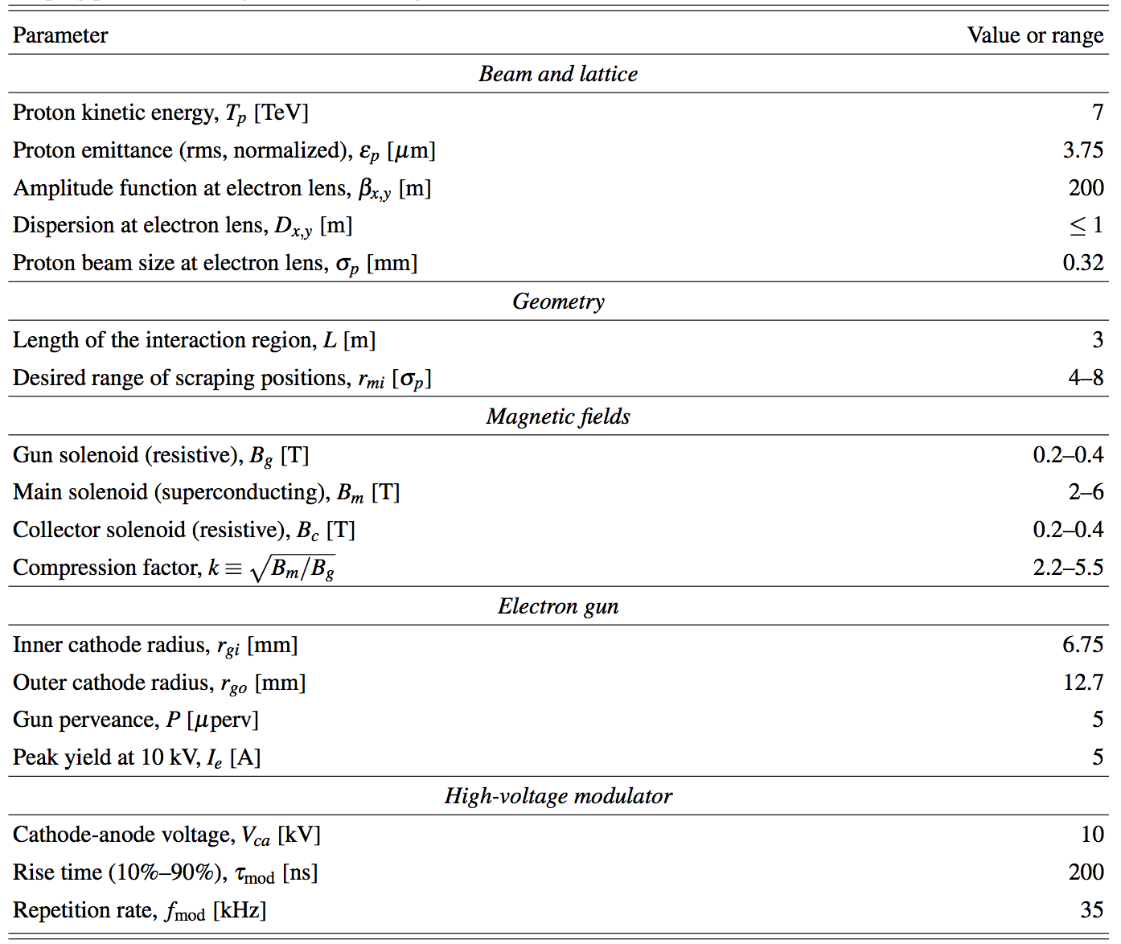

Operational parameters and conditions
The HEBC must provide the possibility to excite the beam halo in a controlled way in all phases of the operational cycle, while inducing negligible beam core blow-up. This requirement is particularly important during the stable beam conditions when HEBC might work continuously in order to control the tail population. Before crab cavities are operational, it is expected that halo control will only be needed to mitigate effects of beam lifetime drops before the beams are put in collision.

Technical and Installation services required

Clearly, the installation of a HEBC has important impacts on different systems: cryogenics, vacuum, powering, machine layout.

Table 2: Technical services
Domain | Requirement
Electricity & Power | YES
Cooling & Ventilation | YES: cooling for the collector.
Cryogenics | YES
Control and alarms | YES
Vacuum | YES
Instrumentation | YES

Table 3: Installation services
Domain | Requirement
Civil Engineering | NO
Handling | YES
Alignment | YES

P & I Diagrams

--

Reliability, availability, maintainability

Deployment of electron beam devices in other machines like the Tevatron has indicated that this technology can be considered mature and suited for high-reliability machines like the LHC and HL-LHC. A similar device is being commissioned at the BNL RHIC facility for beam-beam compensation purposes. The operational experience at RHIC will provide further insight on this matter.

Radiation resistance

The usage of superconducting magnets for the HEBC calls for an installation in a low beam loss environment. IR4 is proposed.

List of units to be installed and spares policy
- One device per beam, spare policy of components to be defined.

preliminary CONFIGURATION and installation constraints

Longitudinal range

The longitudinal position of HEBC devices must be chosen in order to respect the criterion of equal horizontal and vertical beam size. Suitable location in IR4 were proposed that fulfil this requirement. These location are presently being evaluated taking into account the 3D integration constraints and the different optics scenarios for the pre- and post-LS3 operation.

Volume

We foresee indicatively a longitudinal space reservation of 6-8 metres per device, pending a detailed design and integration study.

It is foreseen to install the HEBC devices in IR4 at a longitudinal location where the beam-beam separation is 420 mm, to ease the cryostat design.

Installation/Dismantling

--.

preliminary INTErface parameters

Interfaces with equipment

Detailed interfaces to vacuum and cryogenics to be studied.

Electrical interfaces

Additional circuits for the different resistive and superconducting magnets of the HEBC. Adequate quench protection system for the superconducting solenoid. None of the existing LHC circuit will need to be modified.

Table 4: Circuits to be generated
New circuit description | Circuit LHC code name (if known) | Approx. current rating (if known) | Approx. voltage rating (if known)
Main superconducting solenoids (2) | TBD | TBD | TBD
Resistive solenoids (2 per device) | TBD | TBD | TBD
Electron beam correctors (??) | TBD | TBD | TBD
Additional corrector magnets | TBD | TBD | TBD
High-voltage modulator | TBD | TBD | TBD

List circuits to be modified/affected by the installation of the new equipment

Table 5: Circuits to be modified/affected
Circuit LHC code name | Action on the circuit

Cost & Schedule

Cost evaluation

Cost to be charged on the collimation code 61064.

Approximated Schedule

Two production and installation scenarios are considered for the HEBC deployment:
- installation in LS2 (“Scen. 1”);
- Installation in LS3 (“Scen. 2”).

Note that for Scen. 2, it must be planned to update the IR4 cryogenics already in LS2.

It is important to note that
- The possibility to perform dedicated beam tests at RHIC for LHC collimation studies is being pursued in collaboration with BNL;
- The possibility to setup a test stand at CERN for electron beam generation is being pursued in collaboration with BI, in synergy with the electron cooler studies for the ELENA machine.
- The HEBC study profits from obvious synergies with the generation of electron beams for long range beam-beam compensation at the LHC [Funct. Spec. on ebeam for LRBB, by H. Schmickler].

Table 6: Tentative schedule – Scenario 11 for implementation in LS2
Phase | 2014 |  | 2015 |  | 2016 |  | 2017 |  | 2018 | 2019 | 2020 | 2021 | 2022
Conceptual specs.
Technical design
Assessment of HEBC
needs with LHC beams
Review of baseline
Production Scen. 1
Adaptation of cryo. IR4

Table 7: Tentative schedule – Scenario 2 for implementation in LS3
Phase | 2014 |  | 2015 |  | 2016 |  | 2017 |  | 2018 | 2019 | 2020 | 2021 | 2022
Conceptual specs.
Technical design
Assessment of HEBC
needs with LHC beams
Adaptation of cryo. IR4
Iteration on design
Production Scen. 2

Schedule and cost dependencies

Sharing with consolidation project shall be considered if the deployment is needed in LS2.

Technical reference documents
[1] to be completed
[2] G. Stancari et al., “Conceptual design of hollow electron lenses for beam halo control in the Large Hadron Collider,” FNAL and CERN note, to be published.
[3]

APPROVAL PROCESS comments FOR VERSION X.0 of the CONCEPTUAL SPECIFICATION

PLC-HLTC / Performance and technical parameters Verification

Comments or references to approval notes. In case of rejection detailed reasoning

Configuration-Integration / Configuration, installation and interface parameters Verification

Comments or references to approval notes. In case of rejection detailed reasoning

TC / Cost and schedule Verification

Comments or references to approval notes. In case of rejection detailed reasoning

Final decision by PL

Comments or references to approval notes. In case of rejection detailed reasoning

