CERN-ACC-year-xxx
Stefano.Redaelli@cern.ch
Robert.Appleby@cern.ch
Alessandro.Bertarelli@cern.ch
Roderik.Bruce@cern.ch
Anton.Lechner@cern.ch

Chapter #

Collimation system

A. Bertarelli, R. Bruce, F. Carra, F. Cerutti, L. Esposito, L. Gentini, P. Gradassi, A. Lechner, J.M. Jowett, A. Marsili, E. Quaranta, E. Skordis, G. Steele
CERN, Geneva, Switzerland
R.B. Appleby, M. Serluca, J. Molson
UMAN, The University of Manchester and the Cockcroft Institute, United Kingdom
S. M. Gibson, R. Kwee-Hinzmann, H. Garcia Morales, L. J. Nevay
URHL, Royal Holloway, United Kingdom
R. Barlow, H. Rafique, A. Toader,
UHUD, University of Huddersfield, United Kingdom
A. Faus-Golfe, L. Lari (now at ESS),
IFIC

LHC multi-stage collimation system

Motivation
A variety of processes can cause unavoidable beam losses during normal and abnormal operation. Because of the high stored energy of above 700 MJ, the beams are highly destructive. Even a local beam loss of a tiny fraction of the full beam in a superconducting magnet could cause a quench, and large beam losses could cause damage to accelerator components. Therefore, all beam losses must be tightly controlled. For this purpose, a multistage collimation system has been installed [1,3–8] to safely dispose of beam losses. Unlike other high-energy colliders, where the main purpose of collimation is to reduce experimental background, the LHC and HL-LHC require collimation during all stages of operation to protect its elements.
The HL-LHC imposes increased challenges for the collimation system. For the same collimation cleaning and primary beam loss conditions as in the LHC, the factor ~2 increase in total stored beam energy foreseen by the HL-LHC parameters requires a corresponding improvement of cleaning performance to achieve the same losses in cold magnets. Total losses might also exceed the robustness limit of collimators. The LHC system was designed to withstand without damage lifetime drops down to 0.2 h during 10 s, corresponding to peak losses up to 500 kW. The collimation system must be upgraded to cope with this higher loss levles.
The larger stored energy also imposes more severe challenges for the collimator robustness against design loss scenarios for cleaning. In case of single-turn beam failures, brighter beams impose higher demands on the collimator materials and designs. The higher peak luminosity challenges entail the definition of new concepts for physics debris cleaning and an overall redesign of the IR collimation layouts. For example, in the present LHC layout, the inner triplet represents the IR aperture bottleneck and is protected by two dedicated tertiary collimators per plane per beam. Future optics scenarios might add critical aperture restrictions at magnets further away from the IP, requiring additional cleaning and protection.
To meet the new challenges, the HL-LHC collimation system therefore builds on the existing LHC collimation system, with the addition of several upgrades.

Collimation system inherited from LHC
The backbone of the HL-LHC collimation system will remain, as for the present LHC, the betatron (IR7) and momentum (IR3) cleaning systems installed in two separated warm insertions [1]. A very efficient halo cleaning, as required to operate the LHC with unprecedented stored beam energies in a superconducting collider, is achieved by placing very precisely blocks of materials close to the circulating beams, while respecting a pre-defined collimator hierarchy that ensures optimum cleaning in a multi-stage collimation process. This is illustrated schematically in Figure 1. Most collimators consist of two movable blocks referred to as “jaws”, typically placed symmetrically around the circulating beams. The present system deployed for the LHC operation between 2010 and 2013 provided a cleaning efficiency above 99.99 % [2], i.e. it ensured that less than 10⁻⁴ of the beam losses is lost in superconducting magnets. As of end of LS1, the devices built under the responsibility of the LHC collimation project are 116 devices, 106 of which are movable, in LHC ring and transfer lines.
The LHC collimators are built as high precision devices in order to ensure the correct hierarchy of devices along the 27 km ring with beam sizes as small as 200 microns. Details of the collimator design can be found in [20]. Key features of the design are (1) a jaw flatness of about 40 microns along the 1 m-long active jaw surface, (2) a surface roughness below 2 microns, (3) a 5 micron positioning resolution (mechanical, controls), (4) an overall setting reproducibility below 20 microns [21], (5) a minimal gap of 0.5 mm, and (6) evacuated heat loads of up to 7 kW in steady-state regime (1 h beam lifetime) and of up to 30 kW in transient conditions (0.2 h beam lifetime). Two photographs of the present LHC collimator are given in Figure 2, where a horizontal and a 45 degree tilted collimator are shown. An example of the tunnel installation layout for a IR7 collimator is given in Figure 3. The complete list of collimators, including injection protection collimators in the transfer lines (built within the LHC collimation project), is given in Table 1. For completeness, the injection protection TDI blocks and the one-side beam dump collimator TCDQ are also listed (see Chapter 19). The full system comprises 118 collimators, 108 of which are movable.
Since the collimator jaws are close to the beam (e.g., the minimum collimator gap in 2012 was 2.1 mm, i.e. jaws were 1.05 mm apart from the circulating beam), the collimation system has also a critical role in the passive machine protection in case of beam failures that cannot be counteracted by active systems. Primary and secondary collimators in IR7 are the closest to the beam; their jaws are mainly made of robust Carbon-fibre Carbon composites (CFC), and are designed to withstand without significant permanent damage beam impacts for the worst failure cases such as impacts of a full injection batch of 288x1.15x10¹¹ protons at 450 GeV and of up to 8x1.15x10¹¹ protons at 7 TeV [22]. However they contribute significantly to the machine impedance, critical in particular at top energy, because of the low conductivity of the CFC. Impedance constraints determine the smallest gaps that can be used in IR3 and IR7 and hence the minimum beta* in the experiment [3]. Note that the few dump protection elements contribute to small fractions to the impedance budget. Other absorbers and tertiary collimators are positioned at larger gaps in units of the local beam size. They can be less robust than primary and secondary collimators because they are less exposed to beam losses. Thus, metal-based jaws can be used which are more effective in absorbing particles.
The initial collimator design has been improved by adding 2 beam position monitors (BPMs) on either extremity of each jaw [23] and 18 collimators (16 TCTP and 2 TCSP) were already upgraded with this new design during LS1. This concept allows a fast collimator alignment as well as a constant monitoring of the beam orbit at the collimator as opposed to the BLM-based alignment that can only be performed during dedicated low-intensity commissioning fills. The BPM buttons will improve significantly the collimation performance in terms of operational flexibility and β* reach [3]. The BPM-embedded design is considered as the baseline for future collimation upgrades and the BPM design is equally applicable to all collimators regardless of the jaw material. The concept has been tested extensively at the CERN SPS with a collimator prototype with BPMs [24, 25, 26]. An example of a CFC jaw prototype with in-jaw BPMs is shown in Figure 4.
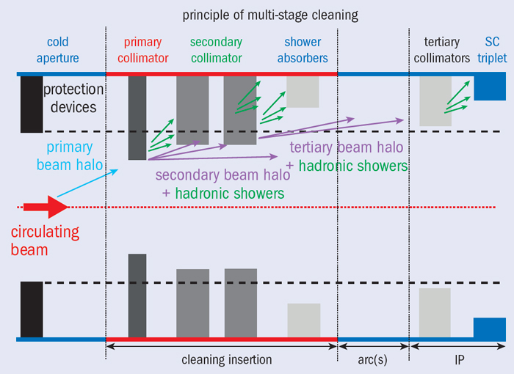
Fig. 1: Schematic illustration of the multi-stage collimation cleaning at the LHC. Primary and secondary collimators (darkest grey) are the devices closest to the circulating beam and are made of robust carbon-fibre composites. Shower absorbers and tertiary collimators (lighter grey) sit at larger apertures and are made of a Tungsten alloy to improve absorption. Collimators of different families are ordered in a pre-defined collimation hierarchy that must be respected in order to ensure the required system functionalities. The collimator hierarchy is ensured by defining collimator settings in units of local beam size at the collimator location.
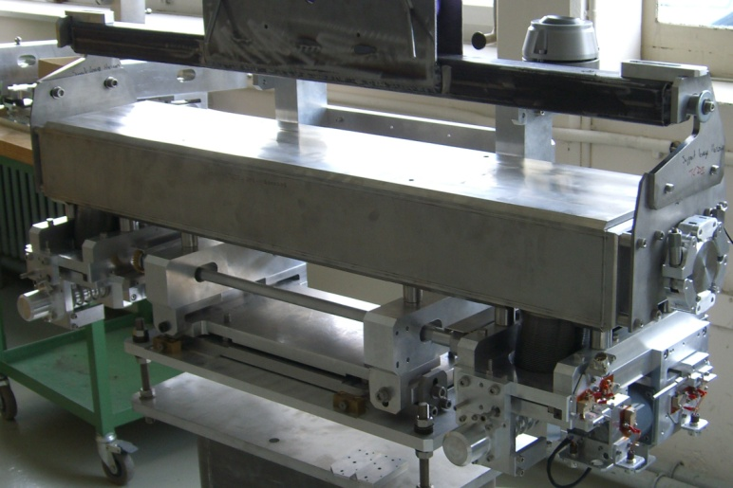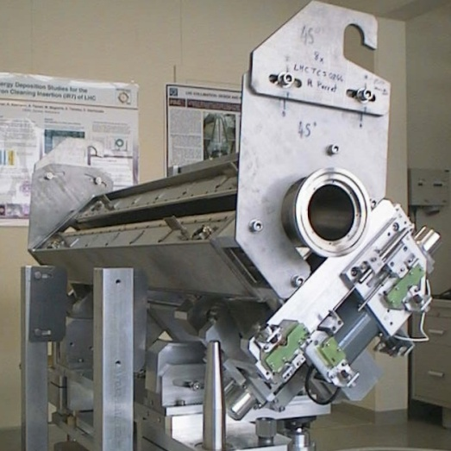
Fig. 2: Photograph of a horizontal (left) and a skew (right) LHC collimator. The latter has the vacuum tank open to show the two movable CFC jaws.
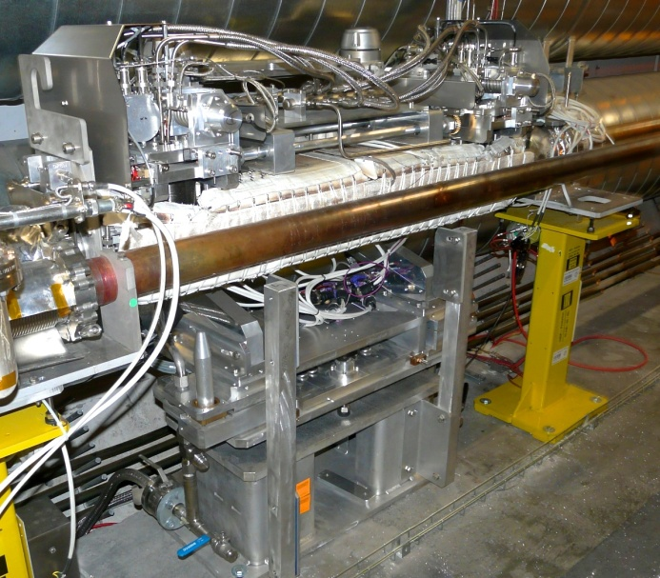
Fig. 3: Photograph of the active absorber TCLA.B6R7.B1 as installed in the betatron cleaning insertion.

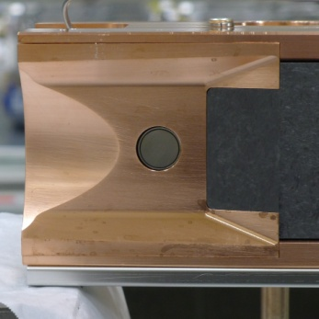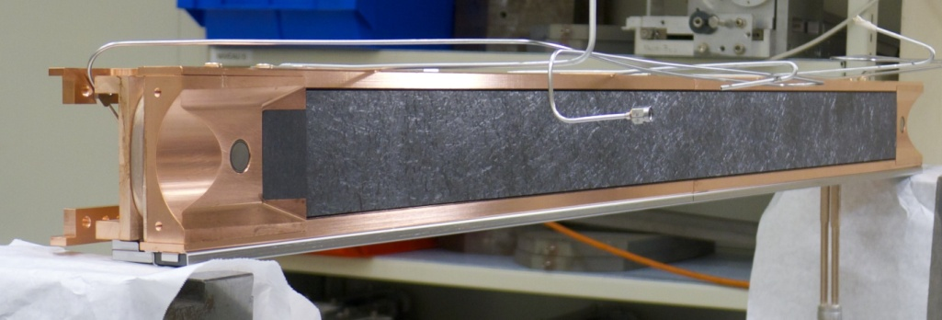
Fig 4: New Carbon/Carbon collimator jaw with integrated BPMs at each extremity to be installed as secondary collimator in the dump insertion IR6. A detail of the BPM is given on the left side. A variant of this design, made with a Glidcop support and Tungsten inserts on the active jaw part, will be used for the tertiary collimators in all IRs.

In addition to the beam halo cleaning, the collimation system has also other important roles:
- Passive machine protection: the collimators are the closest elements to the circulating beam and represent the first line of defence in case of various normal and abnormal loss cases Due to the damage potential of the LHC beams, this functionality has become one of the most critical aspects for the LHC operation and commissioning. In particular, it must be ensured that the triplet magnets in the experiments are protected during the betatron squeeze [3].
- Active cleaning of collision debris products: this is achieved with dedicated (TCL) collimators located on the outgoing beams of each high-luminosity experiment that catch the debris produced by the collisions. These keep losses below the quench limit of the superconducting magnets in the matching sections and dispersion suppressors close to the interaction points.
- Experiment background optimization: this is one of the classical roles of collimation systems in previous colliders like ISR, SppS and Tevatron. For the LHC, the contribution to background from beam halo has always been expected to be small, due to effective IR7 collimation cleaning that induces only limited losses close to the experiments. The initial run confirmed this expectation [4].
- Concentration of radiation losses: for high power machines, it is becoming increasingly important to be able to localize beam losses in confined and optimized “hot” areas rather than having a distributed activation of equipment along the machine. This is an essential functionality to allow easy access for maintenance in the largest fraction of machine.
- Local protection of equipment and improvement of lifetime: Dedicated movable or fixed collimators are used to shield equipment. For example, eight passive absorbers are used in the collimation insertions in order to reduce the total dose to warm dipoles and quadrupoles that otherwise would have a short lifetime in the high-radiation environment foreseen during the nominal LHC operation.
- Beam halo scraping and halo diagnostics: Collimator scans in association to the very sensitive LHC beam loss monitoring system proved to be a powerful way to probe the population of beam tails [5, 6], otherwise too small compared to the beam core to be measured by conventional emittance measurements. Thanks to their robustness, the present primary collimators can also be efficiently used to scrape and shape the beams, as in [7].
In order to fulfil all these functionalities, the LHC collimation system features an unprecedented complexity compared to previous state-of-the-art in particle accelerators. The Run 1 system required managing about 400 degrees of freedom for collimator movements [8]. As a comparison, the Tevatron collimation system had less than 30 degrees of freedom. For this reason, the possibility to operate reliably the collimation system has always been considered as a major concern for the LHC performance. Upgrade scenarios must address improved operational aspects as the HL-LHC goal rely on machine availability.
Table 1: Collimators for the LHC Run 2, starting in 2015. For each type, acronyms, rotation plane (horizontal, vertical or skew), material and number of devices, summed over the two beams, are given. For completeness, movable injection and dump protection devices are also listed. In addition, the collimation system comprises 10 fixed-aperture absorbers in IR3 and IR7 to reduce total doses to worm magnets of the cleaning insertions.
Functional type | Name | Plane | Number | Material
Primary IR3 | TCP | H | 2 | CFC
Secondary IR3 | TCSG | H | 8 | CFC
Absorber IR3 | TCLA | H,V | 8 | Inermet 180
Primary IR7 | TCP | H,V,S | 6 | CFC
Secondary IR7 | TCSG | H,V,S | 22 | CFC
Absorber IR7 | TCLA | H,V,S | 10 | Inermet 180
Tertiary IR1/2/5/8 | TCTP | H,V | 16 | Inermet 180
Physics debris absorbers IR1/5 | TCL | H | 12 | Cu, Inermet180
Dump protection IR6 | TCDQ | H | 2 | CFC
 | TCSP | H | 2 | CFC
Injection protection (transfer lines) | TCDI | H,V | 13 | C
Injection protection IR2/8 | TDI | V | 2 | hBN,Al, Cu/Be
 | TCLI | V | 4 | C, CFC
 | TCDD | V | 1 | Copper

Baseline upgrades to the LHC collimation system
To cope with the increased challenges in HL-LHC, several baseline upgrades of the LHC system are proposed. We discuss how to improve the cleaning performance, the impedance, and the collimation in the experimental IRs.

Upgrades for improved cleaning

Upgrades to the IR7 system
Protons and ions interacting with the collimators in IR7 emerge from the IR with a changed magnetic rigidity. This represents a source of local heat deposition in the cold dispersion suppressor (DS) magnets downstream of IR7, where the dispersion starts to increase (see [62] and references): these losses are the limiting locations for collimation cleaning, i.e. they are the highest cold losses around the ring. This may pose a certain risk for inducing magnet quenches, in particular in view of the higher intensities expected for HL-LHC.
A possible solution to this problem is to add local collimators in the dispersion suppressors, which is only feasible with a major change of the cold layout at the locations where the dispersion start rising. Indeed, the present system’s multi-stage cleaning is not efficient at catching these dispersive losses. Clearly, the need for local collimation depends on the absolute level of losses achieved in operation and the quench limit of superconducting magnets. In this design phase when the quench limits and the operational performance are not yet known accurately enough at energies close to 7 TeV, it is important to take appropriate margins to minimize the risk of being limited in the future (post-LS1 operation and even more in the HL-LHC era).
A strategy to eliminate any risk of quench is the installation of DS collimators (TCLDs, Target Collimator Long Dispersion suppressor). As shown below, two collimators per side of IR7 would be sufficient to effectively intercept the protons or ions that would otherwise hit the DS magnets. In order to make space for the new collimators, it is envisaged to replace, for each TCLD, an existing main dipole by two shorter 11T dipoles with the TCLD in between as schematically shown in Figure 5 and 5 bis. This is a modular solution that can be applied to any dipole without additional changes to the adjacent superconducting magnets or other cold elements [37].
Extensive tracking and energy deposition simulations have been performed to assess the effect of the TCLDs [39, 40, 63, 64, 65], based on the assumption that the dipoles MB.B8R7 and MB.B10R7 are substituted for the B1 cleaning, and MB.B8L7 and MB.B10L7 for the B2 cleaning. This layout makes room for two TCLDs per beam. For example, the simulated energy deposition profile of the DS magnets for the case of 0.2 h lifetime in the nominal LHC beam is illustrated in Figure 6. It is seen that the presence of local DS collimators reduces the peak energy deposition by about a factor 10 compared to the present layout with standard dipoles. If the LHC total intensity reach were limited by collimation losses, this solution would allow increasing the reach by the same factor. 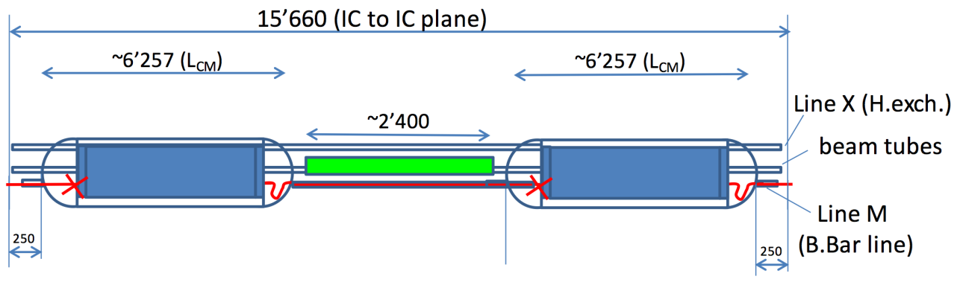
Fig. 5: Schematic view of the assembly of two shorter 11 T dipoles with a collimator in between, which can replace one standard main dipole. Courtesy of V. Parma.
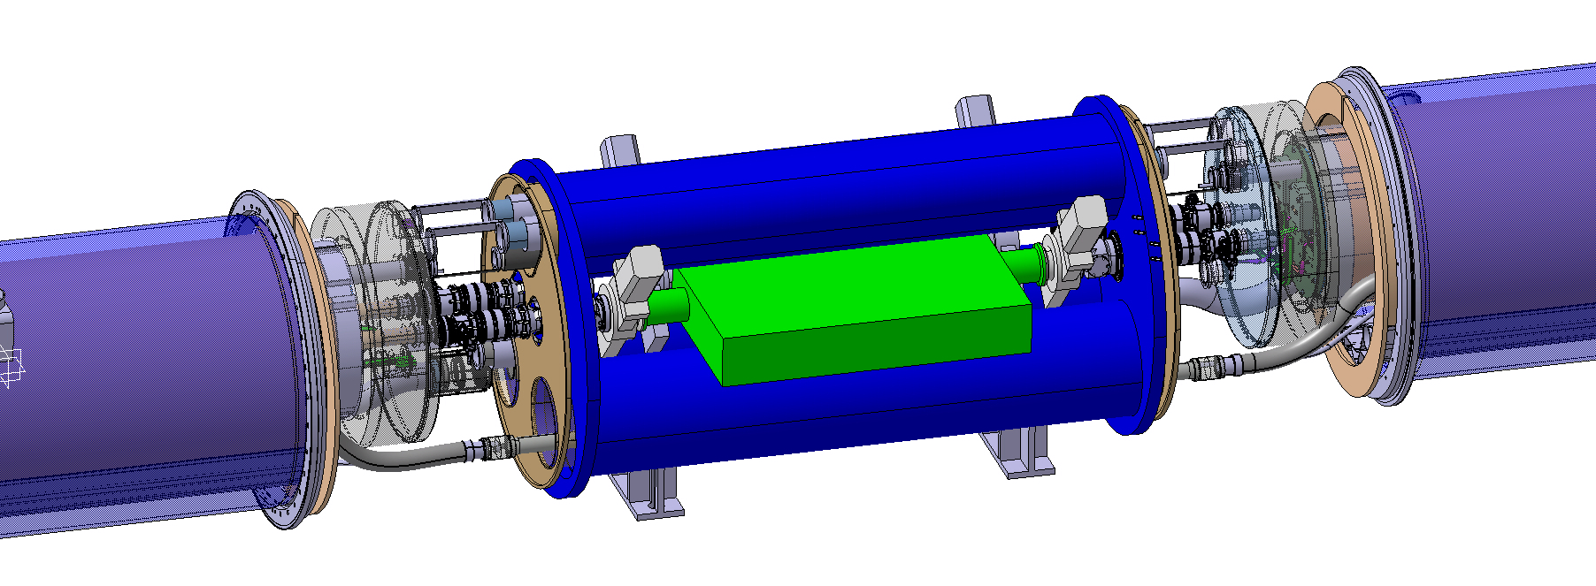
Fig. 5 bis: preliminary 3D model of a TCLD assembly showing the collimator (in green), the two short dipole cryostats and the connection cryostat. Note the very tight space constraints for the collimator unit.

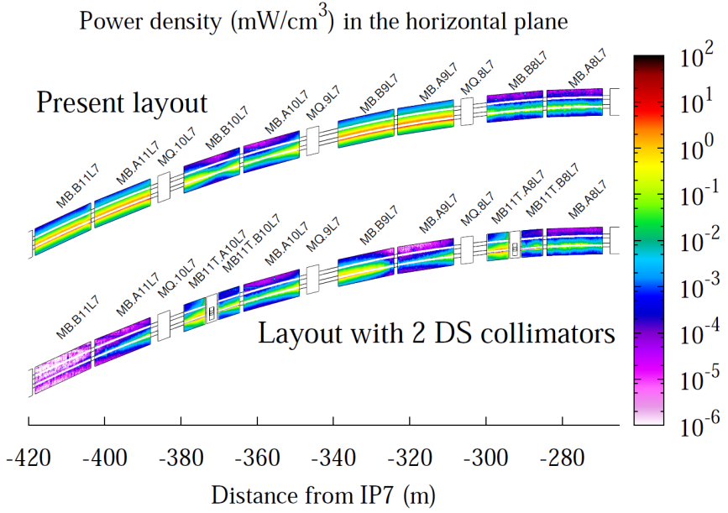
Fig. 6: Simulated power density map in the horizontal plane of DS dipoles for nominal 7 TeV operation and a beam lifetime of 0.2h (4.5e11 protons lost per second). Comparison of the present layout and a layout with 2 TCLDs. Results correspond to relaxed collimator settings. Beam direction is from the right to the left. From [40].
TCLD collimators also make the cleaning performance more robust against various error of the collimation system, the optics, and orbit [65], as they remove the off-momentum particles at the first high dispersion location downstream of IR7. This is of particular concern for the ATS optics that requires modified optics in the cold arcs. Indeed, for the HL baseline optics, this solution almost eliminates losses around the ring coming from the telescopic squeeze. Should the total intensity be limited by collimation cleaning, the factor 10 quoted above would translate into the same gain factor for the total stored beam energy.
Furthermore, the improvement in cleaning could be very beneficial for the LHC operation even if not limited by the collimation losses. For example, a better cleaning performance might allow relaxing the opening of some secondary collimators with a subsequent reduction of the machine impedance. It should be noted also that the DS collimation solution might also mitigate issues related to radiation damage of cold magnets protected by the TCLD collimators and the activation of near-by components.
The real need for this gain can only be addressed after having accumulated beam experience at higher energies during the post-LS1 operation (including beam tests of quench limits at energies close to 7 TeV). On the other hand, a recent collimation project review recommended to pursue with high priority the preparation of DS collimation in IR7 [59].
Even if the full performance improvement provided by the DS collimation solution in IR7 relies on 2 TCLD collimators per side, alternative solutions based on one single unit are being considered as possible “staged” deployment in IR7, in case of performance limitations during high intensity proton operation were made apparent by the post-LS1 operation experience.
The TCLD collimators design is derived from the one of the standard LHC collimators [66], in particular it incorporates the latest design improvements, such as in-jaw BPMs. TCLD collimators require a reduced set of controls cables because each jaw will be moved with one single motor but still require cooling water and baking equipment. The key parameters are listed in Table 2. Although some design features are less demanding, also due to lower losses compared to other collimators, integration design aspects are much more complicated due to their location between cold elements.
The new baseline that relies on shorter 11 T dipoles has been reviewed from the integration point of view [12]. The space is tight and the length of all components and transitions must be carefully optimized. The present baseline is that the TCLD will have an active jaw length of 80 cm that proved to be sufficient to improve the cleaning in all relevant cases. Tungsten heavy alloy is assumed for the material because the TCLD will rarely be exposed to large beam load, so there is no need at this stage to consider advanced materials. From the RF view point, designs with transverse RF finger (as in the present system) as well as with ferrite blocks to absorb high order modes (as in the collimators with BPMs) are being comparatively assessed. A possible design is shown in Figure 7, where a detail of the collimator jaw extremity is given.

Table 2: Key parameters of TCLD collimators
Characteristics | Units | Value
Jaw active length | mm | 80
Jaw material | -- | Inermet 180
Flange-to-flange distance | mm | TBD
Number of jaws | -- | 2
Orientation | -- | Horizontal
Dipole replaced by 11 T dipole/TCLD | -- | MB.B10
Number of BPMs per jaw | -- | 2
RF damping | -- | Fingers or ferrite
Cooling of the jaw | -- | Yes
Cooling of the vacuum tank | -- | No
Minimum gap | mm | < 2
Maximum gap | mm | > 45
Stroke across zero | mm | > 4
Number of motors per jaw | -- | 1
Angular adjustment | -- | No
Transverse jaw movement (5th axis) | -- | No

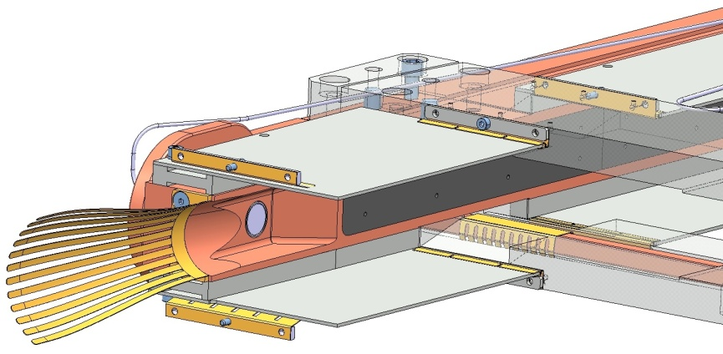
Fig. 7: Detail of one corner of the TCLD collimator to be installed in the DS between two new 11 T dipoles. The present design foresees an 80 cm long jaw made of tungsten (the first of 4, 20 cm tungsten tiles is shown) and will have 2 jaws. Designs with transverse RF fingers or ferrite tiles are being comparatively assessed to reduce the detrimental effects of trapped RF modes.

Upgrades for improved cleaning of physics debris close to experiments
Collision products emerging from the interaction points might be lost in the matching sections and the dispersion suppressors (DSs) around the experiments. In particular, protons that changed their magnetic rigidity represent a source of local heat deposition in the first DS cells where the dispersion function starts rising. These physics debris losses may pose a certain risk of inducing magnet quenches.
Mechanisms with similar effects occur also during heavy-ion operation [52, 53, 54, 12]. Secondary ion beams with a changed magnetic rigidity are created when ions undergo ultra-peripheral interactions at the collisions. The dominating processes are bound-free pair production (BFPP), where electron-positron pairs are created and an electron is caught in a bound state by one (BFPP1) or both (BFPP2) nuclei, thus changing their charge, and 1- or 2-neutron electromagnetic dissociation (EMD1 and EMD2) where one of the colliding ions emits one or 2 neutrons, respectively, thus changing mass. Further photo-induced processes also take place, but the four ones mentioned here have the higher cross sections. An example of ion beams produced in collisions of ²⁰⁸Pb⁸²⁺ nuclei in IR2 is given in Figure 8.
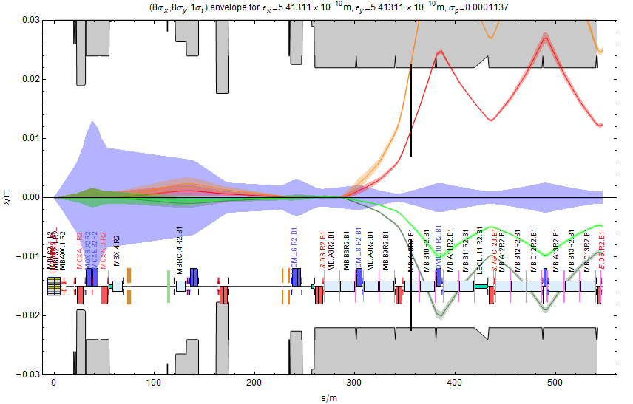
Fig. 8: 1-σ envelope of the main Pb⁸²⁺ beam (violet) together with the dispersive trajectories of ions undergone BFPP1 (red), BFPP2 (orange), EMD1 (light green) and EMD2 (dark green) coming out of the ALICE experiment in nominal optics. The DS collimator appears as a black line. Varying its opening allows different secondary beams to be intercepted.
As can be seen, these secondary beams are lost very locally due to the discrete change of magnetic rigidity and may pose a risk of inducing magnet quenches [54,62]. For the LS2 ALICE upgrade, aiming at a peak luminosity of 6 x 10²⁷cm⁻²s⁻¹ (about 6 times higher than the nominal one), the dominant Bound-Free Pair Production (BFPP1) beam can carry about 150W, resulting in a power load in the coils of the MB.B10 dipole of about 50 mW/cm³ [67]. This is about a factor 2 above the quench limit according to figures presented at a recent collimation review [59]. Similar losses occur also in IR1 and IR5 during ion operation.
A strategy to eliminate any risk of quenches in the experimental IRs, both for proton and heavy-ion runs, is the installation of TCLD collimators in the DS to catch ions beams before they reach the magnets, as schematically shown in Figure 8. For heavy-ion operation, one collimator per side of the experiment would be sufficient to effectively intercept the secondary beams from the most dominant processes in a location where these ions are well separated from the main beam.
Extensive energy deposition simulations in IR2, where MB.A10 is substituted by a pair of 11 T magnets and a TCLD collimator, confirm this assumption [62, 67]. The proposed TCLD collimator installation, with a jaw based on 80 cm of a tungsten heavy alloy, is expected to reduce by more than a factor 100 the peak power density in the new 11 T dipoles compared to the power density in cold dipoles with the present layout with old dipoles and no TCLD collimators [67]. DS collimation in IR2 is therefore considered necessary for the ALICE detector upgrade.
Different jaw lengths and materials have been comparatively addressed for the specific case of ions in IR2 by using as a figure of merit the reduction factor of losses in the DS dipoles [67]. Simulations show that 50 cm of Copper would suffice (see for example the results presented at the collimation review [59]). However, in order to minimize design effort and production works both for the collimator and for the design of the cryo by-pass, the same length of 80 cm adopted for the TCLD in IR7 (see Table 2) is also used as a baseline for the TCLD collimators in the experimental IRs. For the jaw material, the tungsten alloy Inermet 180 is used as baseline for IR7. Should the Cu design be easier/less costly, it could be considered for the IR2 implementation.
For high-intensity proton operation, the losses observed around IR1 and IR5 can be reduced with 2 TCLD collimators per IR side. The need for such implementation depends on the dipole quench limits and on the effectiveness of the physics debris collimation with TCL collimators. Layouts based on TCL collimators only might be sufficient but this requires further studies with the latest HL-LHC Ir layouts. The TCLDs would then complement the present system of TCLs, which are installed in the straight section, where the local dispersion from the collision point is low.

Upgrades for improved impedance
The LHC impedance budget is largely dominated by the contribution of the LHC collimators. For this reason, the present collimation system has been conceived in a way that it can be easily upgraded to reduce the impedance [55]: every secondary collimator slot in IR3 and IR7 features a companion slot for the future installation of a low-impedance secondary collimator. A total of 22 slots (IR7) and 8 slots (IR3) are already cabled for a quick installation of new collimators – referred to as TCSMP in the present database naming convention – that can either replace the present TCSGs or be used together with them. Partial preparation of these slots is on-going in LS1.
The importance of minimizing the machine impedance for the HL-LHC has been emphasized in [56, 57, 58] and also in a recent collimation project review [59]. We therefore foresee that, by the time of the full HL-LHC implementation (LS3), some or all the available TCSMP slots might be equipped with advanced collimators using new materials, and possibly coating, to reduce the impedance. A staged installation starting already after LS1 is possible.
Secondary collimators in the betatron cleaning insertion also have a crucial role in the LHC machine protection and might be exposed to large beam losses. Therefore, new material choices and designs must be robust also against beam failure (at least the ones exposed to horizontal losses). The driving requirements for the development of new materials are thus (1) low resistive-wall impedance in order to avoid beam instabilities, (2) high cleaning efficiency, (3) high geometrical stability to maintain the extreme precision of the collimator jaw during operation despite temperature changes and (4) high structural robustness in case of accidental events like single-turn losses. It is interesting to note that several of these requirements are shared with other advanced thermal management applications, so that the object of this R&D program may have interesting spin-off effects in several fields, e.g. aerospace, medical applications, nuclear, electronics etc.
A new family of materials, with promising features, has been identified: metal (carbide)-carbon composites. These materials combine the outstanding thermal and physical properties of two carbon allotropes, diamond or graphite, with the electrical and mechanical properties of metal and transition metal-based ceramics. The best candidates are Copper-Diamond (Cu-CD) and Molybdenum Carbide -Graphite (Mo-Gr), shown in Figure 9. In particular, Mo-Gr may provide interesting properties regarding operating temperature, thermal shock resistance and, thanks to its availability in a wide range of mass density, also energy absorption capability. Additionally, this material may be effectively coated with pure Molybdenum, dramatically decreasing the RF impedance contribution of future collimators. The addition of carbon fibres increases the mechanical strength of Mo-Gr. The mechanical stability of a material sample under the impact of highly energetic particle pulses has been verified through a detailed experiment at CERN HiRadMat facility [29, 30].
The present baseline for the upgraded secondary collimators relies thus on a Molybdenum Carbide- Graphite (MoGr) composites, possibly coated with pure Mo. Other lower Z refractory coatings are presently under study. The Mo coating considered now would reduce the surface resistivity by about a factor 10 to 20 compared to Mo-Gr and by more than a factor 100 compared to CFC. The benefit on the impedance budget of the collimation system would be significant: in the relevant frequency range, impedance would be reduced to 10 % of the one of the CFC jaws [60], as illustrated in Fig. 10.
On the other hand, the new design and materials [61] must be validated for operation. Material properties and the coating options have to be validated for the operation in the LHC. For this purposes, a rich program of validation is in progress, involving:
- tests at HiRadMat, covering both material samples as well as full jaw validation;
- mechanical engineering prototyping;
- beam tests at the LHC, planned for 2016 (collimation installation in the 2015 shutdown).
In addition to the impedance improvements, the new TCSPM also feature a number of improvements in the mechanical design (Fig. 11) [61]. They incorporate the BPM button design. The key hardware parameters are listed in Table 3.
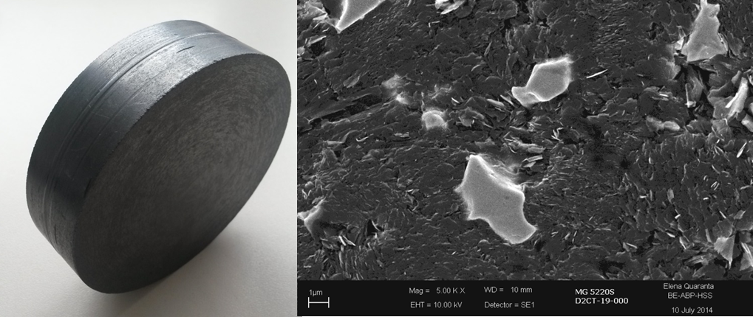
Fig. 9: MoGr plate recently produced by Brevetti Bizz, Italy (left). Dimensions of the plate: 90mm diameter and 24.3mm thickness. It is a massive piece prepared in view of the production of the LHC collimator jaw inserts. A detail of the microstructure is shown on the right side, where the graphite flakes matrix well sintered with the carbon fibers is visible together with few molybdenum carbide “islands” of about 5μm length.
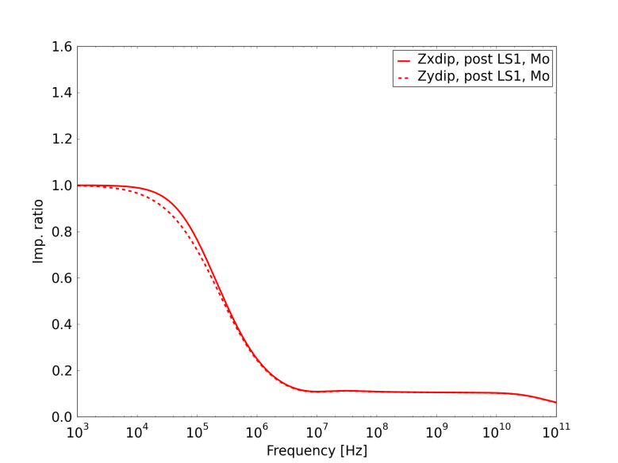
Fig. 10: Collimation impedance versus frequency: impedance ratio between Mo coating on Mo-Gr (50 m layer) and present CFC jaw. A secondary collimator is considered. Courtesy of N. Mounet.

Fig. 11: Preliminary design of the TCSMP jaw. This features 10 MoGr blocks. Also note lengthened jaw taperings, futhere reducing contribution to HOM RF instabilities in the geometrical transition zones.

Table 3: Parameters of TCSMP collimators
Characteristics | Units | Value
Jaw active length | mm | 1000
Jaw material | -- | MoGr (TBD)
Flange-to-flange distance | mm | 1480
Number of jaws | -- | 2
Orientation | -- | Horiz., vert., skew
Number of motors per jaw | -- | 2
Number of BPMs per jaw | -- | 2
RF damping | -- | Fingers
Cooling of the jaw | -- | Yes
Cooling of the vacuum tank | -- | Yes
Minimum gap | mm | < 1
Maximum gap | mm | > 60
Stroke across zero | mm | > 5
Angular adjustment | -- | Yes
Jaw coating | -- | Mo (TBC)
Transverse jaw movement (5th axis) | mm | +/- 10

Upgrades to the collimation of the incoming beam collimation in the experimental IRs
The LHC Run 1 operation period has shown that protection of the insertion regions (IRs) is a key asset for the machine performance: the available aperture, to be protected in all operational phases, determines the collimation hierarchy. The present tertiary collimators (TCTP, Target Collimator Tertiary with Pickup) are made of a heavy tungsten alloy (Inermet 180). They effectively protect the elements downstream but are not robust against high beam losses, in particular during very fast beam failures which might occur if the beam dumping system does not trigger synchronously with the abort gap (an asynchronous beam dump). Setting margins are added to the collimator hierarchy to minimise the risk of exposure of TCTPs to beam losses in case of such failures [3]. A design with improved robustness would allow reducing these margins and, as a result, pushing further the β* performance of the LHC, in particular for the HL optics baseline (ATS) that features an unfavourable phase between dump kickers and triplet magnets.
In addition, the HL-LHC updated IR layout puts additional aperture constraints [2, 3]: up to 4 more tertiary collimators might be required in IR1/5 to protect the Q4 and Q5 quadrupole magnets, in addition to those installed in the present layout (2 TCTP collimators – one horizontal and one vertical – protect the inner triplet). The present baseline under study includes a pair of new collimators in front of the Q5. On-going studies are addressing (1) the need for additional Q4 protection and (2) the need to keep tertiary collimators at the present locations in case additional tertiaries are added upstream.
A new design of tertiary collimators, referred to as TCTPM (Target Collimator Tertiary with Pick-up Metallic), is under study to address the new challenges. This design will be based on novel materials to improve the collimator robustness while ensuring adequate absorption, adequate cleaning and protection of the elements downstream. The TCTPM design and material choice must also take impedance constraints under consideration to keep the collimator impedance under control. A summary of the technical key parameters are given in Table 4.
The experimental experience of beam impacts on collimator material samples at HiRadMat [4, 5] indicates that a Molybdenum-Graphite (MoGr) composite can improve the TCTP robustness by a factor several hundreds. Note that the present Inermet design is expected to undergo severe damage requiring a collimator replacement if hit by one single LHC nominal bunch of 10¹¹ proton at 7 TeV. Other advanced materials are being studied as possible alternatives to further improve the robustness. The HL beam parameters with larger charge and smaller emittance pose additional challenges in terms of beam damage potential.
Despite being less critical because of the larger β* values, upgraded TCTP’s are under consideration also for IR2/8.
Table 4: Equipment parameters of the TCTPM
Characteristics | Units | Value
Jaw active length | Mm | 1000
Jaw material | -- | MoGr (TBD)
Flange-to-flange distance | Mm | 1480 (to be reviewed)
Number of jaws | -- | 2
Orientation | -- | Horiz., vert.
Number of motors per jaw | -- | 2
Number of BPMs per jaw | -- | 2
RF damping | -- | Fingers
Cooling of the jaw | -- | Yes
Cooling of the vacuum tank | -- | Yes
Minimum gap | mm | < 1
Maximum gap | mm | > 60 (to be reviewed)
Stroke across zero | mm | > 5
Angular adjustment | -- | Yes
Jaw coating | -- | No
Transverse jaw movement (5th axis) | mm | +/- 10 mm (at least)

Advanced collimation concepts
Other advanced collimation concepts that still require R&D and therefore cannot be considered yet as a baseline are discussed in this section.

Halo diffusion control techniques
The 2012 operational experience indicates that the LHC collimation would profit from halo control mechanisms. These were used in other machines like HERA and Tevatron. The idea is that, by controlling the diffusion speed of halo particles, one can act on the time profile of the losses, for example by reducing rates of losses that otherwise would take place in short time, or simply by controlling the static population of halo particles in a certain aperture range. These aspects were recently discussed at a collimation review on the possible usage of the hollow e-lens collimation concept at the LHC [41], where it was concluded that hollow e-lenses could be used at the LHC for this purpose. In this case, a hollow electron beam, running parallel to the proton or ion beam, is used to generate an annular beam in the transverse (x,y) plane. This hollow beam produces an electromagnetic field affecting only halo particles above a particular transverse amplitude and can change their transverse speed. The conceptual working principle is illustrated in the left part of Figure 12. A solid experimental basis achieved at the Tevatron indicates this solution is promising for the LHC ([42] and reference therein).
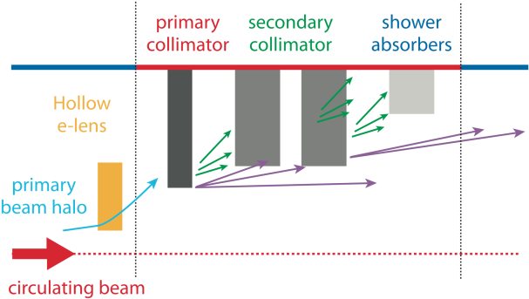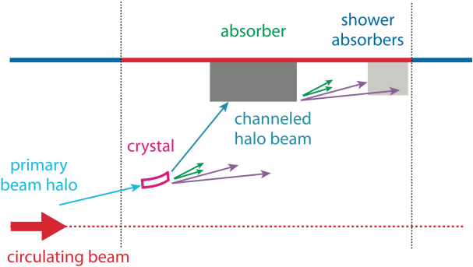
Fig. 12: Illustrative view of the collimation system with integrated hollow e-lens or equivalent halo diffusion mechanism (left) and of an ideal crystal-based collimation (right). A reduced collimator layout than the one in Fig. 1 is adopted to show the betatron cleaning functionality only (one side only). Halo control technics are used to globally change the diffusion speed of halo particles and rely on the full collimation system remaining in place. Crystals entail a change of concept where the whole beam losses are concentrated, ideally, in one single beam absorber per plane.
The potential advantages of the electron lens collimation are several:
- Control of the primary loss rates, with potential mitigation of peak loss rates in the cold magnets, for a given collimation cleaning. Peak power losses on the collimators themselves can be optimized as well.
- Controlled depletion of beam tails, with beneficial effects in case of fast failures.
- Reduction of tails population and therefore peak loss rates in case of orbit drifts.
- Beam scraping at very low amplitudes (>3σ) without damage risk as for bulk scrapers.
- Tuning of the impact parameters on the primary collimators with possible improvement in cleaning efficiency.
Since the main beam core is not affected, the HEBC operation is transparent for the luminosity performance if this technique works as designed.
The usage of HEBC requires the collimation system in place in order to dispose of the tail particles expelled in a controlled way by the HEBC. No losses occur at the HEBC location and the tail control mechanism can be put in place in any ring location. Larger beam size locations are favourable as they entail reduced alignment accuracy for the hollow beam. The IR4 is considered as a best candidate for two HEBC devices due to cryogenics availability, low-radiation environment, and quasi-round beam.
While the functionality of HEBC will provide clear benefits for the LHC operation, the real need for such scheme at the LHC and HL-LHC has to be addressed after gaining sufficient operational experience at energies close to 7 TeV on quench limits, beam lifetime and loss rates during the operational cycle, and collimation cleaning. Fast failure scenarios of the crab cavities require a low tail population above about 4 beam sigma: HEBC is the only technique solidly validated experimentally in other machines that could ensure a safe operation in this case.
The HEBC is targeted at enabling active control of beam tails above 3 beam sigma, with tail depletion efficiencies of the order of 90 % over times of tens of seconds, in all phases of the operational cycle, specifically before and after beams are put in collision.
The HEBC implementation should ensure (1) the possibility to pulse the current turn-by-turn (as required to drive resonances in the linear machine before beams are in collision); (2) a train-by-train selective excitation (leaving “witness” trains with populated halos for diagnostics and machine protection purposes).
The main systems/components of a HEBC can be summarized as:
- Electron beam generation and disposal: electron gun and collector, with the required powering.
- Several superconducting and resistive magnets: solenoids, dipoles and correctors to stabilize and steer the electron beam.
- Beam instrumentation for the optimization of the electron beam.
The parameters listed here are extracted from the conceptual design document [68] compiled by the colleagues from FNAL who worked on this topics within the US-LARP collaboration. A detail engineering design is now on-going at CERN. The first goal will be to define the volumes for a 3D integration into the LHC.
Table 5: Equipment parameters of the HEBC from [68]
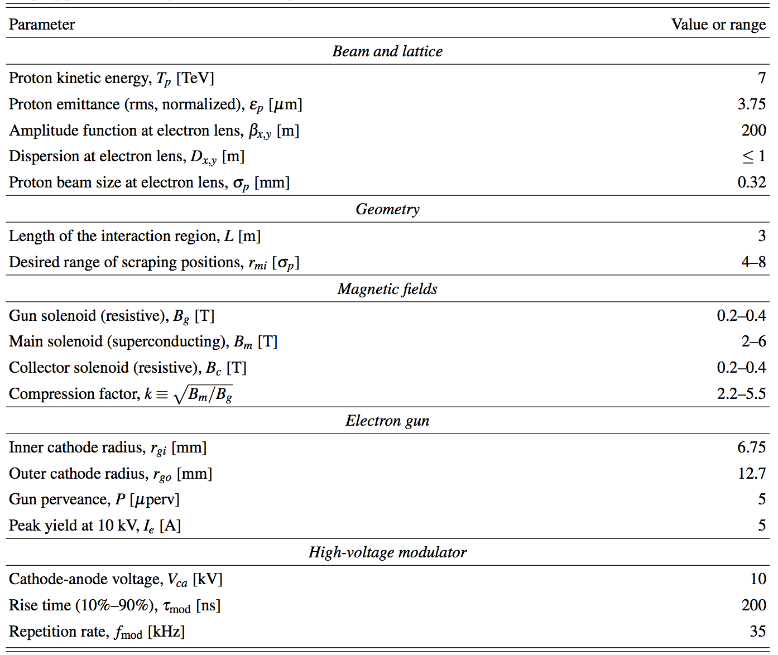

At the collimation review [41], it became clear that, if loss spikes were limiting the LHC performance after LS1, the hollow e-lens solution would not be viable because it could only be implemented in a next long shutdown at the earliest (driven by time for the integration into the cryogenics system). It is therefore crucial to work on viable alternatives that, if needed, might be implemented on an appropriate time scale. Two alternatives are presently being considered:
- Tune modulation through a ripple in the current of lattice quadrupoles;
- Narrow-band excitation of halo particles with the transverse damper system.
Though very different from the hardware point of view, both these techniques rely on exciting tail particles through resonances induced in the tune space by appropriate excitations. This works in the assumption of a presence of a well-known and stable correlation between halo particles with large amplitudes and corresponding tune shift in tune space (de-tuning with amplitude). Clearly, both methods require a solid experimental verification in a very low noise machine like the LHC, in particular to demonstrate that this type of excitations do not perturb the beam core emittance. Unlike hollow e-lenses, that act directly in the transverse plane by affecting particles at a amplitudes above the inner radius of the hollow beam, resonance excitation methods required a good knowledge of the beam core tune even in dynamic phases of the operational cycle, so the possibility to use these techniques at the LHC remains to be demonstrated. For this purpose, simulation efforts are on-going with the aim of defining the required hardware interventions during LS1 that might enable beam tests of these two halo control methods early on in 2015. Ideally, these measurements would profit from appropriate halo diagnostic tools. However we are confident that conclusive measurements could be achieved with the techniques describe for example in [5].

Crystal collimation
Highly pure bent crystal can be used to steer high-energy particles that get trapped between the potential of parallel lattice planes. Equivalent bending fields up to hundreds of Tesla can be achieved in crystals with a length of only 3-4 mm, which allows in principle to steer halo particles to a well-defined point. As opposed to a standard collimation system based on amorphous materials, requiring several secondary collimators and absorbers to catch the products developed through the interaction with matter (Figure 1), one single absorber per collimation plane is in theory sufficient in a crystal-based collimation system [43]. This is shown in the scheme in Figure 12 (right). Indeed, nuclear interactions with well-aligned crystals are much reduced compared to a primary collimator, provided that high channeling efficiencies of halo particles can be achieved (particles impinging on the crystal to be channelled within a few turns). This is expected to reduce significantly the dispersive beam losses in the DS of the betatron cleaning insertion compared to the present system that is limited by the leakage of particles from the primary collimators. Simulations indicate a possible gain between 5 and 10 [44] even for a layout without an optimized absorber design. The crystal collimation option is particularly interesting for collimating heavy-ion beams thanks to the reduced probability of ion dissociation and fragmentation compared to the present primary collimators. SPS test results are promising [45].
Another potential of crystal collimation is a strong reduction of the machine impedance due to the facts that (1) only a small number of collimator absorbers is required and that (2) the absorbers can be set at much larger gaps thanks to the large bending angle from the crystal (40-50 μrad instead of a few μrad from the multiple-Coulomb scattering in the primary collimator). On the other hand, an appropriate absorber design must be conceived in order to handle the peak loss rates in case of beam instabilities: the absorber must withstand continuous losses up to 1 MW during 10 s while ensuring the correct collimation functionality. This is a change of paradigm compared to the present system where such losses are distributed among several collimators. Other potential issues concern the machine protection aspects of this system (the implications if the crystal is not properly aligned and so channels an large fraction of the total stored energy to the wrong place) and the operability of the system that requires mechanical angular stability in the sub-μrad range to be ensured through the operational cycle of the LHC (injection, ramp, squeeze and collision).
Promising results have been achieved in dedicated crystal collimation tests at SPS performed from 2009 within the UA9 experiment [45, 46, 47]. On the other hand, some outstanding issues about the feasibility of the crystal collimation concept for the LHC can only be addressed by dedicated beam tests at high energy in the LHC. For this purpose, a study at the LHC has been proposed [48]: two goniometers housing crystals have been installed in IR7 during LS1 for horizontal and vertical crystal collimation tests. The main purpose of beam tests at the LHC is to demonstrate the feasibility of the crystal-collimation concept in the LHC environment, in particular to demonstrate that such a system can provide a better cleaning of the present high-performance system throughout the operational cycle. Until a solid demonstration is achieved, crystal collimation schemes cannot be considered for future HL-LHC baseline scenarios.

Improved optics scenarios for the collimation insertions
Alternative optics concepts in IR7 can be conceived in order to improve some present collimation limitations without major hardware changes. For example, non-linear optics schemes derived from the linear collider experience [49] were considered for IR7. The idea is that one can create a “non-linear bump” that deforms the trajectories of halo particles and effectively increases their transverse amplitudes in a way that allows opening the gaps of primary and secondary collimators. These studies are well advanced from the optics point of view but for the moment it was not easily possible to find a layout solution providing the same cleaning as the present system [50]. These studies, and other aimed at increasing the beta functions at the collimators, are on-going.

Rotatory collimator design
The rotatory collimator design developed at SLAC proposes a “consumable collimator” concept based on 2 round jaws with 20 flat facets that can be rotated to offer to the beam a fresh collimator material in case a facet is damaged [27]. This design features a low-impedance and is based on standard non-exotic materials. It is conceived for a high-power operation, with a performing 12 kW active cooling system to withstand the extreme power loads experienced by the secondary collimators in IR7. A photograph of this device before closing the vacuum tank is given in Figure 11, where the rotatory glidcop (a copper alloy) jaws are visible. The first full-scale prototype of this advanced collimator concept has recently been delivered to CERN [28] and is being tested in preparation of beam tests. The ultimate goal is to validate the rotation mechanism after high-intensity shock impacts at the HiRadMat facility, aimed at demonstrating that the concept of consumable collimator surface can indeed work for the LHC beam load scenarios. The precision accuracy of this prototype and the impedance are also being tested together with its vacuum performance. The vacuum measurements indicated that the SLAC prototype is suitable for installation in the SPS or even LHC. Optimum strategy for beam tests is being established based on these new results.
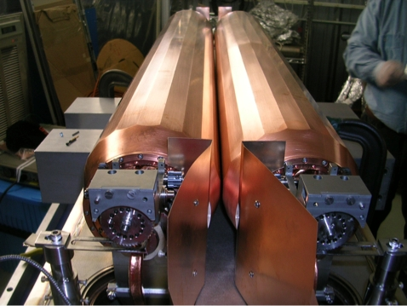
Fig. 8: Photograph of the SLAC rotatory collimator prototype jaws before assembly in the vacuum tank. Courtesy of T. Markiewicz (SLAC).

Other collimators of the present system required in HL-LHC
It is important to realize that more than 60 % of the LHC collimators, not in the present collimation upgrade besaline described above, must remain reliably operational for the HL-LHC era (see lists in Table. 1). Even devices whose design is deemed adequate for the HL-LHC parameters, can hardly survive for the lifetime of the LHC machine without appropriate maintenance (or even without being replaced). A long-term strategy must be put in place order to ensure that the LHC collimation system can meet the performance and availability challenges of the HL-LHC project. In this section, the LHC collimators that must are needed also for HL-LHC, possibly with improved design and features, are described.

IR3 and IR7 primary collimators (TCP, TCPP)
Carbon-based primary collimators (TCP, Target Collimator Primary) are used in the LHC to define the primary beam halo cut in the momentum (IR3) and betatron (IR7) cleaning insertion. One TCP collimator per beam is used in IR3 (horizontal orientation) whereas 3 collimators are used in IR7 (horizontal, vertical and skew orientations) for a total of 8 primary collimators in the LHC. Since these collimators are the closest ones to the circulating beams, their jaws are built with a robust Carbon-Fibre Composite (CFC) that is designed to withstand the design LHC failure scenarios at injection (full injection train of 288 bunches impacting on one jaw) and at 7 TeV (up to 8 bunches impacting on one jaw in case of an asynchronous dump) [1]. The need to improve the TCP collimator design in view of the updated beam parameters for the HL-LHC design is being assessed.
The LHC primary collimator upgrade might be needed for HL-LHC if the present design:
- proved not to be adequate to cope with the design LHC failure scenarios updated for the upgraded HL-LHC beam parameters (larger bunch intensity and smaller emittances);
- proved not to be adequate for standard operational losses with a larger stored beam energy in HL-LHC: for the same assumed minimum beam lifetime in operation, the total loss rates expected on the collimators might be up to a factor 2 larger for HL-LHC than for LHC;
- can be improved in a way that HL-LHC could profit from; e.g. improved materials or improved alignment features (integrated BPMs) for a more efficient operation.
The primary collimators are a fundamental element of the LHC multi-stage collimation hierarchy and are required in all operational conditions with beam in the machine. These are therefore high-reliability devices that must be compatible with operation in very high radiation environments and withstand standard operational losses and relevant failure cases without permanent damage that can jeopardize their functionality.
Note that presently a design with BPM-integrated jaw for primary collimators is being studies within the collimation project. This design, referred to as TCPP (TCP with Pick-up) uses for the moment the same CFC materials for the jaw but provides greatly improved operational features in terms of alignment speed and beam position monitoring. This design is considered also for HL upgrades.

IR3 and IR7 secondary collimators (TCSG)
Carbon-based secondary collimators (TCSG, Target Collimator Secondary Graphite) are used in the LHC as secondary stage of the beam halo cut in the momentum (IR3) and betatron (IR7) cleaning insertion. Four secondary collimators per beam are used in IR3 whereas 11 collimators are used in IR7 for a total of 30 TCSG collimators in the LHC. Horizontal, vertical and skew orientations are used in different locations. Since these collimators are among the closest ones to the circulating beams, their jaws are built with a robust Carbon-Fibre Composite (CFC) that is designed to withstand the same design LHC failure scenarios at injection and at 7 TeV as the primary collimators.
The present baseline for HL-LHC is that new secondary collimators, TCSPM, based on advanced robust and low-impedance materials will be added in IR3 and IR7, using existing TCSM slots [2]. In this scenario, the need to maintain operational the present CFC secondary collimators remains to be assessed. This depends for example on whether the new TCSPM collimators will be able to withstand the injection failure scenario. These aspects are presently under study.

IR3 and IR7 active shower absorbers collimators (TCLA)
Tungsten-based shower absorbers collimators (TCLA, Target Collimator Long Absorber) are used in the LHC as third or forth stage of cleaning of beam halos in the momentum (IR3) and betatron (IR7) cleaning insertion. Four TCLA collimators per beam are used in IR3 whereas five collimators are used in IR7 for a total of 18 TCLA collimators in the LHC. Horizontal and vertical orientations are used depending on the location. Operationally, these collimators are not supposed to intercept primary or secondary beam losses. They are therefore built using a heavy tungsten alloy that maximises efficiency in cleaning but that it is not robust. The need to improve the TCLA collimator design in view of the updated beam parameters for the HL-LHC design is being assessed.
The upgrade of the LHC shower absorber collimators might be needed for HL-LHC if the present design:
- proved not to be adequate for the standard operational losses with a larger stored beam energy in HL-LHC: for the same assumed minimum beam lifetime in operation, the total loss rates expected on the collimators might be up to a factor 2 larger for HL-LHC than for LHC;
- can be improved in a way that HL-LHC could profit from; e.g. improved materials or improved alignment features (integrated BPMs) for a more efficient operation.
The TCLA collimators are an important element of the LHC multi-stage collimation hierarchy and are required in all operational conditions with beam in the machine. Operation can continue temporarily in case of isolated TCLA failures but, since they are an essential ingredient for the collimation cleaning performance, we assumed here that HL operation for physics without TCLA collimators will not be possible. These are therefore high-reliability devices that must be compatible with operation in very high radiation environments and withstand standard operational losses and relevant failure cases without permanent damage that can jeopardize their functionality.
As a joint study with the LHC dump team, is has been proposed to consider the addition of two TCLA collimators per beam in IR6 in order to improve the protection of the Q4 and Q5 magnets immediately downstream of the dump protection devices [69]. The results indicate that this improvement was not necessary for the post-LS1 operation. The requirements for HL will be reviewed in 2015.

IR6 secondary collimators with pick-up (TCSP)
Carbon-based secondary collimators with pick-up buttons (TCSP, Target Collimator Secondary with Pick-up) are used in the LHC IR6 insertion as a part of the LHC protection system. Two collimators are used in the LHC, one per beam, as auxiliary dump protection device in the horizontal plane. In LS1, the TCSG design without integrated beam position monitors (BPMs) was replaced with the new one with BPMs for improved alignment and local orbit monitoring. Since these collimators are among the closest ones to the circulating beams, and are expected to be heavily exposed to beam losses in case of asynchronous dumps, their jaws are built with a robust Carbon-Fibre Composite (CFC) that is designed to withstand the design LHC failure scenarios at injection (full injection train of 288 bunches impacting on one jaw) and at 7 TeV (up to 8 bunches impacting on one jaw in case of an asynchronous dump). The need to improve the IR6 TCSP collimator design in view of the updated beam parameters for the HL-LHC design is being assessed.

Passive absorbers in IR3 and IR7 (TCAPA, TCAPB, TCAPC, TCAPD)
Tungsten-based passive shower absorbers collimators (TCAP, Target Collimator Absorber Passive) are used in the LHC as fixed-aperture collimators in the momentum (IR3) and betatron (IR7) cleaning insertion to reduce radiation doses to the warm quadrupole and dipoles in these insertions. Two TCAP collimators per beam are used in IR3 whereas three collimators are used in IR7 for a total of 10 TCAP collimators in the LHC. Four variants of these collimators exist to match the dimensions and orientations of the aperture of the adjacent warm magnets: TCAPA, TCAPB, TCAPC, TCAPD. Operationally, these collimators are not supposed to intercept primary or secondary beam losses but rather to absorb shower products generated by halo particles impinging on primary and secondary collimators. They are built using a heavy tungsten alloy that maximises shower absorption, surrounded by copper. The need to improve the TCAP collimator design in view of the updated beam parameters for the HL-LHC design is being assessed.
The TCAP collimators ensure that doses on warm magnets in the cleaning insertions are minimized. Doses are determined by the integrated luminosity and therefore the possibility to improve the warm magnet protection must be envisaged for the HL-LHC luminosity goal. The upgrade of the passive absorber collimators might be needed for HL-LHC if the present design:
- proved not to be adequate for the standard operational losses at higher in HL-LHC;
- can be improved by increasing the lifetime of warm magnets due to radiation wear, e.g. thanks to improved materials or collimator improved layouts and designs.

Tertiary collimators with pick-up in the experimental regions (TCTP)
Tungsten-based tertiary collimators with pick-up buttons (TCTP, Target Collimator Tertiary with Pick-up) are used in the LHC to protect the superconducting triplets and the experiments in each experimental insertion against horizontal (TCTPH) and vertical (TCTPV) beam losses. A pair of TCTPH and TCTPV collimators is installed in front of each triplet, on the incoming beam, for a total of sixteen (16) collimators in the LHC. The new design with BPM-embedded jaws has been adopted in all IRs during LS1 and is expected to provide crucial improvement to the LHC performance in terms of IR flexibility (faster alignment) and beta* reach (more precise orbit control).
Operationally, tertiary collimators are not supposed to intercept primary or secondary beam losses. They are therefore built using a heavy tungsten alloy that maximizes efficiency in cleaning but that it is not robust. This is an important concern for TCTP’s because they might be exposed to single-turn beam losses in case asynchronous beam dumps. The need to improve the TCTP collimator design in view of the updated beam parameters for the HL-LHC design is being assessed. The possibility to replace TCTP’s with new collimators that use most robust materials is envisaged before LS3 for the most exposed collimators.
The present baseline for HL-LHC is that new tertiary collimators, TCTPM, based on advanced, more robust materials will be used in the experimental regions. Existing TCTP’s might be reused in the IRs as TCL collimators or as tertiary collimators if the present design/material prove to be adequate. Present collimators could also be used in other IRs where new materials are not needed, by adding the feature of the BPM (e.g., as TCLA collimators in IR3 or IR7).

Physics debris collimators in the experimental regions (TCL)
Physics debris absorbers (TCL, Target Collimator Long) are used in IR1 and IR5 to protect the matching sections and the dispersion suppressor from beam losses caused by collision product. The LHC IR layouts as of 2015 feature 3 horizontal TCL collimators per beam and per IR, for a total of 12 TCL collimators), installed in cells 4, 5 and 6. Their jaws are made of Copper (TCLs in cells 4 and 5) and Inermet 180 (cell6), as the latter were installed by recuperating tertiary collimators replaced in LS1 with the new TCTPs. As explained above, TCL collimators might be re-used for HL-LHC as a similar layout is foreseen.

Acknowledgement
We wish to thank ….

References
[1] | O. Brüning (Ed.) et al., LHC Design Report Vol. 1, CERN-2004-003-V-1.
[2] | R. Assman et al., “The final collimation system for the LHC”, proceedings of EPAC2006, Edinburgh (UK), 2006. Also as CERN-LHC-PROJECT-REPORT-919 (2006).
[3] | R. Bruce et al., “LHC beta* reach in 2012”, LHC Operation Workshop, EVIAN2011, Evian (FR), 2011. http://indico.cern.ch/event/155520
[4] | R. Bruce et al., “Sources of machine-induced background in the ATLAS and CMS detectors at the CERN Large Hadron Collider”, Nuclear Instruments and Methods in Physics Research A 729 (2013) 825–840 .
[5] | G. Valentino et al., “Beam diffusion measurements using collimator scans at the LHC”, Phys. Rev. Spec. Top. Accel. Beams 16 (2013) 021003.
[6] | K.H. Mess and M. Seidel, “Collimators as diagnostic tools in the proton machine of HERA”, Nucl. Instrum. Meth. A351 (1994) 279-285.
[7] | H. Burkhardt, S. Redaelli, B. Salvachua, G. Valentino, “Collimation down to 2 sigmas in special physics runs in the LHC”, proceedings of IPAC2013, Shanghai (China). Also as CERN-ACC-2013-0144 (2013).
[8] | S. Redaelli et al., “LHC collimator controls for a safe LHC operation”, proc. of ICALEPSC2011, Grenoble (FR), 2011. http://accelconf.web.cern.ch/AccelConf/icalepcs2011/papers/wepmu020.pdf
[9] | B. Salvachua et al., “Cleaning Performance of the LHC Collimation System up to 4 TeV”, proc. of IPAC2013, Shanghai (China). https://cds.cern.ch/record/1574583?ln=en
[10] | B. Salvachua et al., “Lifetime analysis at high intensity colliders applied to the LHC,” proc. of IPAC2013, Shanghai (China). http://cds.cern.ch/record/1574586/files/CERN-ACC-2013-0072.pdf
[11] | N. Mounet et al., “Beam stability with separated beams at 6.5 TeV,” proc. of LHC Operations Workshop, EVIAN2012, Evian (Fr). https://indico.cern.ch/getFile.py/access?contribId=18&sessionId=10&resId=0&materialId=paper&confId=211614
[12] | 2013 Collimation Project Review, http://indico.cern.ch/event/251588
[13] | S. Redaelli et al., “Quench Tests at the Large Hadron Collider with Collimation Losses at 3.5 Z TeV,” proc. of HB2012, Beijing (CH). http://accelconf.web.cern.ch/AccelConf/HB2012/papers/mop245.pdf
[14] | Recommendation from the external review panel of the 2013 collimation review. Available here.
[15] | A. Marsili et al., “Simulations and measurements of physics debris losses at the 4 TeV LHC,” proceedings of IPAC2013, Shanghai (China).
[16] | CERN EDMS document 1283867 (2013), also available at http://lhc-collimation-project.web.cern.ch/lhc-collimation-project/LS1/default.php.
[17] | CERN EDMS document 1283826 (2013), also available at http://lhc-collimation-project.web.cern.ch/lhc-collimation-project/LS1/default.php.
[18] | L. Esposito, presentation at the 2nd HiLumi Annual meeting, Frascati (I), 2012. http://indico.cern.ch/event/183635
[19] | L. Esposito, presentation at the 3rd HiLumi Annual meeting, Daresbury (UK), 2012. http://indico.cern.ch/event/257368
[20] | A. Bertarelli et al., “The mechanical design for the LHC collimators,” proceedings of EPAC2004, Lucern (CH), EPAC-2004-MOPLT008.
[21] | S. Redaelli et al., “Final implementation and performance of the LHC collimator control system,” proceedings of PAC09, Vancouver (CA).
[22] | A. Bertarelli et al., “Mechanical design for robustness of the LHC collimators,” proc. of PAC2005, Knoxville (USA). http://accelconf.web.cern.ch/AccelConf/p05/PAPERS/TPAP004.PDF
[23] | F. Carra et al., “LHC collimators with embedded beam position monitors: a new advanced mechanical design,” proc. of IPAC2011, San Sebastian (E), IPAC-2011-TUPS035.
[24] | D. Wollmann et al., “First beam results for a collimator with in-jaw beam position monitors,” proc. of IPAC2011, http://accelconf.web.cern.ch/AccelConf/IPAC2011/papers/thpz027.pdf
[25] | D. Wollmann et al., “Experimental verification for a collimator with in-jaw beam position monitors,” proc. of HB2012, http://accelconf.web.cern.ch/AccelConf/HB2012/papers/mop242.pdf
[26] | G. Valentino et al., “Successive approximation algorithm for BPM-based LHC collimator alignment,” submitted to PRST-AB (2013).
[27] | J. Smith et al., “Design of a rotatable copper collimator for the LHC phase II collimation upgrade,” EPAC2008, Genova (I). http://accelconf.web.cern.ch/AccelConf/e08/papers/mopc096.pdf
[28] | T. Markiewiz, “Status of SLAC RC,” presentation at the 3rd HiLumi annual meeting, Daresbury (UK), 2013. http://indico.cern.ch/event/257368
[29] | A. Bertarelli et al., “First results of an experiment on advanced collimator materials at CERN HiRadMat facility,” proc. of IPAC2013, Shanghai (China). https://cds.cern.ch/record/1635957/files/CERN-ACC-2013-0268.pdf
[30] | A. Bertarelli et al., “An experiment to test advanced materials impacted by intense proton pulses at CERN HiRadMat facility”, Nucl. Instr. Meth. B (2013) http://dx.doi.org/10.1016/j.nimb.2013.05.007
[31] | M. Cauchi et al., “High energy beam impact tests on a LHC tertiary collimator at CERN HiRadMat facility,” submitted to PRST-AB (2013).
[32] | S. Redaelli, “The LHC collimation baseline for HL-LHC,” presentation at the 3rd HiLumi annual meeting, Daresbury (UK), 2013. http://indico.cern.ch/event/257368
[33] | A. Marsili, “Simulations of collimation cleaning performance for HL-LHC optics,” proc. of IPAC2013, Shanghai (China).
[34] | R. Assmann et al., “Accelerator physics concept for upgraded LHC collimator performance,” PAC2009, Vancouver (CA). https://cds.cern.ch/record/1307562/files/EuCARD-CON-2009-047.pdf
[35] | S. Redaelli et al., “Do we really need a collimation upgrade?” LHC Performance Workshop, Chamonix2012, https://indico.cern.ch/event/164089
[36] | 2011 Collimation Project review, https://indico.cern.ch/event/139719
[37] | Review of 11 T dipoles and cold collimation, https://indico.cern.ch/event/155408
[38] | HiLumi-WP5 (collimation) section at the 3rd Joint HiLumi LHC-LARP Annual Meeting, Daresbury (UK), 2013. http://indico.cern.ch/event/257368
[39] | A. Marsili, “Simulated cleaning for HL-LHC layouts with errors”, presentation at the 3rd Joint HiLumi LHC-LARP Annual Meeting, Daresbury (UK), 2013. http://indico.cern.ch/event/257368
[40] | A. Lechner, “Energy deposition with cryo-collimators in IR2 (ions) and IR7”, presentation at the 3rd Joint HiLumi LHC-LARP Annual Meeting, Daresbury (UK), 2013. http://indico.cern.ch/event/257368
[41] | Review of hollow e-lens for the LHC collimation, https://indico.cern.ch/event/213752
[42] | G. Stancari, “Progress towards the conceptual design of a hollow electron lens for the LHC”, presentation at the 3rd Joint HiLumi LHC-LARP Annual Meeting, Daresbury (UK), 2013. http://indico.cern.ch/event/257368
[43] | W. Scandale, “Crystal-based collimation in modern hadron colliders,” Int.J.Mod.Phys. A25S1 (2010) 70-85
[44] | D. Mirarchi et al., “Layouts for crystal collimation tests at the LHC,” proc. of IPAC2013, Shanghai (China) https://cds.cern.ch/record/1573725?ln=en
[45] | W. Scandale et al., “Comparative results on collimation of the SPS beam of protons and Pb ions with bent crystals,” Phys.Lett. B703 (2011) 547-551
[46] | W. Scandale et al., “Optimization of the crystal-assisted collimation of the SPS beam,” Phys. Lett. B726 (2013) 182-186
[47] | W. Scandale et al., “Strong reduction of the off-momentum halo in crystal assisted collimation of the SPS beam,” Phys.Lett. B714 (2012) 231-236
[48] | CERN EDMS document 1329235, LHC-TEC-EC-0001 (2013).
[49] | A. Faus-Golfe et al., “Non-linear collimation in linear and circular colliders,” proc. of EPAC2006, Edinbourgh (UK). http://accelconf.web.cern.ch/AccelConf/e06/PAPERS/WEXFI03.PDF
[50] | L. Lari et al., “Studies for an alternative LHC non-linear collimation system,” proc. of IPAC2012 . http://accelconf.web.cern.ch/AccelConf/IPAC2012/papers/moppd077.pdf
[51] | H.-H. Braun et al, “Collimation of Heavy Ion Beams in LHC”, proceedings of EPAC 2004, Lucerne, http://accelconf.web.cern.ch/AccelConf/e04/PAPERS/MOPLT010.PDF (2004).
[52] | LHC Collimation Review 2009, http://indico.cern.ch/conferenceDisplay.py?confId=55195
[53] | J.M. Jowett et al, “Heavy Ion Beams in the LHC”, proceedings of PAC 2003, Portland (2003), http://accelconf.web.cern.ch/AccelConf/p03/PAPERS/TPPB029.PDF
[54] | R. Bruce et al, “Beam losses from ultraperipheral nuclear collisions between ²⁰⁸Pb⁸²⁺ ions in the Large Hadron Collider and their alleviation”, Phys. Rev. ST Accel. Beams 12, 071002 (2009).
[55] R. Assmann et al., Collimation chapter of the LHC Design Report, edited by O. Brüning et al., http://ab-div.web.cern.ch/ab-div/Publications/LHC-DesignReport.html
[56] HiLumi WP2 deliverable document D2.1, https://cds.cern.ch/record/1557082/files/CERN-ACC-2013-009.pdf
[57] HiLumi WP2 milestone document M29, “Initial estimate of machine impedance”, https://cds.cern.ch/record/1644770/files/CERN-ACC-2014-0005.pdf
[58] HiLumi WP2 milestone document M31, “Preliminary estimates of beam-beam effect”, http://cds.cern.ch/record/1709432/files/CERN-ACC-2014-0066.pdf
[59] Recommendation of 2013 Collimation Project review panel, https://indico.cern.ch/event/251588/
[60] N. Mounet, “Trensverse impedance in the HL-LHC era”, presentation at the 3rd HiLumi Annual meeting, Daresbury, UK (2013), https://indico.cern.ch/event/257368/
[61] F. Carra et al., “Mechanical engineering and design of novel collimators for HL-LHC,” IPAC2014, Dresden, GE (2014). http://accelconf.web.cern.ch/AccelConf/IPAC2014/papers/mopro116.pdf
[62] HiLumi-WP5 deliverable document 5.4, available on the HiLumi web page: http://hilumilhc.web.cern.ch/HiLumiLHC/results/deliverables/
[63] R. Bruce, A. Marsili, S. Redaelli, “Cleaning performance with 11 T dipoles and local dispersion suppressor collimation at the LHC”, IPAC2014, Dresden, GE (2014). http://accelconf.web.cern.ch/AccelConf/IPAC2014/papers/mopro042.pdf
[64] A. Lechner et al., “Power deposition in LHC magnets with and without dispersion suppressor collimators downstream of the betatron cleaning insertion”, IPAC2014, Dresden, GE (2014). http://accelconf.web.cern.ch/AccelConf/IPAC2014/papers/mopro021.pdf
[65] A. Marsili, R. Bruce, S. Redaelli, “Collimation cleaning for HL-LHC optics with error models,” IPAC2014, Dresden, GE (2014). http://accelconf.web.cern.ch/AccelConf/IPAC2014/papers/mopro040.pdf
[66] L. Gentini, presentation at the 30th meeting of the Collimation Upgrade Specification working group, http://indico.cern.ch/event/278104/
[67] G. Steele et al., “Heat load scenarios and protection levels for ions”, presentation at the 2013 LHC Collimation Project review, http://indico.cern.ch/event/251588
[68] G. Stancari et al., “Conceptual design of hollow electron lenses for beam halo control in the Large Hadron Collider,” FNAL note FERMILAB-TM-2572-APC (2014) and CERN ATS note to be published.
[69] Collimation Working group meeting, https://indico.cern.ch/event/244412/

