ENGINEERING CHANGE REQUEST

Installation in IR2 of dispersion suppressor collimators (TCLD)
BRIEF DESCRIPTION OF THE PROPOSED CHANGE(S):
During LHC heavy-ion collisions, ultra-peripheral interactions take place. These modify the charge-to-mass ratio of outgoing ions, which can be lost on the aperture in the dispersion suppressors around the collision points. With the HL-LHC Pb beam parameters and luminosity, the impacted magnets are likely to quench. As demonstrated in the 2015 operation, this can be alleviated in IR1 and IR5 through orbit bumps, displacing the losses to the empty connection cryostat. This is not possible in IR2 where, instead, an installation of one new horizontal tungsten collimator (TCLD) per side is proposed. Instead of substituting a dipole with a TCLD and a pair of 11T magnets as foreseen for IR7, the baseline for IR2 is to install the collimators in the connection cryostat in cell 11 and to use orbit bumps to steer losses to this location. The new connection cryostat is described in a separate ECR.
This activity is within the scope of the HL-LHC project (WP5).
DOCUMENT PREPARED BY: | DOCUMENT TO BE CHECKED BY: | DOCUMENT TO BE APPROVED BY:
R. Bruce BE-ABP,  A. Mereghetti BE-ABP,  S. Redaelli BE-ABP. | C. Adorisio, M. Barberan, I. Bejar Alonso,  M. Bernardini, C. Bertone, C. Boccard,  L. Bottura, G. Bregliozzi, S. Bustamante,  J. P. Corso, S. Deleval, B. Delille,  R. de Maria, P. Fessia, R. Folch,  J. F. Fuchs, C. Gaignant, M. Giovannozzi,  G. Girardot, E. Jensen, R. Jones,  J. Jowett, I. Lamas, M. Lamont,  D. Missiaen, Y. Muttoni, M. Nonis,  T. Otto, E. Page, G. Pigny, B. Salvant,  F. Savary, R. Steerenberg, L. Tavian,  M. Tavlet, D. Tommasini, C. Vollinger,  J. Wenninger, C. Zamantzas, M. Zerlauth. | P. Collier  (on behalf of the LMC)  L. Rossi  (on behalf of the HL-LHC project)
DOCUMENT SENT FOR INFORMATION TO:
ATS groups leaders
SUMMARY OF THE ACTIONS TO BE UNDERTAKEN:

EXISTING SITUATION AND INTRODUCTION
When heavy ions undergo ultra-peripheral interactions in the collision points of the experiments, secondary ion beams with a modified magnetic rigidity are generated [1, 2]. These ions represent a source of local heat deposition in the adjacent dispersion suppressor regions where the dispersion function starts rising. The dominating processes are bound-free pair production (BFPP), where electron–positron pairs are created and one (BFPP1) or two (BFPP2) electrons are caught in a bound state of one of the colliding nuclei, thus changing their charge, and 1- or 2-neutron electromagnetic dissociation (EMD1 and EMD2) where one nucleus emits one or two neutrons, thus changing mass. Further photon-induced processes also take place, but the four mechanisms mentioned here have the higher cross-sections. An example of ion beams produced in collisions of ²⁰⁸Pb⁸²⁺ nuclei in IR2 is given in Figure 1.
The magnets that are impacted by these losses are likely to quench at the high luminosities foreseen for HL-LHC. As alleviation, it is planned to install additional collimators (shown as black lines in Figure 1).

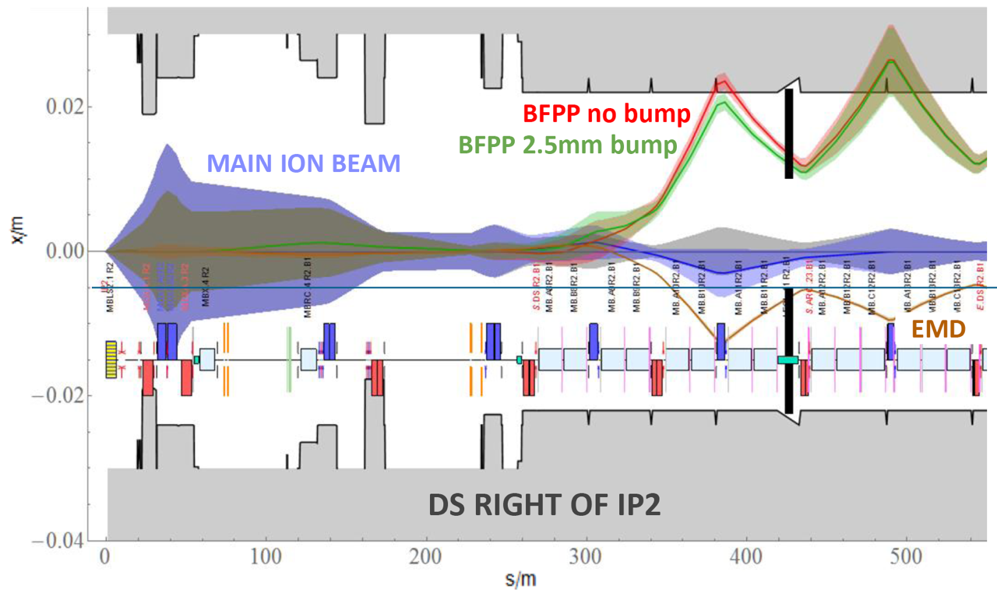
Figure 1 – The 1 σ envelope of the main Pb⁸²⁺ beam (violet) together with the dispersive trajectories of ions undergoing BFPP1 (red) and EMD1 (brown), coming out of the ALICE experiment (IP2). The TCLD collimator jaws appear as black lines. The green line indicates the shifted BFPP1 orbit using a closed orbit bump, which is necessary to intercept the beam with the collimator. The EMD1 beam can be intercepted with the other jaw. Courtesy of J.M. Jowett [8].

REASON FOR THE CHANGE
As can be seen in Figure 1, these secondary beams are lost very locally due to the large and sudden change of magnetic rigidity at the interaction point. After the LS2 ALICE upgrade, aiming at a peak luminosity of 6 × 10²⁷cm⁻² s⁻¹ (about six times higher than the nominal one) [3], the dominant BFPP1 beam can carry about 155 W, resulting in a power load in the coils of the MB.B10 dipole of about 44 mW/cm³ [4] on both sides of ALICE. Similar ion losses also occur in the DS regions around ATLAS and CMS, however at different locations than in IR2. A beam loss experiment carried out during the 2015 Pb-Pb run at 6.37 Z TeV [5] confirmed the long-standing presumption that BFPP1 ions risk to quench magnets [1, 2]. The experiment was carried out around CMS because it was running at slightly higher peak luminosity than ATLAS. The deposited power during the quench was estimated with FLUKA simulations to be about a factor 6 lower than what is calculated for HL-LHC, hence this effect could be a serious limitation for HL-LHC.
During standard operation, special bumps were deployed around ATLAS and CMS to steer the BFPP1 losses into the locations of the connection cryostat, however, because of the quadrupole polarities in IR2, this solution alone is not possible at ALICE. Instead, the HL-LHC baseline is to install one additional collimator, called TCLD, on each outgoing beam in the IR2 dispersion suppressor, where the dispersion is already rising [3]. Orbit bumps ensure that the beam is not lost at the first (lower) dispersion peak (see Figure 1) and enable shifting the losses into the collimators. By closing their jaws further, these TCLDs can also intercept the most powerful EMD beam (EMD1) that would otherwise be lost in IR3. FLUKA simulations have shown that the proposed TCLDs reduce the peak load on the magnets to tractable levels at HL-LHC design luminosity [4].

DETAILED DESCRIPTION
The most loaded magnet in IR2 is MB.B10 on each side. The TCLD in IR2 can be placed further downstream in the connection cryostat (LECL.11R2.B1 and LEBR.11L2.B2). The TCLDs will be installed in the centre of the space presently occupied by the connection cryostat (at the collimator centre, DCUM = 3758.0774 m for R2.B1 and DCUM = 2906.6434 m for L2.B2).
This requires that the present ~12 m long connection cryostats are removed so that each can be replaced by an assembly consisting of a pair of 5.3 m-long cryostats (LEP) with a 2.2 m bypass cryostat in the middle (LEN), as well as the TCLD collimator. The bypass cryostat comes in two different configurations, one for each beam line, depending on whether it is the collimated or the non-collimated line. The cryo-assembly is described in a separate ECR under the responsibility of WP11 [6].

Details on the integration can be found in [7], and the references for the differential drawings are LHCLJ_2U0029 [10] and LHCLJ_2U0028 [11].
In order to optimize design and production efforts, the design of the TCLD assembly is identical to the one used in IR7.
Like most other LHC collimators, the TCLD consists of two parallel jaws collimating the beam in the horizontal plane, with the beam passing in between them. The active material of the jaws is the tungsten alloy Inermet 180. The design of the TCLD collimator, shown in more detail in Figure 2, Figure 3 and Figure 4, is derived from the design of the present LHC collimators, but with some differences. Since the design of the IR2 TCLDs is identical to that of the IR7 ones, and because of the very tight space requirements in IR7, the design is challenging and the active length of the material had to be reduced to only 60 cm, in order to make it fit. This also means that a non-standard support design is used. Furthermore, the bellows at the two longitudinal extremities are integrated in the tank transitions in order to gain longitudinal space. Special tooling for transport, handling and for the retraction of the collimator bellows during the installation has been designed. In order to gain as much space around the TCLD vacuum tank as possible, a new thinner set of heating jackets (aerogel) has also been produced. A 3D drawing of the tank and support is shown in Figure 5. The SmarTeam references are shown in Table 1.
Table 1 SmartTeam references for the TCLD.
Element | SmarTeam reference
Model of the TCLD collimator | STST0694095
Model of the TCLD support | ST1023729
Model of the TCLD jacks | ST0943265

The actuation system does not include any movement in the vertical plane, which allowed reducing the jaw height. Otherwise, each jaw can be independently moved by two stepping motors per jaw, which maintains the possibility to tilt the jaws in the horizontal plane. The maximum opening of each jaw is 25 mm from the centre, 5 mm less than for standard collimators, and the stroke across the centre is 5 mm.
As all recent collimators, the design includes two BPMs per jaw, integrated at the extremities outside of the tapering. The jaws feature water cooling, using squared 9 mm pipes. Each jaw contains also 3 LVDT position sensors and 2 TP100 temperature sensors.
All these require new connections, i.e. pulling new cabling for the motors, including LVDTs and temperature sensors. Cables should be pulled also for the BPMs, which should be connected to the standard DOROS electronics as for other collimators. Furthermore, the water cooling has to be connected to the demineralized main water circuit. A new tapping for incoming and outgoing water with a valve on each extremity of the line is needed. No extra BLM is needed – it is instead foreseen to slightly displace one of the existing BLMs to a position on the connection cryostat in the horizontal plane, just downstream of the TCLD, to monitor losses at the collimator [7].
The characteristics of the TCLD are summarized in Table 2. The layout functional position names for the new collimators and the embedded BPMs are listed in Table 3.
The TCLD will be integrated in a specially designed assembly, containing a beam pipe for the other beam, as well as a cryo-bypass, which is needed since the TCLD is a warm element placed between two cold ones. This assembly, which is discussed more in detail in a separate ECR, is shown in Figure 6. The vacuum flange used for the TCLD is the DN100 with internal diameter of 64 mm.
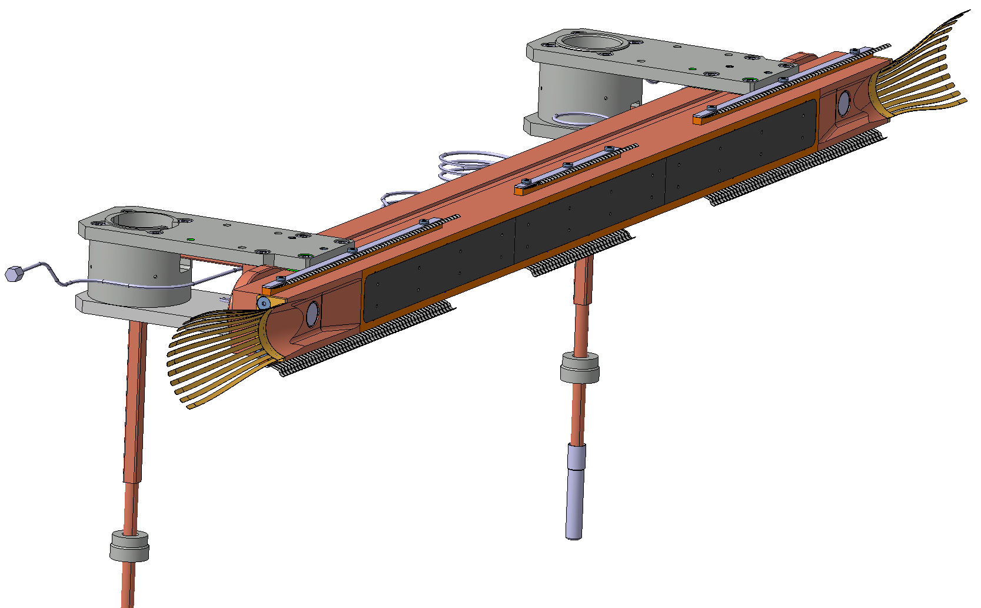
Figure 2 – One of the TCLD jaws, including RF fingers, cooling pipes and BPMs. Courtesy of L. Gentini – SmarTeam number ST0676575.
Figure 3 –Two jaws installed on the table (bottom). Courtesy of L. Gentini – SmarTeam number ST0676575.

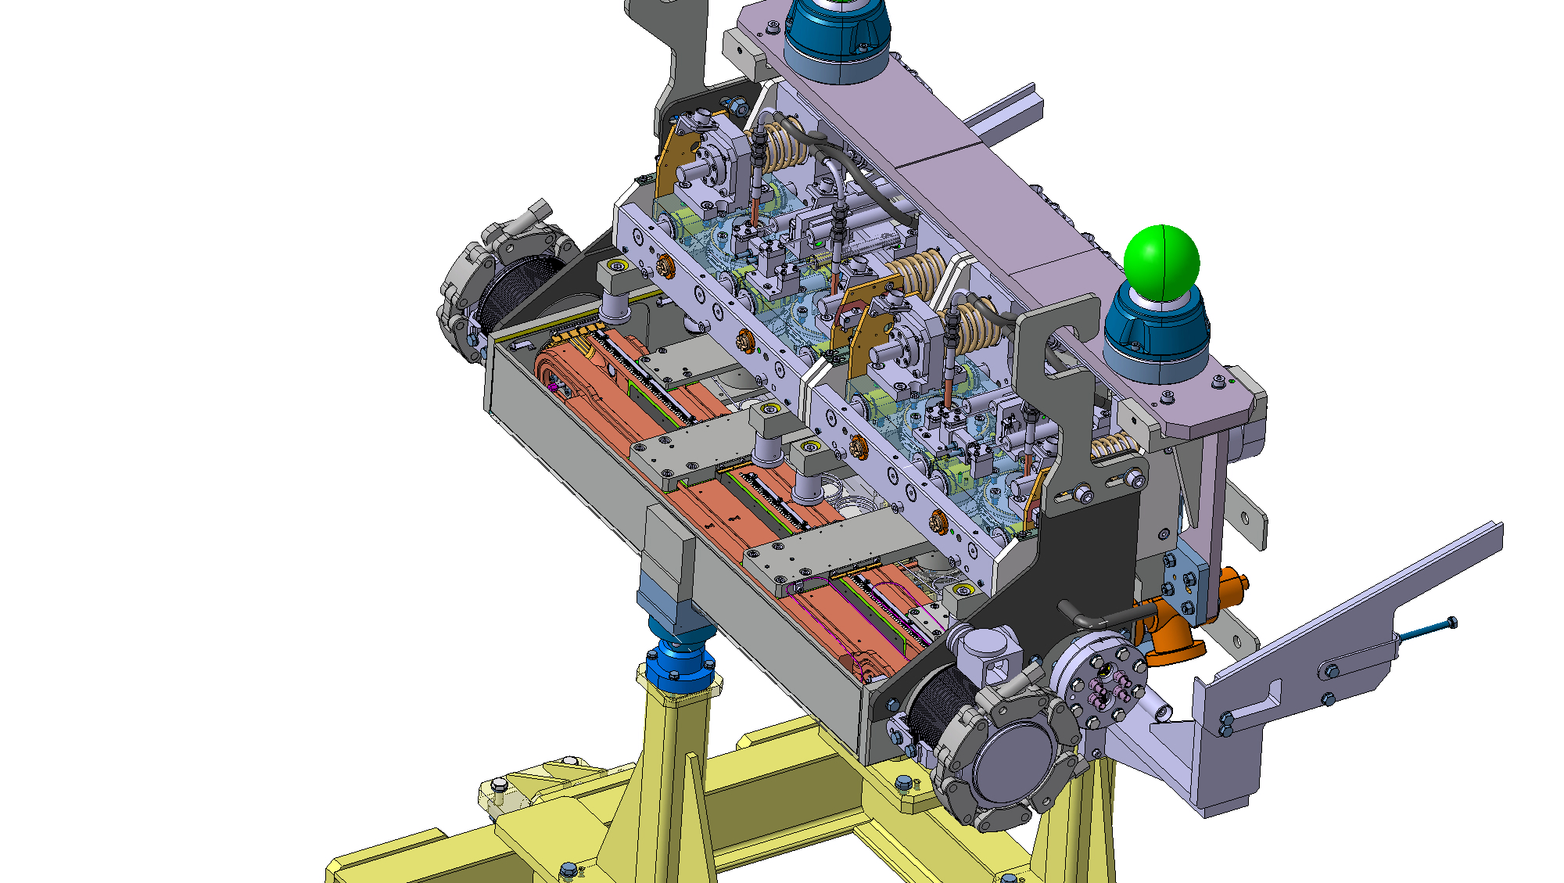
Figure 4 — 3D drawing of the TCLD jaws, integrated in the tank and installed on the supports. Courtesy of L. Gentini – SmarTeam number ST0676575.
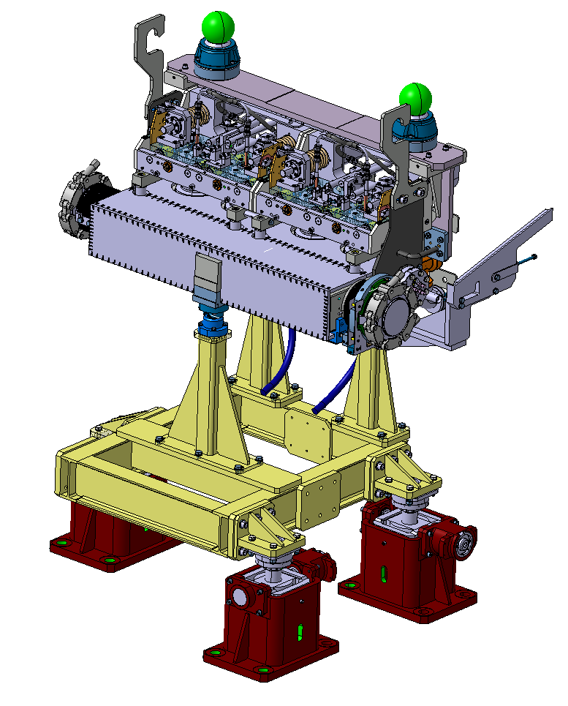
Figure 5 – 3D drawing of the TCLD tank and support. Courtesy of L. Gentini – SmarTeam number ST0676575.
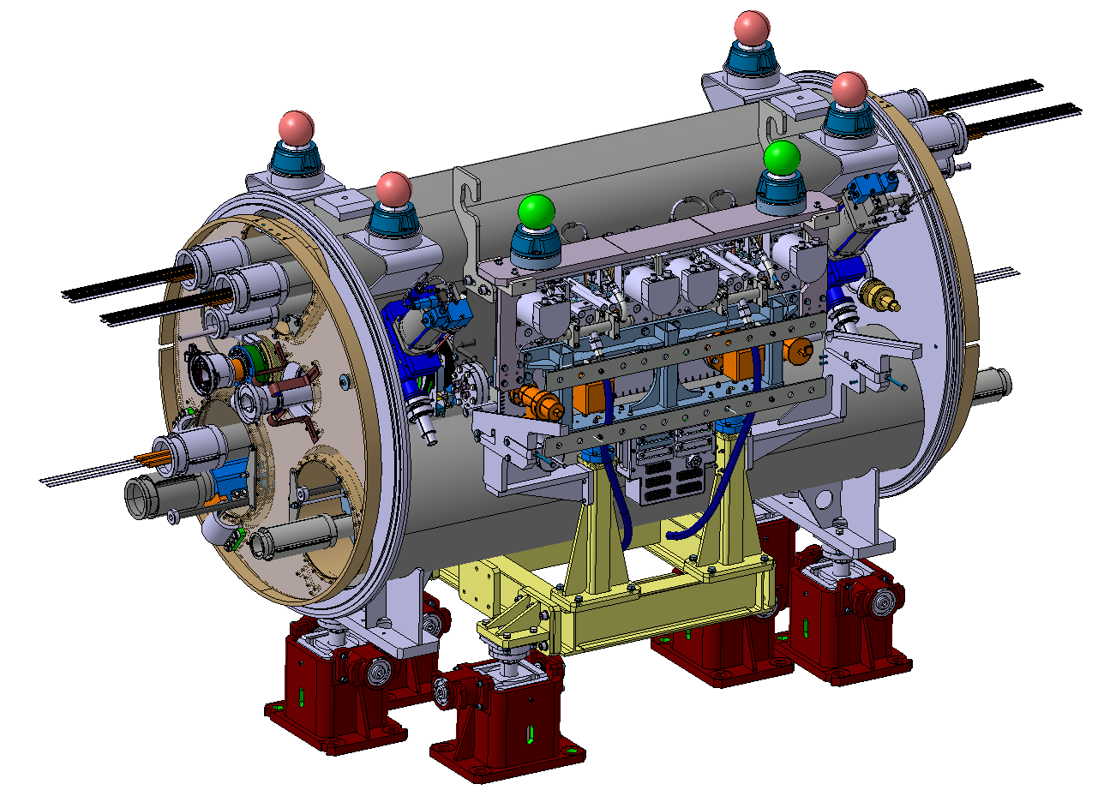
Figure 6 – The assembly to be installed at the location of the IP2 connection cryostats, consisting of TCLD collimator, support, beam pipe for the other beam, and cryo-bypass. Courtesy of L. Gentini – SmarTeam number ST0676575.
Table 2— Detailed parameters of the TCLD collimator.
Characteristics | Units | Value
Jaw active length | mm | 600
Jaw absorbing material | - | Inermet 180
Flange-to-flange distance | mm | 1080
Number of jaws | - | Two
Orientation | - | Horizontal
Number of BPMs per jaw | - | Two
RF damping | - | RF fingers
Cooling of the jaw | - | Yes
Cooling of the vacuum tank | - | No
Minimum gap | mm | <2
Maximum gap | mm | 50
Stroke across zero | mm | 5
Number of motors per jaw | - | Two
Angular adjustment | - | Yes
Transverse jaw movement (fifth axis) | - | No

Table 3 — Layout functional positions names for the new collimators and the embedded BPMs

Vacuum Layout Changes
The installation of the TCLD’s will require the addition of two sector valves, which have a 63 mm inner diameter of the aperture. Consequently, VACSEC12.R and VACSEC23.B will be both divided into three new vacuum sectors as seen on Table 4 and Table 5. With a dual purpose, these tables indicate the start and end DCUM of the new sectors and the vacuum instrumentation to be added to the TCLD and sector valves.

Table 4 – New Vacuum Sectorization in ARC1-2
CURRENT SECTOR | NEW SECTOR | NAME | LENGTH (m) | DCUM START (m) | DCUM END (m) | Notes
VACSEC12.B  (External Beam Line) | VACSEC12.B |  | 2819.7864 | 256.1090 | 3075.8954
VACSEC12.R  (Internal Beam Line) | VACSECA12.R |  | 2649.8904 | 256.1090 | 2905.9994
 |  | VVGSL | 0.1040 | 2905.9994 | 2906.1034 | VGPB
 | VACSECB12.R | TCLD | 1.0800 | 2906.1034 | 2907.1834 | VVFMD, VPNNG, VPNNG, VGFC
 |  | VVGSR | 0.1040 | 2907.1834 | 2907.2874 | VGPB
 | VACSECC12.R |  | 168.6080 | 2907.2874 | 3075.8954

Table 5 – New Vacuum Sectorization in ARC2-3
CURRENT SECTOR | NEW SECTOR | NAME | LENGTH | DCUM START | DCUM END | Notes
VACSEC23.R  (External Beam Line) | VACSEC23.R |  | 2818.0664 | 3588.3254 | 6406.3918
VACSEC23.B  (Internal Beam Line) | VACSECA23.B |  | 169.1080 | 3588.3254 | 3757.4334
 |  | VVGSL | 0.1040 | 3757.4334 | 3757.5374 | VGPB
 | VACSECB23.B | TCLD | 1.0800 | 3757.5374 | 3758.6174 | VVFMD, VPNNG, VPNNG, VGFC
 |  | VVGSR | 0.1040 | 3758.6174 | 3758.7214 | VGPB
 | VACSECC23.B |  | 2647.6704 | 3758.7214 | 6406.3918

The introduction of a new sectorization implies the existence of a pumping port and vacuum instrumentation on each sector. New pumping ports and vacuum instrumentation must be added as described on a separate ECR [9], where the same approach is suggested for both Point 2 and Point 7.

IMPACT ON OTHER ITEMS

IMPACT ON ITEMS/SYSTEMS
BE/BI | BE/BI support is required for the BLM acquisition associated to the collimator. It is required to displace an existing nearby BLM to a position just downstream of each TCLD. Details are found in [7].  BE/BI is responsible for the BPM acquisition. Cables should be pulled for the new BPMs. Controls units DOROS should be installed for the signal processing.
TE/VSC | The installation of the TCLDs will require the installation of vacuum components adjacent to the collimators. In addition, new vacuum instrumentation has to be installed and cabled. This improvement will ultimately introduce two new vacuum sectors on each side of point 2 with the installation of two sector valves per side.
BE/OP | New devices will have to be properly configured in the top level control layer of LSA.
WP11 | The installation of the TCLD is tightly linked to the installation of the cryo-assembly under the responsibility of WP11 [6] (constraints on geometry, schedule, functionality, etc).

IMPACT ON UTILITIES AND SERVICES
Raw water: | No
Demineralized water: | The water cooling circuit of the TCLD will have to be connected to the main water circuit. New tapping, valves and water hoses are required. The new collimators have the same requirements as the present ones and do not add new requirements on the cooling water flows.  The new collimators have the same requirements as the present ones and  will not add new requirements on the cooling water flows.
Compressed air: | Compressed air should be available at the TCLD location. TE-VSC needs it for driving the vacuum sector valves and the temporary pumping group.
Electricity, cable pulling  (power, signal, optical fibres…): | New cables are required for the motors, LVDTs and temperature sensors.  New cables required for BPMs are described in the previous section.
DEC/DIC: | RQF0842047 (EN/SMM)  RQF0906326 (BE/BI)  RQF0912879 (TE/VSC)  Racks in UA23: BY02, BY04 and TYCDD01  Rack in UA27: TYCFL02
Vacuum test at the surface | Once the TCLD is installed, TE-VSC must install the bake-out equipment, perform the bake-out and finally remove all the components for a total of about 2-3 weeks of work per vacuum sector.The TCLD has to pass standard vacuum qualification procedures before and after installation in the tunnel. Sector valves will be installed at each extremity of the TCLD.
Special transport/ handling: | New dedicated transport and installation tooling as well as installation procedure.
Temporary storage of conventional/radioactive components: | No
Alignment and positioning: | Standard alignment procedures apply – at installation, the collimator position should be adjusted by the survey team. Marking position on the floor is needed.  The component must be created / updated in the CERN layout database before any SU activities in the LHC tunnel.  - EN-SMM-ASG section will mark on the floor the beam axis and the beam points (start / end) of the component (0.5 day / component) : the floor need to be cleared (and possibly cleaned) before the tracing.  - EN-SMM-ASG section will mark the drilling positions : a drilling drawing ("plan de percage") with respect to the both beam references marked on the floor by SU will be needed by EN/ACE  - The alignment (0.5 day / component) should be done before the vacuum connection and after the cryostat alignment  The alignment of the TCLD and cryo-bypass will be carried out from the both adjacent cryostats.  In the future, when the adjacent magnets will be re-aligned (vertical or radial displacements) during LHC smoothing campaigns the TCLD and the cryo-bypass will also need to be realigned.
Scaffolding: | No
Controls: | - The LHC control system must be updated to include the new collimator and BPMs.  - The SCADA vacuum control system has to be updated accordingly to the proposed tables and should integrate new vacuum sectors, sector valves, pumps and gauges.
GSM/WIFI networks: | No
Cryogenics: | The implementation of the cryo-bypass is described in the companion ECR by WP11 (under preparation).
Contractor(s): | No
Layout DB: | The Layout DB should be updated on the optical side and for the new vacuum valves, pumps, gauges and vacuum sectorization.  New component codes have to be created for the new sector valves (see Tables 3 and 4)

IMPACT ON COST, SCHEDULE AND PERFORMANCE

IMPACT ON COST
Detailed breakdown of the change cost: | The activity is funded by the HL-WP5, unit 5.2 (DS cleaning)
Budget code: | Various codes across the ATS sectors:  53701: HL-LHC WP05-DS Collimation-EN/STI  53709: HL-LHC WP05-DS Collimation-EN/STI [CONS]  53718: HL-LHC WP05-DS Collimation-EN/SMM  53722: HL-LHC WP05-DS Collimation-EN/SMM [CONS]  64073: HL-LHC WP05-DS Collimation-BE/BI  53707: HL-LHC WP05 Collimator production TCLD-TE/VSC

IMPACT ON SCHEDULE
Proposed installation schedule: | Installation foreseen during 2020.  Readiness to install date: 5th February 2020
Proposed test schedule (if applicable): | Prior to installation: controls tests (EN/STI) and vacuum validation (TE/VSC).  Impact on the EN/EL team to be evaluated.  The new handling equipment is ready and the installation procedure will be available mid-September.
Estimated duration: | 2-3 weeks
Urgency:
Flexibility of scheduling: | Limited  With the present understanding, no specific safety constraints apply if the installation is done as planned with the sector warm. In case of change of schedule, a safety assessment shall be performed.

IMPACT ON PERFORMANCE
Mechanical aperture: | The movable collimator will (intentionally) be operated at smaller aperture than the previous beam pipe, in order to intercept beam losses that otherwise would hit the magnets. This will, however, not have any negative influence on the global aperture.
Impedance: | The impedance has been studied by the impedance team for a preliminary design and no issues were found. Checks of the final design are on-going.  The impedance team requires an impedance measurement with the stretched wire technique for all produced collimators (in addition to the validation of the design that was performed through measurements on prototypes) to detect potential impedance non-conformities before installation. The EN/STI team assessed that this activity is compatible with the present planning. Implications on the budgets are estimated to less than 2 kCHF per collimator that can be absorbed by the general WP5 budget (BC 61071). A risk assessment is being organised to identify other potential implications, in particular on the vacuum conformity of the collimators, before taking a final decision on the feasibility and strategy of these measurements.
Optics/MADX | Changes in the layout DB should be propagated to the MAD-X LHC sequence.
Electron cloud  (NEG coating, solenoid…) | No change
Insulation (enamelled flange, grounding…) | No change
Vacuum performance: | TE-VSC will perform vacuum acceptance tests on each components to assess vacuum compatibility within LHC vacuum environment based on EDMS 1752123. In case of not conformity the collimators could be rejected and not being installedNo change. The collimator will be qualified by VCS before and after installation.
Others:

IMPACT ON OPERATIONAL SAFETY

ÉLÉMENT(S) IMPORTANT(S) DE SECURITÉ
Requirement | Yes | No | Comments
EIS-Access |  | X | --
EIS-Beam |  | X | --
EIS-Machine |  | X | --

OTHER OPERATIONAL SAFETY ASPECTS
The TCLD Safety Assessment Form is available on EDMS 1900519.
Have new hazards been created or changed? | The TCLD doesn’t introduce new hazard during its operation.  An additional risk assessment using the FMEA method (EDMS 1969909) is being finalised to assess the risks during installation, bake-out, regular maintenance and exceptional replacement during run periods.  For exceptional replacement during run periods, relevant arc sectors and cryo bypass must be emptied from liquid helium and heated up to 20K before TCLD exchange. This could be reconsidered if transport can demonstrate that their handling procedure guarantees the highest safety level.
Could the change affect existing risk control measures? | no
What risk controls have to be put in place? | The FMEA will help assess the risk control measures to implement to prevent an He spill during installation, bake-out, regular maintenance and exceptional replacement. Preliminary conclusions indicate that in case of exceptional replacement during runs, the sector shall be warmed up to 20K. A procedure for the regular maintenance will be issued by EN-SMM and EN-STI. Bake-out safety constraints will be defined once the TE-VSC thermal simulations will be available.
Safety documentation to update after the modification | Procedures for installation, bake-out, regular maintenance and exceptional replacement shall be updated wrt the conclusions of the FMEA.
Define the need for training or information after the change | The modus operandi to intervene on the TCLD shall be communicated to the intervening workers.

WORKSITE SAFETY

ORGANISATION
Requirement | Yes | No | Comments
IMPACT – VIC: | X
Operational radiation protection  (surveys, DIMR…): | X |  | Radiation survey will be done at the beginning of LS2 and IR2 will be a supervised radiation area; in cell 11 no residual radiation above the background level is expected.
Radioactive storage of material: |  | X | --
Radioactive waste: |  | X | --
Fire risk/permit (IS41)  (welding, grinding…): |  | X
Alarms deactivation/activation (IS37): |  | X
Others:

REGULATORY TESTS
Requirement | Yes | No | Responsible Group | Comments
Pressure/leak tests: | X |  | Responsible of cooling water circuits.  TE-VSC | Water pressure test of cooling pipes must be done, as specified, before vacuum acceptance test. All cooling pipes must be emptied for the vacuum test. Any water leakage during the bake out could induce short circuits and permanent damage of the bake out system.  Helium leak test of the complete collimator before and after bake out cycle is performed.
Electrical tests: |  | X
Others: | X |  |  | The impedance should be measured and validated - see section 5.3.

PARTICULAR RISKS
Requirement | Yes | No | Comments
Hazardous substances (chemicals, gas, asbestos…): |  | X
Work at height: |  | X
Confined space working: |  | X
Noise: |  | X
Cryogenic risks: | X |  | Warm collimator to be installed between two cold elements with cryo bypass
Industrial X-ray  (tirs radio): | X | X | X-rays of the TCLD bellow after installation must be performed
Ionizing radiation risks (radioactive components):
Others:

FOLLOW-UP OF ACTIONS BY THE TECHNICAL COORDINATION
Action | Done | Date | Comments
Carry out site activities:
Carry out tests:
Update layout drawings:
Update equipment drawings:
Update layout database:
Update naming database:
Update optics (MADX)
Update procedures for maintenance and operations
Update Safety File according to EDMS document 1177755:
Others:

REFERENCES
[1] J.M. Jowett et al., Heavy ion beams in the LHC, 20th IEEE Particle Accelerator Conference, Portland, OR, USA, 12 - 16 May 2003, pp.1682 LHC-Project-Report-642
[2] R. Bruce et al., Beam losses from ultraperipheral nuclear collisions between 208Pb82+ ions in the Large Hadron Collider and their alleviation, Phys. Rev. ST Accel. Beams 12 (2009) 071002.
[3] G. Apollinari, I. Bejar Alonso, O. Bruning, P. Fessia, M. Lamont, L. Rossi, and L. Tavian (editors). High-Luminosity Large Hadron Collider (HL-LHC): Technical Design Report V. 0.1. CERN Yellow Reports: Monographs. CERN-2017-007-M. CERN, Geneva, 2017
[4] G. Steele et al., Heat load scenarios and protection levels for ions, presentation at the 2013 LHC Collimation Review 2013 https://indico.cern.ch/event/251588/timetable/?view=standard
[5] M. Schaumann, et al. LHC BFPP Quench Test with Ions (2015) CERN-ACC-NOTE-2016-0024, 2016
[6] D. Schoerling, Installation of the Connection Cryostat Full Assembly in the LHC P2 (HL-LHC WP11), EDMS LHC-LE-EC-0005 or 1995583
[7] M. Gonzalez de la Aleja, HL-LHC INTEGRATION REPORT FOR INSTALLATION APPROVAL, CERN EDMS document 1903950
[8] J. Jowett, Heavy-ion performance of HL-LHC, Presentation at the 7th HL-LHC Collaboration meeting, Ciemat, Madrid, November 2017, https://indico.cern.ch/event/647714/contributions/2632851/attachments/1557678/2450759/HL-LHC_Madrid_Jowett_14Nov2017.pdfhttps://indico.cern.ch/event/647714/contributions/2632851/attachments/1557678/2450759/HL-LHC_Madrid_Jowett_14Nov2017.pdf
[9] G. Bregliozzi et al., Engineering Change Request: New Vacuum Pumping Ports in the ARCs linked to the 11T and TCLDs Installation, CERN EDMS Document No. 1966384
[10] J. Oliveira, Differential Layout C11L2 LS2, CERN EDMS document 2007797
[11] J. Oliveira, Differential Layout C11R2 LS2, CERN EDMS document 2007796

