ENGINEERING CHANGE REQUEST

Installation of Low-Impedance Primary Collimators with BPMs (TCPPM) in IR7
BRIEF DESCRIPTION OF THE PROPOSED CHANGE(S):
The primary collimators (TCPs) are essential for the operation at high intensity at the LHC as they are used to intercept primary off-momentum and betatron losses in the multi-stage cleaning systems in IR3 and IR7. As a part of the consolidation of the collimation system, horizontal and primary collimators of IR7 (four collimators) will be replaced in LS2. The new collimators will ensure high-efficiency operations in Run III and in the HL-LHC era. The new design with in-jaw beam position monitors will be used. As a part of the HL-LHC-WP5, the absorbing material will also be upgraded to a low-impedance material (MoGr). This ECR details the hardware installation, proposed to take place during the Long Shutdown 2 (LS2).
DOCUMENT PREPARED BY: | DOCUMENT TO BE CHECKED BY: | DOCUMENT TO BE APPROVED BY:
Roderik Bruce BE-ABP  Alessio Mereghetti BE-ABP  Stefano Redaelli BE-ABP | O. Aberle, J. Albertone, C. Adorisio,  G. Arduini, M. Barberan, I. Bejar Alonso,  M. Bernardini, A. Bertarelli, F. Bertinelli,  C. Bertone, C. Boccard, G. Bregliozzi,  S. Bustamante, M. Calviani, F. Carra,  G. Cattenoz, P. Chiggiato, J. P. Corso,  B. Delille, R. De Maria, P. Fessia, R. Folch,  J. F. Fuchs, C. Gaignant, L. Gentini,  S. Gilardoni, G. Girardot, M. Giovannozzi, B. Goddard, E. Jensen, R. Jones, I. Lamas Garcia, M. Lamont, J. Lendaro, A. Masi,  D. Missiaen,Y. Muttoni, T. Otto, E. Page, S. Roesler, B. Salvant, R. Steerenberg,  L. Tavian, M. Tavlet, C. Vollinger, J. Wenninger | P. Collier  (on behalf of the LMC)  L. Rossi  (on behalf of the HL-LHC Project)
DOCUMENT SENT FOR INFORMATION TO:
ATS groups leaders
SUMMARY OF THE ACTIONS TO BE UNDERTAKEN:
[List the main actions to be undertaken]

EXISTING SITUATION AND INTRODUCTION
The betatron collimation system [1] of the Large Hadron Collider (LHC) is located in the Insertion Region 7 (IR7). It is composed by:
- three primary collimators (TCPs), intercepting tail protons;
- eleven secondary collimators (TCSGs), aimed at intercepting most of the beam particles leaking out of the TCPs;
- shower absorbers (TCLAs), aimed at containing the most energetic component of the secondary particle showers started in the upstream collimator families.
Primary and secondary collimators are made of a robust material as they are potentially more exposed to primary beam losses. Carbon fibre composites (CFC) are used, which have the draw back of contributing significantly to the LHC impedance [2].
TCP and TCSG collimators are significantly activated during the LHC high-intensity operations and radiation ageing/wear is a main concern for these collimators, also because after some years of LHC operation, working on these collimators might become challenging in terms of doses to personnel. The horizontal and vertical primary collimators of IR7 (one collimator per beam per plane) are essential for any operation of the LHC at high intensity.
While the TCSGs will all be replaced in two campaigns in LS2 and LS3 as a part the HL-LHC collimation upgrade [3] (see also [4] for the LS2 phase I upgrade), the renewal of primary collimators for the high-efficiency operation in Run III and in the HL-LHC era is covered by the Consolidation project. The TCP upgrade starts in LS2 by replacing the horizontal and vertical primary collimators of IR7. The need to replace the IR7 skew collimators and the IR3 TCPs might follow in LS3 or later depending on the ageing of the present TCPs.
The new collimators will be built according to the latest design that embeds in-jaw BPMs and a modular jaw design compatible with different absorbing materials. It is also noted that because of the resistivity of the jaw material and typical gaps deployed in operation, TCPs give an important contribution to machine impedance [2]. The TCP absorbing material will also be upgraded to MoGr (molybdenum-graphite), with similar robustness against beam losses by a factor 5 lower in electrical resistivity than CFC. This reduces the single-collimator impedance by about a factor 2. This upgrade is funded by HL-LHC-WP5.
New primary collimators are called TCPPM, as Target Collimator Primary Pickup Metallic.

REASON FOR THE CHANGE
The construction of new primary collimator as consolidation of the IR7 system is considered necessary to ensure high-efficiency operations in Run III and in the HL-LHC era. The “consolidated” collimator design similar to the one adopted for new collimators built in LS1 [5] will be used. This will add BPMs to the design for a faster alignment and orbit interlock capability. A TCP prototype with BPMs has already been used in operation since 2016 [6].
As a part of the HL-LHC-WP5, the TCP absorbing material will also be upgraded. MoGr will be used to reduce by about a factor 5 the material resistivity, for a gain of about a factor 2 in single-collimator impedance.

DETAILED DESCRIPTION
The present TCPPM design (see Figure 1) is similar to the one of the present TCPs [1]; among the most noticeable differences, there are the jaw material and the presence of Beam Position Monitors (BPMs). In fact, the design foresees jaws made of a composite material (MoGr) obtained from Molybdenum and graphite, chosen for its lower impedance and similar robustness with respect to the jaw material of the present TCPs (Carbon-Fiber-Composite, CFC). The new material is characterised by an impedance lower by about a factor 2 with respect to the one of CFC. The collimator jaws are equipped with BPM button pick-ups, for an easy determination of the beam closed orbit at the collimator and fast and precise alignment of the jaws. A third BPM is installed on the tank, to measure the beam position on the axis orthogonal to the one of cleaning.
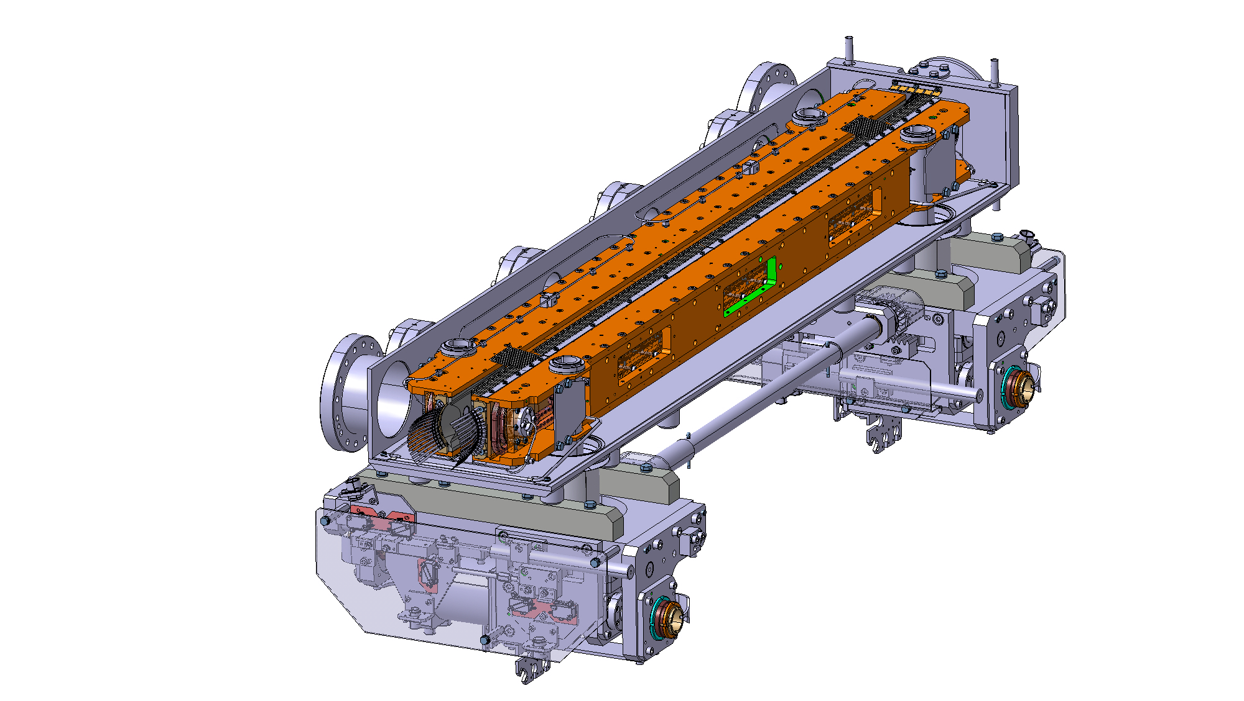
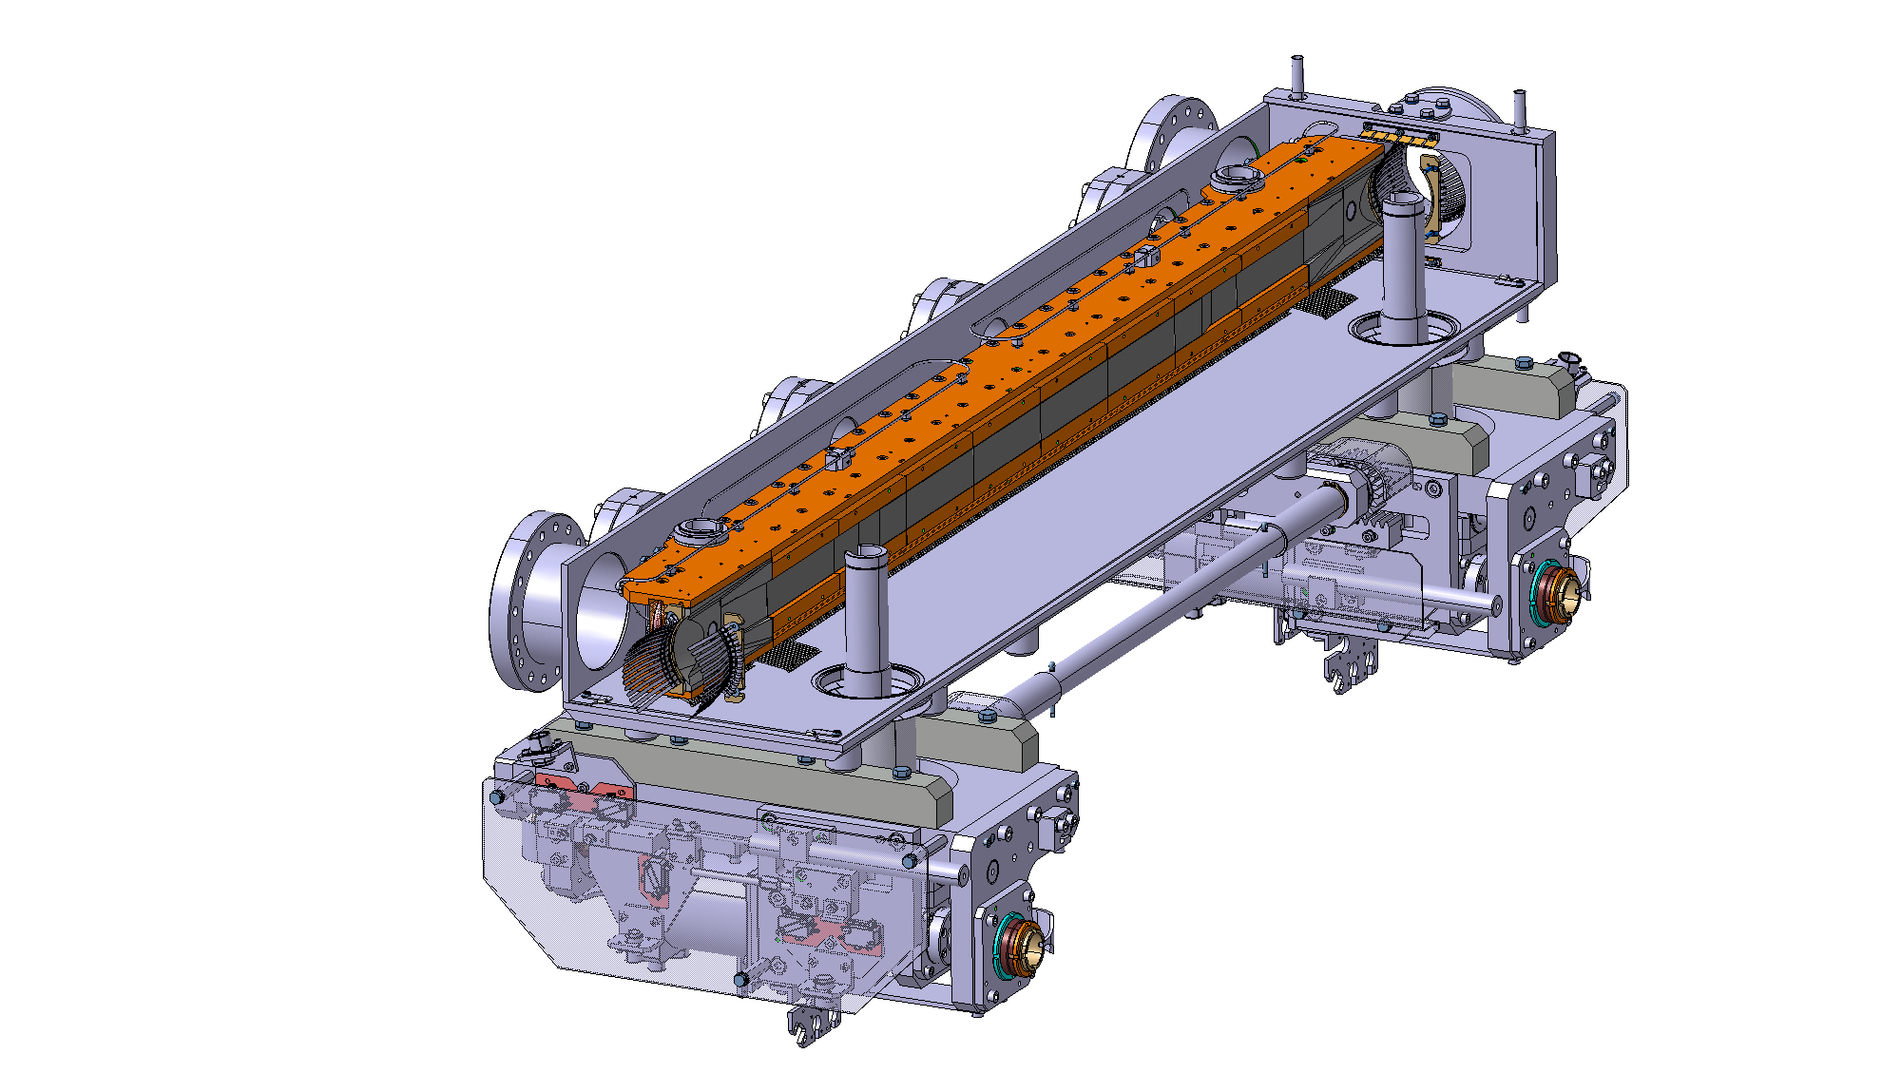
Figure 1 — 3D view [5] of the TCPPM collimator. Top: full collimator, with RF fingers. Bottom: sketch with left jaw only to show the 60 cm active length (obtained through blocks of different thickness).
Table 1 summarises the main collimator parameters of the TCPPM design. The installation of the new collimators is done by replacing the existing ones. Table 2 lists the concerned slots for both B1 and B2. The layout names for the new collimators and the names of the embedded BPMs are listed in Table 2.
Table 1 — Detailed parameter list of the TCPPM collimator design.
Characteristics | Units | Value
Jaw active length | mm | 600
Jaw absorbing material |  | MoGr
Flange-to-flange distance | mm | 1480
Number of jaws |  | 2
Orientation |  | Depending on installation slot (see Table 2)
Number of BPM buttons per jaw |  | 2
Number of tank BPM buttons |  | 2
RF damping |  | RF fingers
Cooling of the jaw |  | Demineralised water
Minimum gap | mm | <2
Maximum gap | mm | 50
Stroke across zero | mm | 5
Number of motors per jaw |  | 2
Angular adjustments |  | Yes
Transverse jaw movement (fifth axis) |  | Yes
Table 2 — Installation slots of the four new TCPPMs in IR7, replacing the existing vertical and horizontal primary collimators in IR7. We propose to keep the same layout names as for the present primary collimators.
B1 Slot | B2 Slot | Skew Angle [deg]
TCP.D6L7.B1 | TCP.D6R7.B2 | 90.0
TCP.C6L7.B1 | TCP.C6R7.B2 | 0.0
Table 3 — Installation slots of the four new TCPPMs in IR7, replacing the existing vertical and horizontal primary collimators in IR7. We propose to keep the same layout names as for the present primary collimators.
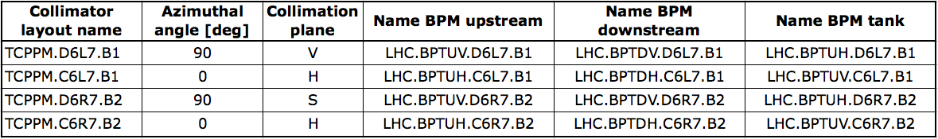

IMPACT ON OTHER ITEMS

IMPACT ON ITEMS/SYSTEMS
BE/BI | BE/BI support is required for the mounting/dismounting of the BLM associated to the collimator:  - BLMTI.06L7.B1E10_TCP.D6L7.B1 (s=19790.05 m);  - BLMTI.06L7.B1E10_TCP.C6L7.B1 (s=19792.05 m);  - BLMTI.06R7.B2I10_TCP.C6R7.B2 (s=20196.27 m);  - BLMTI.06R7.B2I10_TCP.D6R7.B2 (s=20198.27 m).  BE/BI is responsible for the BPM acquisition. Cables should be pulled for the new BPMs. Controls units DOROS should be installed for the signal processing.
BE/OP | Necessary changes to the control system of the LHC must be performed to control the new collimators and read the new BPMs signals.
Item/System xxxxx

IMPACT ON UTILITIES AND SERVICES
Raw water: | No
Demineralized water: | Same circuits as the present TCPs to be replaced.
Compressed air: | No
Electricity, cable pulling  (power, signal, optical fibres…): | Same as the present TCPs. Collimator controls will re-use the cabling of the present TCPs. On the contrary, BPM cables should be pulled for the TCP.D6L7.B1 and for the two TCPs on B2.  Note that new collimators have more temperature sensors that monitor the cooling water. Controls should be updated accordingly.
DEC/DIC: | RQF0943607 (BE/BI)
Racks (name and location): | TZ76
Vacuum (bake outs, sectorisation…): | The TCPPM, once finished, will have to go through the standard vacuum qualification tests before installation in the tunnel, as done for the present TCPs.
Special transport/ handling: | No
Temporary storage of conventional/radioactive components: | Storage of the removed TCPs is under the responsibility of EN/STI. They should be kept as operational spares if radiation levels allow this.
Alignment and positioning: | The component must be updated in the CERN layout Database before SU activities in the LHC tunnel. SU needs to know the positions of both targets by doing a “fiducialisation” with a laser tracker few days before the transportation of the component into the LHC.  Standard alignment procedures apply – at installation, the collimator position should be adjusted by the survey team.
Scaffolding: | No
Controls: | Same as the present TCPs.
GSM/WIFI networks: | No
Cryogenics: | No
Contractor(s): | No
Surface building(s): | No
Others: | No

IMPACT ON COST, SCHEDULE AND PERFORMANCE

IMPACT ON COST
Detailed breakdown of the change cost: | Covered by the Consolidation project except the jaw material.  Material (about 300 kCHF) covered by HL-LHC WP5. See detailed discussions at the 49th HL-TCC meeting of April 19th, 2018 [7].
Budget code: | 61717: Consolidation of LHC primary collimators of IR7 (TCP)  53702: HL-LHC WP05-Halo Cleaning-EN/STI

IMPACT ON SCHEDULE
Proposed installation schedule: | LS2, as late as possible, to minimise dose to personnel while removing the present TCP collimators.
Proposed test schedule (if applicable): | Prior to installation: controls tests (EN/STI) and vacuum validation (TE/VSC). Impact on the EN/EL team to be evaluated.
Estimated duration: | 2-3 weeks
Urgency: | No
Flexibility of scheduling: | Yes. According to production schedule, TCPPM should be available for installation as of Q4 2019.

IMPACT ON PERFORMANCE
Mechanical aperture: | As for all other collimators, the TCPPMs have movable jaws in the collimation plane (horizontal and vertical) and no deterioration is expected. Thus, this installation has no impact on the available aperture.
Impedance: | Improved.
Optics/MADX | No change
Electron cloud  (NEG coating, solenoid…) | No change
Insulation (enamelled flange, grounding…) | No change
Vacuum performance: | No change. The collimator will be qualified by VSC before installation. Therefore, this installation will not cause any vacuum degradation.
Others:

IMPACT ON OPERATIONAL SAFETY

ÉLÉMENT(S) IMPORTANT(S) DE SECURITÉ
No Impact on EISs.

OTHER OPERATIONAL SAFETY ASPECTS
Have new hazards been created or changed? | No
Could the change affect existing risk control measures? | No
What risk controls have to be put in place? | -
Safety documentation to update after the modification | -
Define the need for training or information after the change | -

WORKSITE SAFETY

ORGANISATION
Requirement | Yes | No | Comments
IMPACT – VIC: | X
Operational radiation protection  (surveys, DIMR…): | X |  | RP survey needed
Radioactive storage of material: | X |  | Existing TCPs will be stored as operational spares. Storage space must be made available
Radioactive waste: | X |  | Bolts, seals, consumables from the removed TCPs.
Non-radioactive waste: | X |  | [Specify waste category as per EDMS 1738461; waste quantity; collection/elimination means (i.e. SMB Dept. centralised services or contractor)]
Fire risk/permit (IS41)  (welding, grinding…): |  | X
Alarms deactivation/activation (IS37): |  | X
Others: |  | X

REGULATORY TESTS
Requirement | Yes | No | Responsible Group | Comments
Pressure/leak tests: |  | X
Electrical tests: |  | X
Others:

PARTICULAR RISKS
Requirement | Yes | No | Comments
Hazardous substances (chemicals, gas, asbestos…): |  | X
Work at height: |  | X
Confined space working: |  | X
Noise: |  | X
Cryogenic risks: |  | X
Industrial X-ray  (tirs radio): |  | X
Ionizing radiation risks (radioactive components): | X |  | The collimators are installed in slots presently occupied by other collimators. The elements to be removed will be radioactive.
Others:

FOLLOW-UP OF ACTIONS BY THE TECHNICAL COORDINATION
Action | Done | Date | Comments
Carry out site activities:
Carry out tests:
Update layout drawings:
Update equipment drawings:
Update layout database:
Update naming database:
Update optics (MADX)
Update procedures for maintenance and operations
Update Safety File according to EDMS document 1177755:
Others:

REFERENCES
[1] O. Brüning et al. (eds), “LHC design report”, Vol. I, CERN, Geneva, Switzerland, Rep. CERN-2004-003-V-1, 2004.
[2] N. Mounet, “Trensverse impedance in the HL-LHC era”, presentation at the 3rd
HL-LHC Annual Collaboration meeting, Daresbury, UK (2013), https://indico.cern.ch/event/257368/
[3] G. Apollinari et. al, “High Luminosity Large Hadron Collider (HL-LHC) Technical Design Report V.01'', CERN, Geneva, Switzerland, EDMS n. 1833445 v.09.05, https://edms.cern.ch/document/1833445
[4] TCSPM ECR, under preparation. [add later EDMS refs]
[4] S. Antipov et al., “Machine Impedance and HOM Power Update”, presentation at the 7th HL-LHC Annual Collaboration Meeting, Madrid, Spain (2017), https://indico.cern.ch/event/647714/
[5] S. Redaelli et al., “Replacement of TCT in IR1, IR2, IR5 and of TCSG Collimators in IR6 with Collimators with Embedded BPM Buttons”, LHC-TC-EC-0003 v.1.0, EDMS doc. 1251162.
[6] S. Redaelli et al., “Installation of a primary collimator with orbit pickups (TCPP) replacing a TCP”, LHC-TC-EC-0005 v.1.0, EDMS doc. 1705737.
[7] 49th HL-TCC meeting of April 19th, 2018. https://indico.cern.ch/event/722206/

